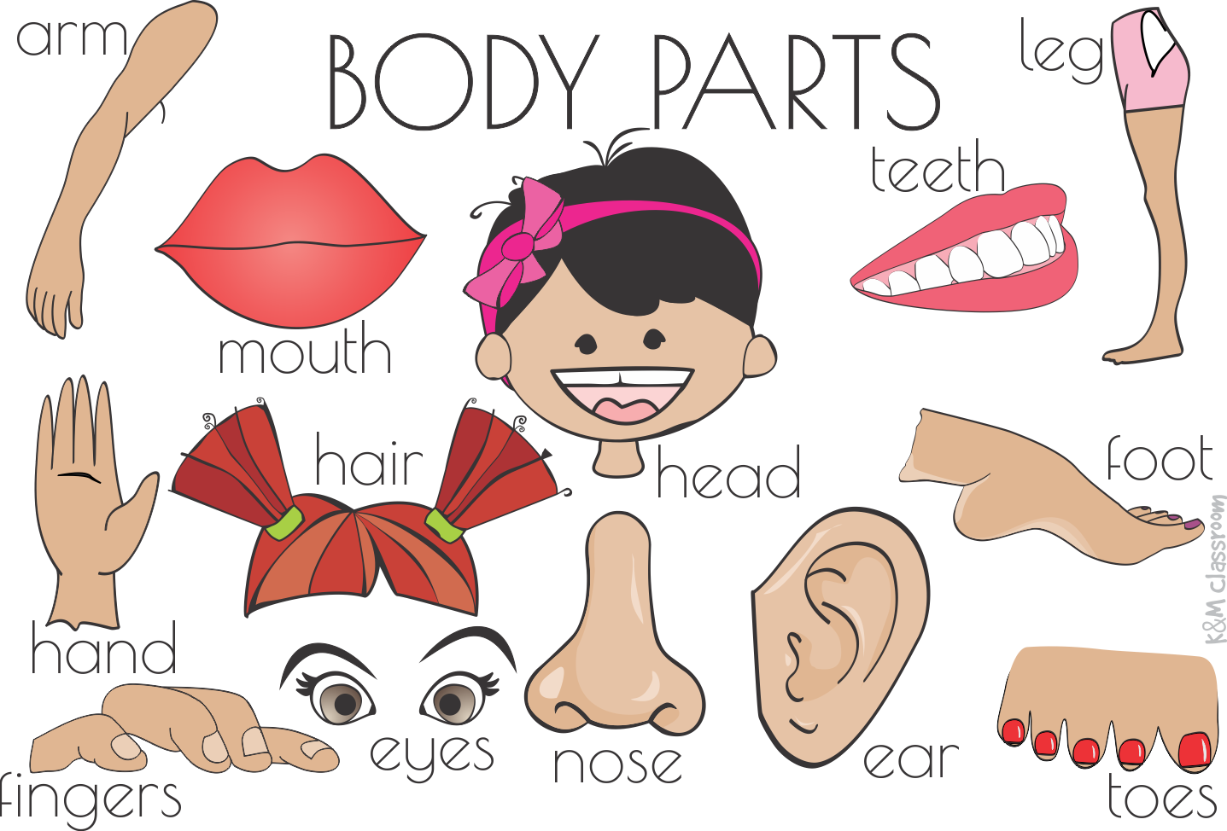
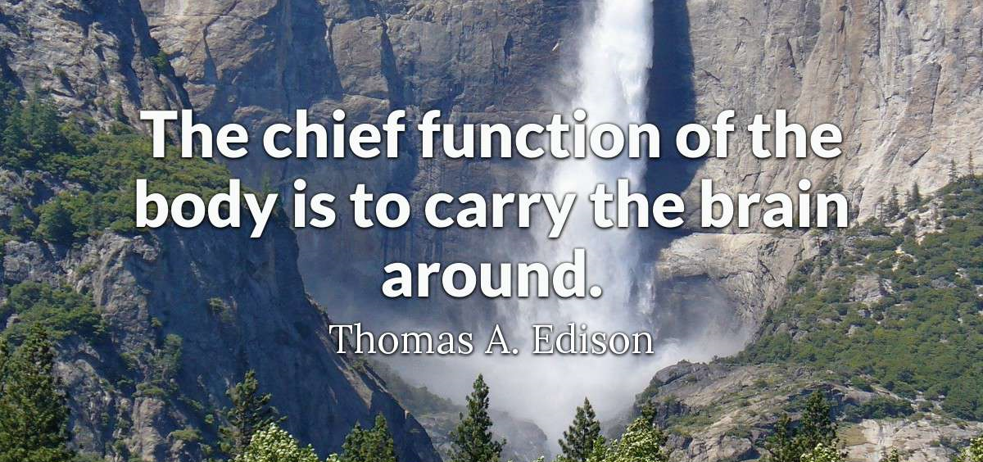

I. Presentation “Parts of the body”

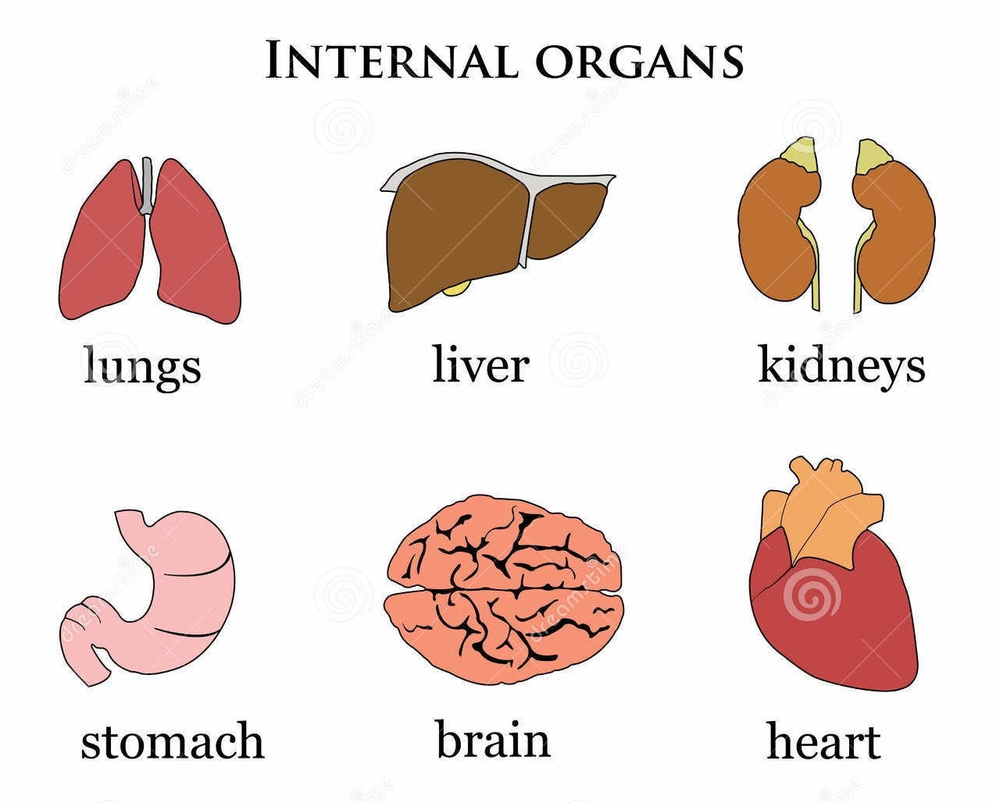
II. Match the sentence halves.
1. the stomach | a. cleans your blood and produces bile.
2. the brain | b. runs down your back
3. the ribs | c. controls your thoughts, feelings and movements
4. the heart | d. large bone which protects your brain
5. the skull | e. bones which go round your chest
6. the lungs | f. where the food which you eat gets broken down
7. the spine | g. are used for breathing
8. the liver | h. carry the blood around your body
9. veins | i. pumps blood around your body

III. Choose the correct answer.
http://esl.fis.edu/vocab/q21/face_r.htm

IV. Choose the correct answer.
http://esl.fis.edu/vocab/q21/body_r.htm

V. Choose the most suitable word for each space.
fingers feet face hairs hands foot hair
legs teeth arms eyes neck tooth
1. She has blond hair, and her ________ are blue.
2. Dinner's ready. Go wash your ________ .
3. She has beautiful ________ . It's long and black.
4. It's time for bed. Go brush your ________ .
5. Can you stand on one ________ for twenty seconds. I can't.
6. Don't eat that chicken with your ________ . Use a fork.
7. Teresa’s went completely dead.
8. Wear a thick scarf around your ________ . It's cold outside.
9. He's shy. Look at his ________ . It's red. He's blushing.
10. I have strong ________ because I go jogging every day.

VI. Complete each sentence.
stomach nails chest nose cheeks face back
muscles toes thumb lips mouth
1. Don't put that in your ________ . You can't eat it.
2. I have a cold. My ________ is running.
3. You have a strong ________ . Help me move the sofa.
4. He has big ________ . He goes to the gym and he lifts weights.
5. I have a big ________ . I eat too much.
6. You should cut your ________ . They're too long.
7. The human body has ten fingers and ten ________ .
8. We call the big finger on the end of the hand the ________ .
9. I think it's cold outside. Your ________ are red.
10. I think I saw his .

Answers:
II. Match the sentence halves.
1. the stomach | a. cleans your blood and produces bile.
2. the brain | b. runs down your back
3. the ribs | c. controls your thoughts, feelings and movements
4. the heart | d. large bone which protects your brain
5. the skull | e. bones which go round your chest
6. the lungs | f. where the food which you eat gets broken down
7. the spine | g. are used for breathing
8. the liver | h. carry the blood around your body
9. veins | i. pumps blood around your body

1. f 2. c 3. e 4. i 5. d 6. g 7. b 8. a 9. h

V. Choose the most suitable word for each space.
fingers feet face hairs hands foot hair
legs teeth arms eyes neck tooth
1. She has blond hair, and her eyes are blue.
2. Dinner's ready. Go wash your hands.
3. She has beautiful hair. It's long and black.
4. It's time for bed. Go brush your teeth.
5. Can you stand on one foot for twenty seconds. I can't.
6. Don't eat that chicken with your fingers . Use a fork.
7. Teresa’s arms went completely dead.
8. Wear a thick scarf around your neck. It's cold outside.
9. He's shy. Look at his face. It's red. He's blushing.
10. I have strong legs because I go jogging every day.

VI. Complete each sentence.
stomach nails chest nose cheeks face back
muscles toes thumb lips mouth
1. Don't put that in your mouth. You can't eat it.
2. I have a cold. My nose is running.
3. You have a strong back. Help me move the sofa.
4. He has big muscles. He goes to the gym and he lifts weights.
5. I have a big stomach. I eat too much.
6. You should cut your nails. They're too long.
7. The human body has ten fingers and ten toes.
8. We call the big finger on the end of the hand the thumb.
9. I think it's cold outside. Your cheeks are red.
10. I think I saw his face.

