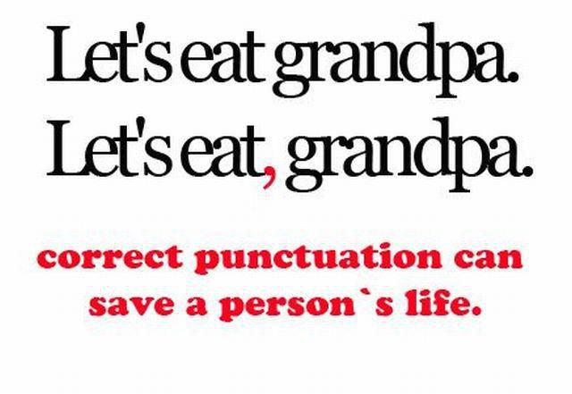
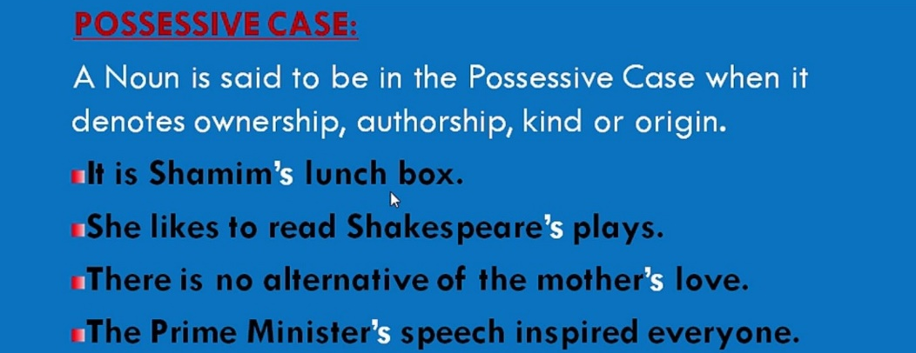
intermediate_lesson_23_possessive_case_part_2

Exercise 1
Choose the correct answer

1. I was surprised by a) the announcement of yesterday b) yesterday’s announcement.
2. a) The guitar playing of David b) David’s guitar playing has improved enormously.
3. a) The completion of the road b) the road’s completion was ahead of schedule.
4. At the supermarket, I found I’d brought the shopping list a) of last week b) last week’s shopping list.
5. a) It’s the responsibility of the firm that built the houses b) the firm that built the houses’ responsibility.
6. a) Britain export b) Britain’s export to the United States has fallen recently.
7. That isn’t much use; it’s a) the calendar of last year b) last year’s calendar.
8. I was shocked by a) the opinion of Alice b) Alice’s opinion.
9. He patted a) the shoulder of his brother b) his brother’s shoulder.
11. He’s a) a friend of a man I know at work b) a man I know at work’s friend.
12. a) The evacuation of the building b) the building’s evacuation took only 10 minutes.
13. a) Last week storm b) last week’s storm caused a lot of damage.
14. There will be a big crowd at a) the football match of this evening b) at this evening’s football match.
Exercise 2
Open the brackets
1. This is my __________ house. (parents)
2. You know John? He’s __________ father. (David and Neil)
3. I borrowed __________ bike. (Lewis)
4. I’ll be staying at my __________. (uncle and aunt)
5. That looks like __________ car. (John and Jean)
6. Could you give me __________ address? (Charles)
7. You need __________ rest. (a couple of days)
8. We usually have __________ holiday in summer. (two weeks)
9. Did you see the cartoon in __________ newspaper? (yesterday)
10. Are you coming to my __________ party? (brother-in-law)
11. __________ versions of the event seemed different. (Mr. Smith and Mr. Sims)
12. There’s a new __________ surgery on the corner of Greenford Street. (Dr. Brown)
13. The company manufactures low cost __________ uniforms. (nurses)

Exercise 3
Correct the mistakes
1. There was a chair near the library’s secretary desk.
2. Mr. Brown was satisfied with the results of Tom and Nick’s visit.
3. I think we ought to drink dear James’ health, and the health of Charles’ wife.
4. I’m not good at other peoples’ affairs.
5. They had found refreshments over the way at Brown’s and Smith’s.
6. I’m really fed up with my landlord’s wife’s complaints about noise.
7. My brother’s-in-law parents have decided to emigrate.
8. It’s not my bag, it’s somebody else.
9. There was a two minute’s wait while the computer started.
10. Janice decided to open a shop specializing in childrens’ clothes.

Exercise 4
Rebuild the phrases using possessive case
1. the cheques of travelers
2. the decision of the authorities
3. a course that lasts three months
4. a shop of the florist
5. . the opinions of each other
6. a rest of a couple of days
7. the changing room for men
8. the dance of Fred and Ginger
9. the dog belonging to the son of my next-door neighbor | works
10. the advice of somebody else
11. the signature of the boss
12. the books that belong to the children
13. the office of the editor-in-chief

