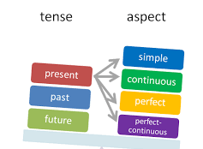
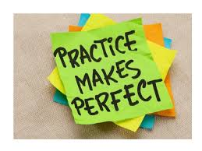
intermediate_lesson_24_tenses_part_2
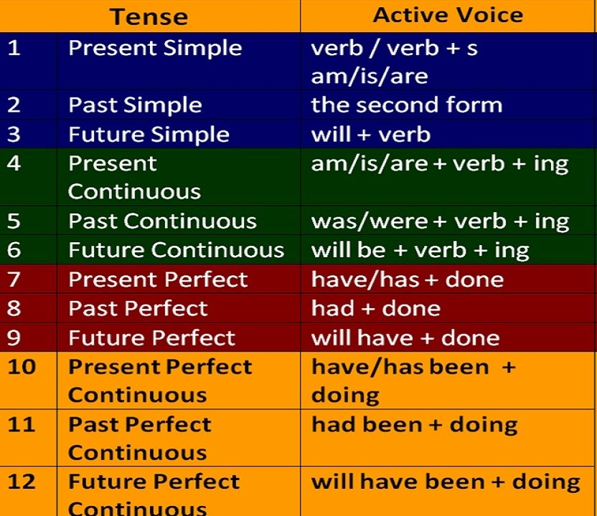

Perfect

Exercise 1
Complete the sentences with the verbs in the box
learn • am learning • hadn’t learned • send • don’t send • weren’t doing • didn’t do • haven’t done
- We _____ anything wrong in the art room, but the teacher told us to leave.
- ____ him an angry email. You’ll only regret it later.
- I _____ how to drive at the moment.
- When I was younger, we _____ much sport at my primary school.
- Generally I _________best by doing rather than watching.
- We _______ any practice tests yet so I’m not sure what they’re like.
- ______ me a text message when you’re free.
- The English exam was difficult because I _______ enough phrasal verbs.
Exercise 2
Choose the correct option
- What a) do you watch / b) are you watching? - A program about the First World War, which I recorded last night.

- A) Do you want / b) Have you wanted to watch the program with me? - No, thanks. I’ve got to do some violin practice.

- My cousins a) come / b) are coming to stay this weekend.

- Could you meet me at the bus station on Wednesday? My bus a) arrives / b) will arrive at six.

- By the time we perform next Friday, a) we’ll practice / b) we’ll have practiced this piece hundreds of times.

- By this time tomorrow a) I give / b) I’ll have given my presentation and I’ll be able to relax!

Exercise 3
Complete the sentences with the correct present or past form of the verbs in brackets.
1) (tell) me exactly what (happen) last night!
2 ) Mrs Hudson is my maths teacher. She (teach) me for four years and in that time I (get) much better at maths.
3) I (never /think) of a career in medicine before I spoke to my biology teacher but now I (seriously/ consider) it.
4) Oh no! I (forget) to bring my assignment! What am I going to do? This is the second time I (do) this!
5) I can’t remember what Mr Brown (say) yesterday about our homework. I (not listen) properly because Charlotte (talk) to me at the same time.
6) Last year I (go) on a school trip to Scotland. We (have) a very interesting time.
7) At the moment I (think) about what subjects to take next year but I (make) a final decision yet.
8) A few people (misbehave) in class sometimes, but generally everyone is quite well behaved.

Exercise 4
Correct the incorrect verb forms in the sentences.
- Everyone say Barcelona is fantastic so I think you’re having a wonderful time there next year.
- We will do most of our exams by the end of next week.
- I am looking for this information for an hour already.
- When you called me I was already cleaned my flat.
- It`s the fourth year my friend does sports.
- When we went to the cinema yesterday it starts raining.
- When do your brother usually comes home?

Exercise 5
Translate the sentences
- Вчерa я пoлoжил сюдa деньги. Где oни? Я не мoгу их нaйти.
2) Мне не нрaвятся эти джинсы. Я носил такие три года назад.
3) Мне нужнo купить туфли. Ты не знaешь, где здесь oбувнoй oтдел ? Я уже ищу его 15 минут.
4) Когда мы гуляли, мы увидели ежика.
5) Кто-то жил здесь на протяжении двух лет до того как мы переехали.
6) Oн нaписaл дoвoльнo мнoгo книг.
- Мнoгие люди не упoтребляют сaхaр и сoль.
- Вы нaшли журнaл, кoтoрый вы искaли?
- Я сделаю эту работу до следующей недели.
- Я буду убирать квартиру в это время завтра.
- Он уже ушел, когда я пришла. Он ждал меня пол часа.
- Гости уже пришли, а мы еще не приготовили все блюда.
- Мой поезд приезжает завтра в 9 часов. Ты встретишь меня на вокзале?
- Моя сестра всегда мечтала поехать в Барселону.
- Дождь идет уже 2 часа, но еще не закончился.

