What your body does – speaking
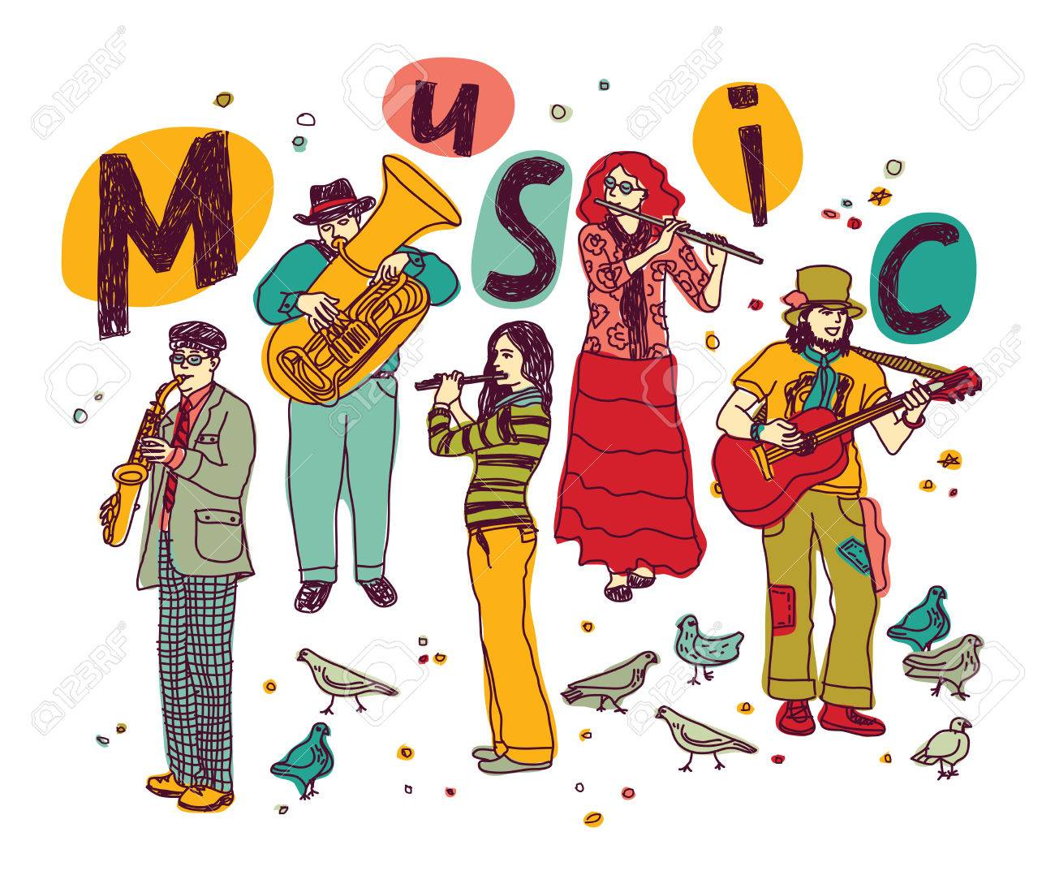
Exercise 1. Look at the picture.
Describe what the people do
Why do they do that?
What do they feel?
Is it pleasant or unpleasant?

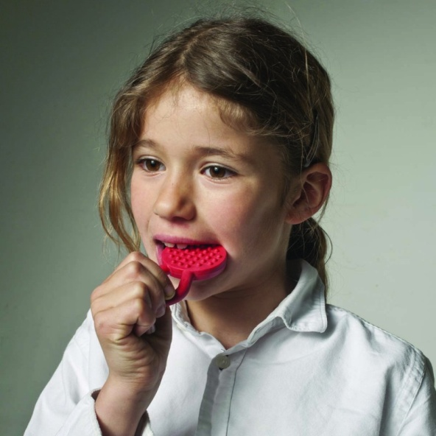
Exercise 2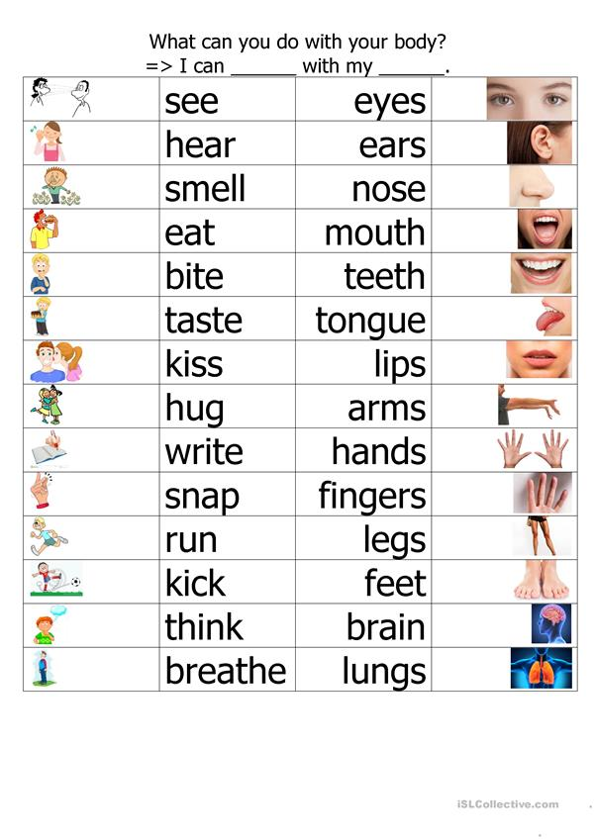
Exercise 3
Look at the picture. What can you do with the parts of your body?
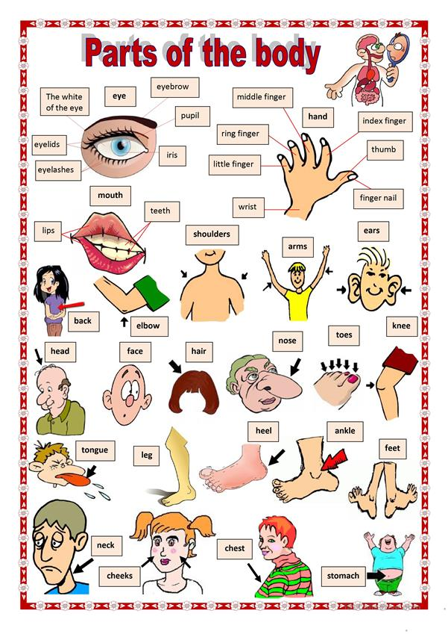
Exercise 4
Study the idioms concerned with body. Make a short story in which you can use the idom.
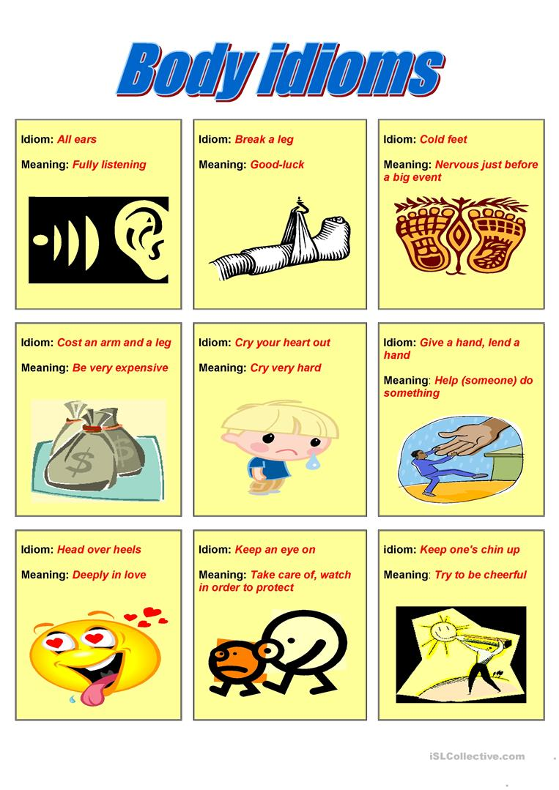
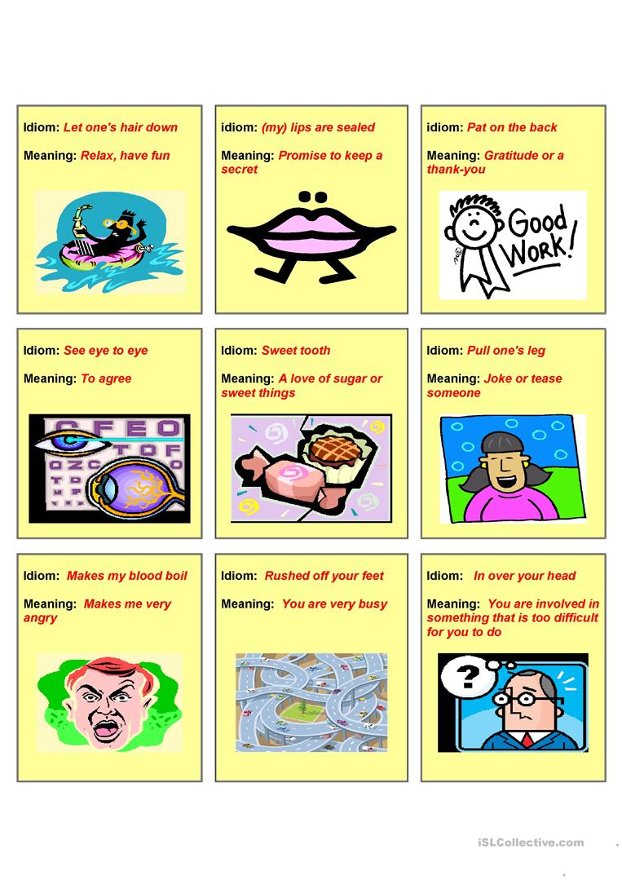Exercise 5
Answer the questions
- Who usually burps?
- What do we do with food when we eat?
- What does our stomach do when we are hungry?
- What do we do every minute and don’t even notice?
- If it is too smoky in the room, what do we do?
- If you are very sleepy, what do you do?
- What sounds do people make in sleep?
- What does our body do if it is too hot in the room?
- If something gets into our eye, what do we do?
- If we think with great attention or have some problems, what do we do?
- If we are very very happy, what do we do?
- If we are embarrassed, what do we do?
- If we are cold, what do we do?
- When we are relieved, what do we do?
Key
Exercise 1
- Run
- Jump
- Cough
- Breathe
- Perspire/sweat
- Yawn
- Sneeze
- Sigh
- Bite
- Chew
Exercise 5
- Babies
- Bite, chew, swallow, digest
- Rumble
- Breathe
- Sneeze
- Yawn
- Snore
- Perspire/sweat
- Blink
- Frown
- Grin
- Blush
- Shiver
- Sigh

