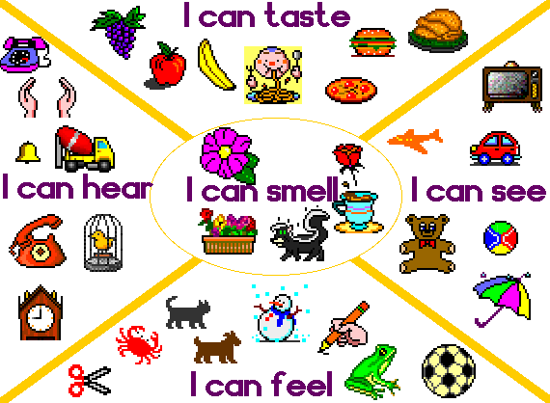

Task 1
Look through the idioms in quizlet:

https://quizlet.com/309282430/flashcards

Task 2
Match the idiom with the name of the sense which it describes:

Senses: hearing, sight, touch, taste, smell

Touch-and-go;

To taste blood;

To keep your ear to the ground;

Under someone’s nose;

To turn a blind eye;

To touch base;

To give someone a taste of their own medicine;

To bend someone’s ear;

To turn your nose up at something;

To see things eye to eye;

To keep in touch;

In poor taste;

Out on your ear;

To sniff around/out;

The apple of someone’s eye;

To hit a nerve;

An acquired taste;

Nothing between your ears;

To smell a rat;

Out of sight, out of mind;

“Touch wood!”;

A bad taste in your mouth;

Ears are burning;

To follow your nose;

In the blink of an eye
Task 3
Write the senses in the chart below and complete it with the right adjectives from the box.
A) hearing, smell, taste, sight, touch
B) aromatic, bitter, blurred, bright, catchy, dark, fluffy, fragrant, loud, rhythmic, rotten, salty, shining, slow, smooth, spicy, sticky, stinky, yummy, wet

Task 4
Fill in the gaps in the sentences with the appropriate adjective
aromatic, bitter, blurred, bright, catchy, dark, fluffy, fragrant, loud, rhythmic, rotten, salty, shining, slow, smooth, spicy, sticky, stinky, yummy, wet, harsh, scented
1.The smell of … eggs reached their noses. It was something really disgusting.
2.The sound of the city was … , with sirens at all hours.
3.Wow, this cheese is really … - are you sure it’s okay to eat?
4.He grows … herbs such as lavender and coriander in pots next to his window.
5.She bought some rose-… candles of a … red colour. Her room smelt so … .
6.Joe made a … cake for his guests.
7.After hitting his head he suffered from … vision.
8.She washed her hands after spreading some … honey on a slice of bread.
9.Chilli peppers made the sauce taste … .
10.The summer sky was blue, with only a few … clouds.
11.Bob enjoyed the … sound of raindrops on the roof.
12.It was really early and the house was … when I woke up.
13.She spoke … to be heard over the music in the disco.
14.His mother put a … cloth on his forehead to reduce the fever.
15.Rachel looked at the …jewels in the shop window.
16.That song’s so …, I can’t get it out of my head.
17.I like this silk because it is very … .
18.This coffee is too … for me and these chips are really … .

Task 5
Choose the correct variant
1.Can you hear/listen to that noise?
2.Did you notice/watch the colour of her eyes?
3.I can’t see/look at anything from here.
4.Don’t look/watch behind you.
5.How long did you see/watch TV for?
6.I glanced at/stared Julia.
7.I see/can see something in your eye.
8.I overheard/caught a funny story on the bus.
9.What can you listen/hear?

Task 6
Complete the sentences with a suitable word
disappeared, observant, glanced/looked, looked, seem/appear, staring, sounds, can, catch, noticed
1.When I told them, I … that they both looked very surprised.
2.She said her name but I’m afraid I didn’t … what it was.
3.I … hear a bird singing. It … like a blackbird.
4.Why is that man … at me? Have I done something wrong?
5.I spoke to him about the exam. He doesn’t … to be nervous.
6.Did you see Nadia last night? I thought she … ill.
7.I … at my watch and realized it was time to go.
8.Sally always notices if I change my hairstyle. She’s very … .
9.A minute ago she was here, then she … . I don’t know where she is now.

ANSWERS
Task 2
Sight: In the blink of an eye; Out of sight, out of mind; The apple of someone’s eye; To see things eye to eye; To turn a blind eye
Smell: To follow your nose; To smell a rat; To sniff around/out; To turn your nose up at something; Under someone’s nose
Hearing: Ears are burning; Nothing between your ears; Out on your ear; To bend someone’s ear; To keep your ear to the ground
Taste: A bad taste in your mouth; An acquired taste; In poor taste; To give someone a taste of their own medicine; To taste blood
Touch: “Touch wood!”; To hit a nerve; To keep in touch; To touch base; Touch-and-go
Task 3
hearing: catchy, loud, rhythmic, slow
smell: aromatic, fragrant, rotten, stinky
taste: bitter, salty, yummy, spicy
sight: blurred, bright, dark, shining
touch: fluffy, smooth, sticky, wet
Task 4
aromatic, bitter, blurred, bright, catchy, dark, fluffy, fragrant, loud, rhythmic, rotten, salty, shining, slow, smooth, spicy, sticky, stinky, yummy, wet, harsh, scented
1.The smell of rotten eggs reached their noses. It was something really disgusting.
2.The sound of the city was harsh, with sirens at all hours.
3.Wow, this cheese is really stinky - are you sure it’s okay to eat?
4.He grows aromatic herbs such as lavender and coriander in pots next to his window.
5.She bought some rose-scented candles of a bright red colour. Her room smelt so fragrant.
6.Joe made a yummy cake for his guests.
7.After hitting his head he suffered from blurred vision.
8.She washed her hands after spreading some sticky honey on a slice of bread.
9.Chilli peppers made the sauce taste spicy.
10.The summer sky was blue, with only a few fluffy clouds.
11.Bob enjoyed the rhythmic sound of raindrops on the roof.
12.It was really early and the house was dark when I woke up.
13.She spoke loud to be heard over the music in the disco.
14.His mother put a wet cloth on his forehead to reduce the fever.
15.Rachel looked at the shining jewels in the shop window.
16.That song’s so catchy, I can’t get it out of my head.
17.I like this silk because it is very smooth.
18.This coffee is too bitter for me and these chips are really salty.
Task 5
1.Can you hear/listen to that noise?
2.Did you notice/watch the colour of her eyes?
3.I can’t see/look at anything from here.
4.Don’t look/watch behind you.
5.How long did you see/watch TV for?
6.I glanced at/stared Julia.
7.I see/can see something in your eye.
8.I overheard/caught a funny story on the bus.
9.What can you listen/hear?
Task 6
disappeared, observant, glanced/looked, looked, seem/appear, staring, sounds, can, catch, noticed
1.When I told them, I noticed that they both looked very surprised.
2.She said her name but I’m afraid I didn’t catch what it was.
3.I can hear a bird singing. It sounds like a blackbird.
4.Why is that man staring at me? Have I done something wrong?
5.I spoke to him about the exam. He doesn’t seem/appear to be nervous.
6.Did you see Nadia last night? I thought she looked ill.
7.I glanced/looked at my watch and realized it was time to go.
8.Sally always notices if I change my hairstyle. She’s very observant.
9.A minute ago she was here, then she disappeared. I don’t know where she is now.

