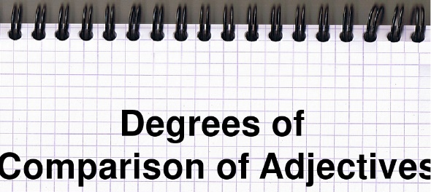
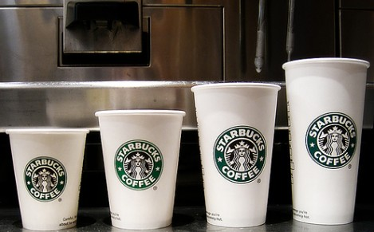
intermediate_lesson_25_degrees_of_comparison_part_2

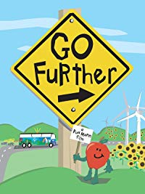

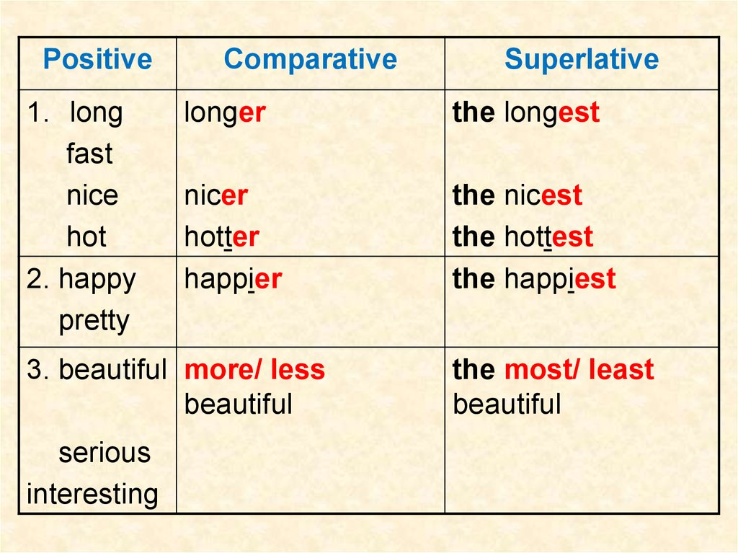

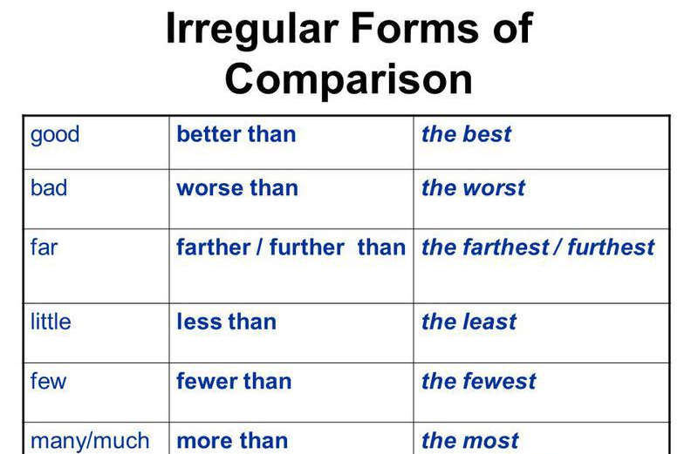
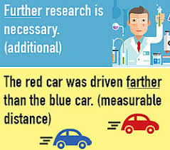

Exercise 1
Choose the correct answer
1. My brother’s handwriting is ................................ mine.
a) worse than
b) worse then
c) the worst than

2. Health is more important ................................. wealth.
a) than
b) then

3. Blood is ................................ than water.
a) thicker
b) thickest
c) more thick

4. Everest is .................................... peak in the world.
a) highest
b) the highest
c) higher

5. This is ....................................... play that I have ever heard on the radio.
a) the more interesting
b) the most interesting
c) most interesting

6. The elephant is one of ......................................... animals in the world.
a) the large
b) the largest
c) the larger

7. An ocean is certainly ......................................... than a sea.
a) the bigger
b) bigger
c) big

8. She is ………………… than her sister.
a) pretty
b) prettier
c) prettiest

9. Martha is a ………………….. girl.
a) nice
b) nicer
c) nicest

10. Sophie is the …………………… girl in the class.
a) intelligent
b) more intelligent
c) most intelligent

11. China is a ……………….. country.
a) big
b) bigger
c) biggest

12. China is ………………… than India.
a) big
b) bigger
c) biggest

13. This is the ………………… book I have ever read.
a) interesting
b) more interesting
c) least interesting

14. Take the ………………….. of the two routes.
a) short
b) shorter
c) shortest

Exercise 2
Correct the mistakes
- Susie is the more beautiful of all the four sisters.
- The planet Mars is far from the earth than the satellite moon.
- I am most interested in cricket than in football.
- Mark speaks English badder than German.
- This restaurant is the most cheaper in our city.
- It is the more unusual dish I have ever eaten.
- It is more little windy today then yesterday.
- You will feel happyer if you spend more time with your family.
- This hotel is the farest in this area.
- Today was the worse day in my life.

Exercise 3
Open the brackets using the correct degree

- My sister thinks she's(intelligent) than me, but I don't agree!
- Avatar is probably(bad) film I've seen!
- What is(wet) month of the year in England?
- Do you think the Harry Potter films are(good) than the books?
- Who is(powerful) person in your country?
- I think Men in Black 1 was(funny) than Men in Black 3.
- Is Angelina Jolie(old) than Sandra Bullock?
- John is (nice) person that I know.
- Who is the(tall) person in your family?
- My mum is the(good) cook in the world.
- December is the(cold) month of the year in my country.
- What's the(dangerous) animal in the world?
- Ethan is the (happy) boy that I know.
- Where are the(nice) beaches in your country?
- She bought the(big) cake in the shop.
- Who is the(famous) singer in your country?

Exercise 4
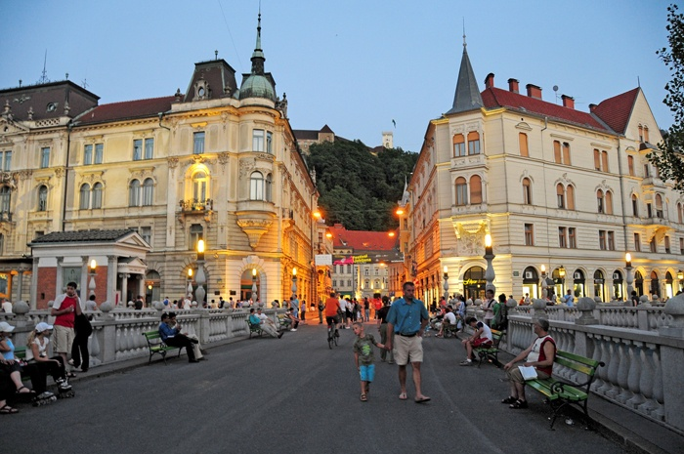
Describe these two pictures using the comparative degree of comparison of adjectives

