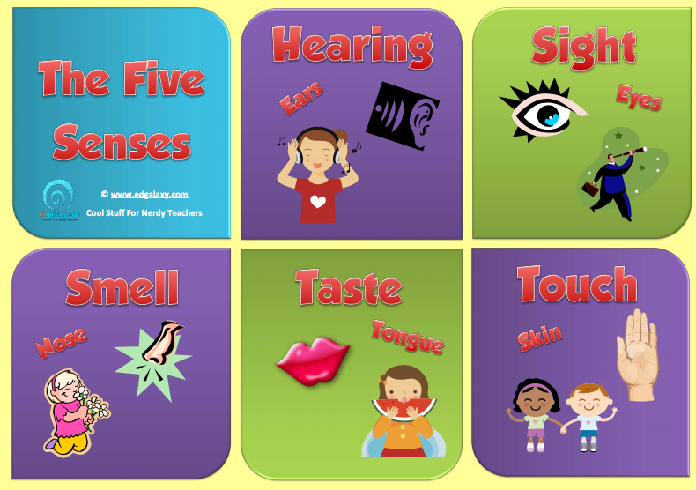

Task 1
Look through the words in quizlet:
https://quizlet.com/115603277/english-the-six-senses-flash-cards/

Task 2
Replace the underlined phrase with a single word that has the same meaning
1.Most cities such as London have a traffic problem.
2.This blanket has a horrible smell.
3.My towel still feels a little wet.
4.The soup is without much flavour.
5.The film was similar to his others.
6.I put my hand on the radiator and it felt cold.
7.She moved her hand firmly over her leg.

Task 3
Complete the sentences
1.You don’t need salt. It’s already very … .
2.The persimmon is a strange fruit. It looks … a tomato but doesn’t taste … one.
3.They were both … their feet to the music.
4. … the button if you want the receptionist to come.
5.Be careful – don’t … the door. The paint is still wet.
6.He … me on the shoulder and asked me to move my head.
7.The policeman … the thief’s arm and pushed him to the ground.
8.When I came downstairs, I could … the steak frying; it was wonderful.
9.You had ice cream, didn’t you? What … did you have? – Strawberry, but it didn’t … like strawberry.

Task 4
Which of these expressions is not a natural collocation?
1.a delicate scent/fragrance/stink of pine needles
2.the rich aroma/odour/scent of freshly ground coffee
3.the pungent smell/perfume/stench of the fish market
4.a weak/slight/bitter aftertaste
5.a faint hint/flavour/aroma of expensive perfume
6.the bland flavour/taste/savour of mashed potato

Task 5
Match the two parts of the sentences
1.Since my cold I’ve lost my sense of …
2.This delicious spice really brings out …
3.This drink contains no artificial …
4.Our delicious appetisers will tickle your …
5.The pack of fox hounds lost …
a. the scent, b.taste buds, c.smell, d.flavourings, e.the flavour

Task 6
Match the two parts of the sentences.
1.Yes, I can hear you loud and …
2.It’s nice to get some peace and …
3.I need to get out of all the hustle and …
4.The city was filled with strange sights and …
5.The saucepans fell down with an almighty …
a.bustle, b.clear, c.crash, d.quiet, e.sounds

Task 7
Do this quiz about five senses:
https://bogglesworldesl.com/quizgames/fivesensesquiz.php

ANSWERS
Task 2
1.Most cities like London have a traffic problem.
2.This blanket stinks.
3.My towel still feels damp.
4.The soup is bland.
5.The film was like his others.
6.I touched the radiator and it felt cold.
7.She rubbed her leg.

Task 3
1.You don’t need salt. It’s already very salty.
2.The persimmon is a strange fruit. It looks like a tomato but doesn’t taste like one.
3.They were both tapping their feet to the music.
4. Press the button if you want the receptionist to come.
5.Be careful – don’t touch the door. The paint is still wet.
6.He tapped me on the shoulder and asked me to move my head.
7.The policeman grabbed the thief’s arm and pushed him to the ground.
8.When I came downstairs, I could smell the steak frying; it was wonderful.
9.You had ice cream, didn’t you? What flavour did you have? – Strawberry, but it didn’t taste like strawberry.

Task 4
1.a delicate scent/fragrance/stink of pine needles
2.the rich aroma/odour/scent of freshly ground coffee
3.the pungent smell/perfume/stench of the fish market
4.a weak/slight/bitter aftertaste
5.a faint hint/flavour/aroma of expensive perfume
6.the bland flavour/taste/savour of mashed potato

Task 5
1.Since my cold I’ve lost my sense of smell.
2.This delicious spice really brings out the flavour.
3.This drink contains no artificial flavourings.
4.Our delicious appetisers will tickle your taste buds.
5.The pack of fox hounds lost the scent.

Task 6
1.Yes, I can hear you loud and clear.
2.It’s nice to get some peace and quiet.
3.I need to get out of all the hustle and bustle.
4.The city was filled with strange sights and sounds.
5.The saucepans fell down with an almighty crash.
a.bustle, b.clear, c.crash, d.quiet, e.sounds

