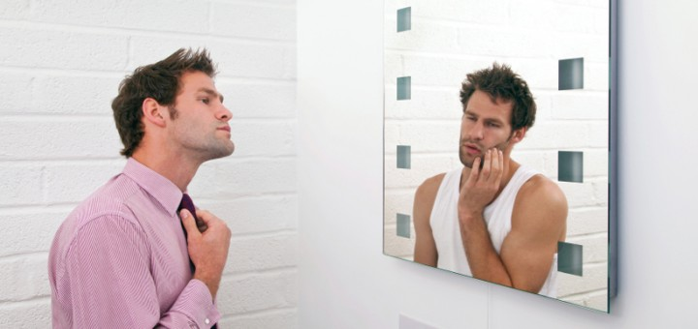

https://quizlet.com/35834396/english-appearance-flash-cards/

Ex.1 Answer these remarks with the opposite description.

1 A: Was that his brother, the dark-skinned, wavy-haired one?
B: No, quite the opposite, his brother's...
2 A: She's always quite well-dressed, so I've heard.
B: What! Who told you that? Every time I see her, she's...
3 A: So Charlene's that rather plump fair-haired woman, is she?
B No, you're looking at the wrong one. Charlene's...
4 A: So, tell us about the new boss; good looking?
B: No, I'm afraid not; rather...
5 A: I don't know why, but I expected the tour-guide to be middle-aged or elderly.
B: No, apparently she's only...

Ex.2 Complete the sentences.
- Does she wear contact .......
- Her has gone grey, and it's completely changed her .......
- She's still very slim, so you can't say she's ....... a baby in July.
- I'm feeling so old these days — look at these ....... around my eyes!
- My baby's skin is so ....... to touch, but my hands are really
- She's got a beautiful figure: she's tall and .......
- You can say she's been on holiday — she's got a lovely .......

Ex.3 True or false? Write T or F.
1 Contact lenses are the same as glasses. ……..
2 Skin can be rough or smooth. ......
3 A tallish person is very tall. ......
4 A pregnant woman has just had a baby. ......
5 You get tanned sitting in the sun. ......
6 Everyone has a good figure. .......
7 You usually use 'pretty' to describe a man. .......
8 Your hair can go white or grey. ......

Ex.4. Complete the questions. Answer these questions about yourself.
In your family
- who is in a good……..?
- who's going g……..?
- who's ……..-shaven?
- who's broad …….. ?
- who's well ……..?
- who's sk……..?
- who's dark-……..?
- who's got a sk…….. on their body?

Ex.5 WANTED! MISSING! Complete the information about people’s appearance in these police posters.
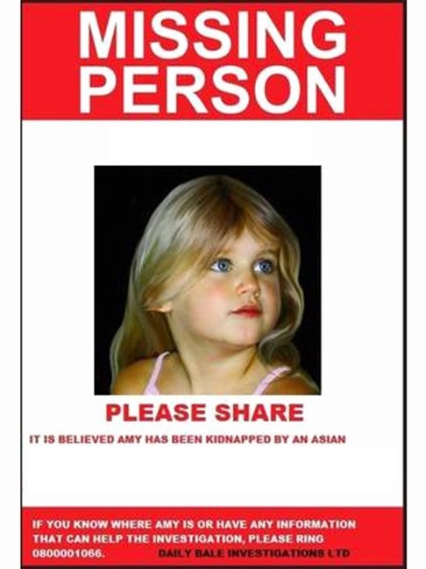
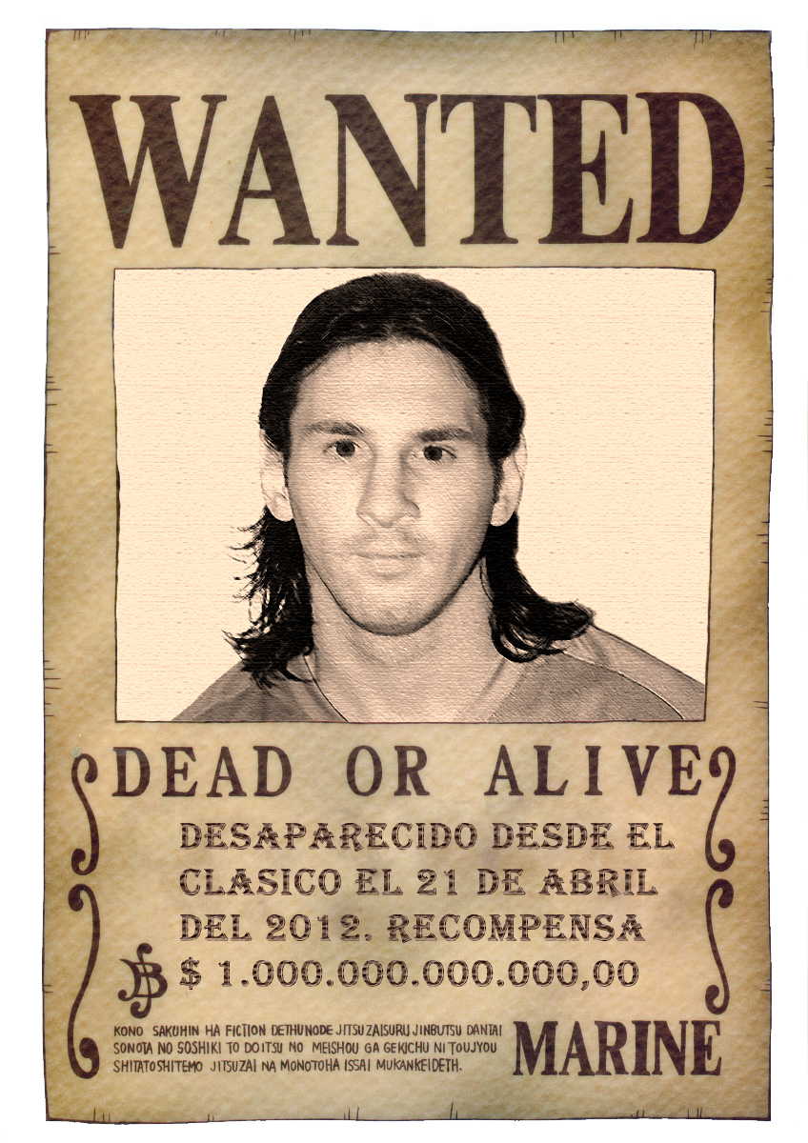
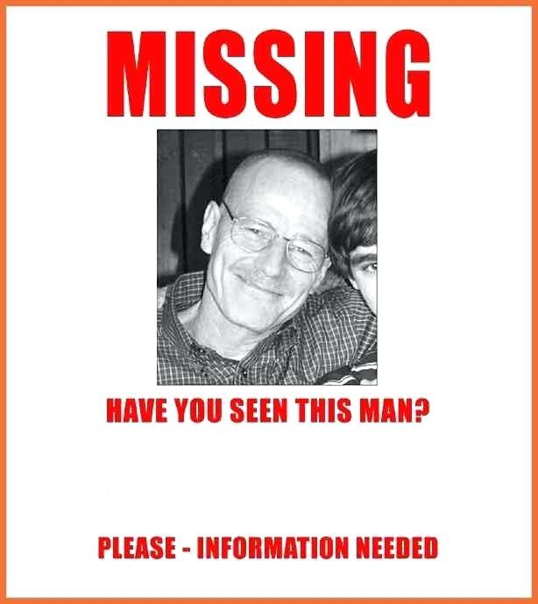

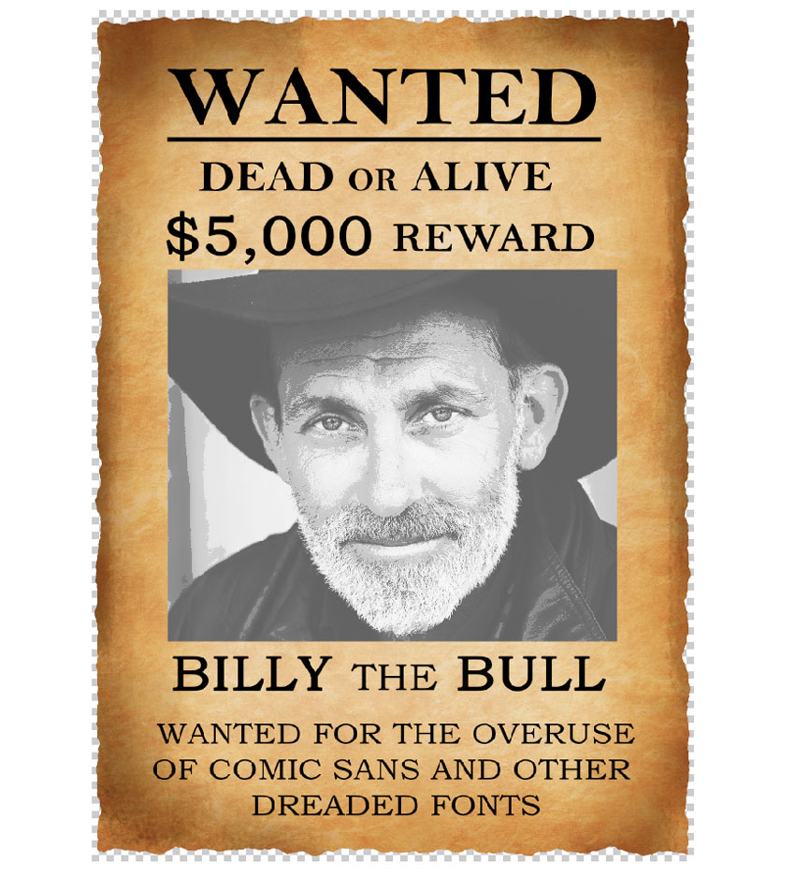
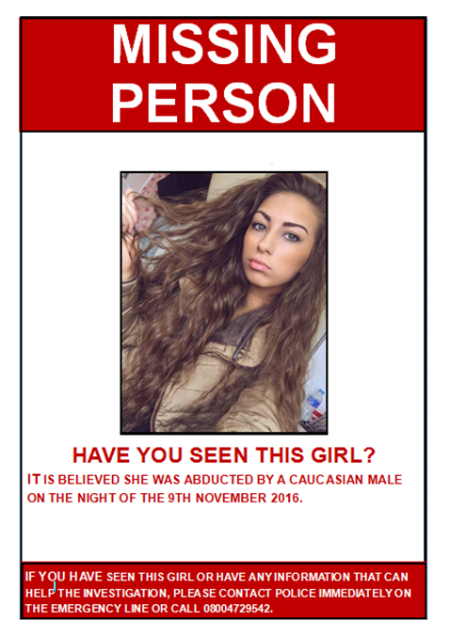

Answer key

Ex.2 Complete the sentences.
- Does she wear contact lenses
- Her has gone grey, and it's completely changed her appearance
- She's still very slim, so you can't say she's ..expecting..... a baby in July.
- I'm feeling so old these days — look at these ...wrinkles.... around my eyes!
- My baby's skin is so .smooth...... to touch, but my hands are really
- She's got a beautiful figure: she's tall and ..slim.....
- You can say she's been on holiday — she's got a lovely ....tan...

Ex.3 True or false? Write T or F.
1 Contact lenses are the same as glasses. ……F..
2 Skin can be rough or smooth. ....T..
3 A tallish person is very tall. ...F...
4 A pregnant woman has just had a baby. ..F....
5 You get tanned sitting in the sun. ..T....
6 Everyone has a good figure. ....F...
7 You usually use 'pretty' to describe a man. ....F...
8 Your hair can go white or grey. ...T...

Ex.4. Complete the questions. Answer these questions about yourself.
In your family
- who is in a good…shape…..?
- who's going grey……..?
- who's …clean…..-shaven?
- who's broad …shoulders….. ?
- who's well …built…..?
- who's skinny……..?
- who's dark-skinned……..?
- who's got a skar…….. on their body?

