Lesson 27- Adverbs-Grammar (part 2)

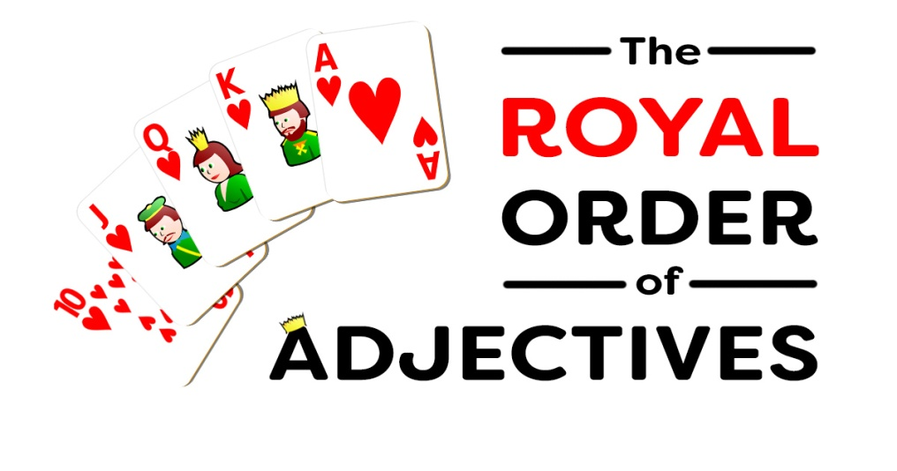

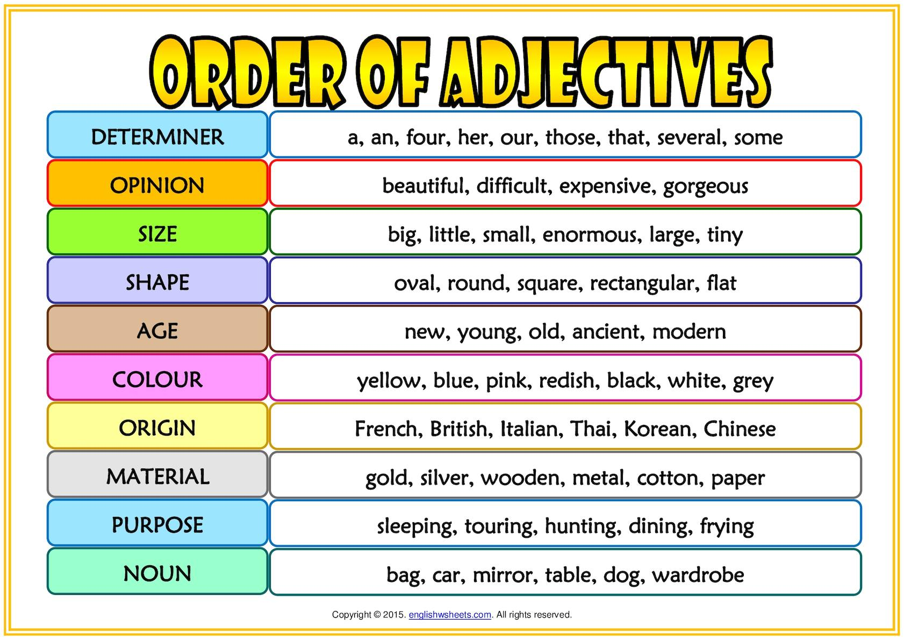

Exercise 1

Put the adjectives in brackets in correct position
- We wanted a grey metal table.
- They bought a new red car.
- She went home and sat on her comfortable old wooden bed.
- He bought a fabulous British woollen suit.
- They have black Dutch bicycles.
- He wants some really delicious French cheese.
- A pretty young girl walked into the room.
- He has a lot of interesting old books.
- She bought a new red plastic lunchbox.
- He is looking for a stylish black leather bag.
- She dropped the beautiful old plate and it smashed.
- I want an amazing green silk dress.
- She drank hot black Italian coffee.
- He saw an old French writing desk.
- They stayed in a cute little cottage.
- I visited a spooky ancient German castle.
- He has a beautiful old silver ring.
- We ate some round green English apples.
- I need a comfortable computer desk.
- They went on holiday to a beautiful small wooden cabin.

Exercise 2
http://englishtests.ucoz.com/GrammarTests/Position_of_Adjectives.htm

Exercise 3
Decide wether these adjactives are in the correct position. Choose Yes (Y) or No (N)
- I would like two, generous, gigantic slices of pie. T
- That new, lovely girl is in my class. F
- Mom is a beautiful, tall, Armenian woman.T
- Last year was the longest, worst year of my life. F
- That green, tiny, pretty gem is my favorite.F
- I like to have at least one, trustworthy, old friend. T
- We will eat off of the ugly, square plastic dishes. T
- France is a huge, graceful, old country. F
- I bought a cute, second-hand, purple dress. F
- That temperamental, small, Australian dog is mine. T
- I believe there are many, tiny garden fairies outside. T
- That wooden, big, lop-sided box is mine.F
- My first, tortoiseshell, fat cat is named Abby. F
- I love those long, green, silk socks. T
- I ate gigantic, two all-beef hot dogs. F
Exercise 4
Put the adjectives in brackets in the correct position
- an unusual gold ring
- a beautiful old house
- black leather gloves
- an old American ﬁlm
- a long thin face
- big black clouds
- a lovely sunny day
- an ugly yellow dress
- a long wide avenue
- little, old, red car
- a nice new green sweater
- a small black metal box
- a big fat black cat
- a lovely little young village
- pretty long black hair
- an interesting old French painting
- an enormous red and yellow umbrella

