Lesson 27- Adverbs-Grammar (part 2)

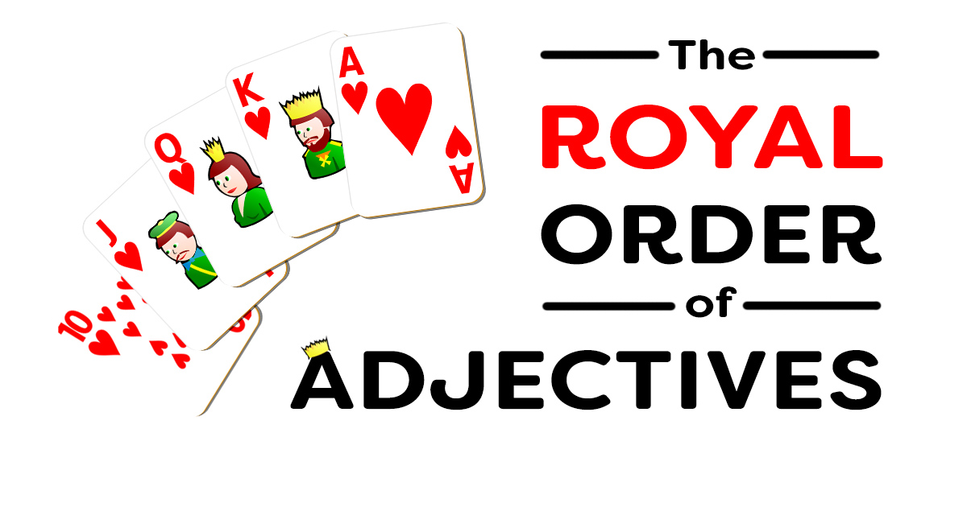

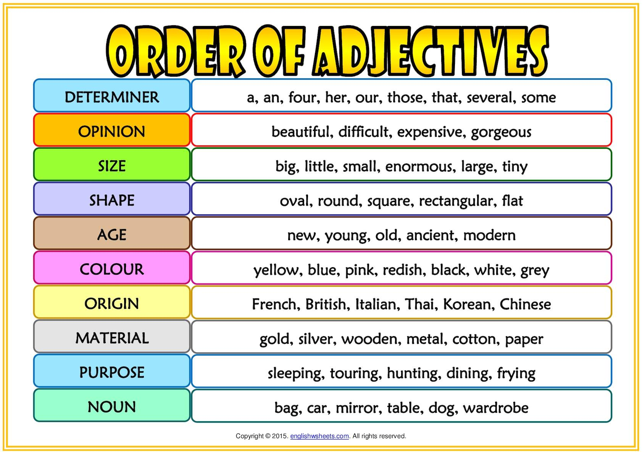

Exercise 1

Put the adjectives in brackets in correct position
- We wanted __________________________________ (grey / a / metal) table
- They bought __________________________________ (red / a / new) car.
- She went home and sat on __________________________________ (comfortable / her / wooden / old) bed.
- He bought __________________________________ (woollen / a / British / fabulous) suit.
- They have __________________________________ (Dutch / black) bicycles.
- He wants __________________________________ (some / French / delicious / really) cheese.
- __________________________________ (young / a / pretty) girl walked into the room.
- He has __________________________________ (a lot of / old / interesting) books.
- She bought __________________________________ (plastic / red / a / new) plastic lunchbox.
- He is looking for __________________________________ (leather / stylish / a /black) bag.
- She dropped __________________________________ (old / beautiful / the) plate and it smashed.
- I want __________________________________ (silk / green / an / amazing) dress.
- She drank __________________________________ (Italian / black / hot) coffee.
- He saw __________________________________ (French / writing / old / an) desk.
- They stayed in __________________________________ (little / a / cute) cottage.
- I visited __________________________________ (ancient / a / spooky / German) castle.
- He has __________________________________ (silver / old / beautiful / a) ring.
- We ate __________________________________ (green / English / round / some) apples.
- I need __________________________________ (computer / comfortable / a) desk.
- They went on holiday to __________________________________ (small / wooden / a / beautiful) cabin.

Exercise 2
http://englishtests.ucoz.com/GrammarTests/Position_of_Adjectives.htm

Exercise 3
Decide wether these adjactives are in the correct position. Choose Yes (Y) or No (N)
- I would like two, generous, gigantic slices of pie.
- That new, lovely girl is in my class.
- Mom is a beautiful, tall, Armenian woman.
- Last year was the longest, worst year of my life.
- That green, tiny, pretty gem is my favorite.
- I like to have at least one, trustworthy, old friend.
- We will eat off of the ugly, square plastic dishes.
- France is a huge, graceful, old country.
- I bought a cute, second-hand, purple dress.
- That temperamental, small, Australian dog is mine.
- I believe there are many, tiny garden fairies outside.
- That wooden, big, lop-sided box is mine.
- My first, tortoiseshell, fat cat is named Abby.
- I love those long, green, silk socks.
- I ate gigantic, two all-beef hot dogs.
Exercise 4
Put the adjectives in brackets in the correct position
- an unusual ring (gold)
- an old house (beautiful)
- black gloves (leather)
- an American ﬁlm (old)
- a long face (thin)
- big clouds (black)
- a sunny day (lovely)
- an ugly dress (yellow)
- a wide avenue (long)
- red car (old / little)
- a new sweater (green / nice)
- a metal box (black / small)
- a big cat (tall / black)
- a little village (young / lovely)
- long, hair (black / pretty)
- an old painting (interesting/ French)
- an enormous umbrella (red / yellow)

