PDF

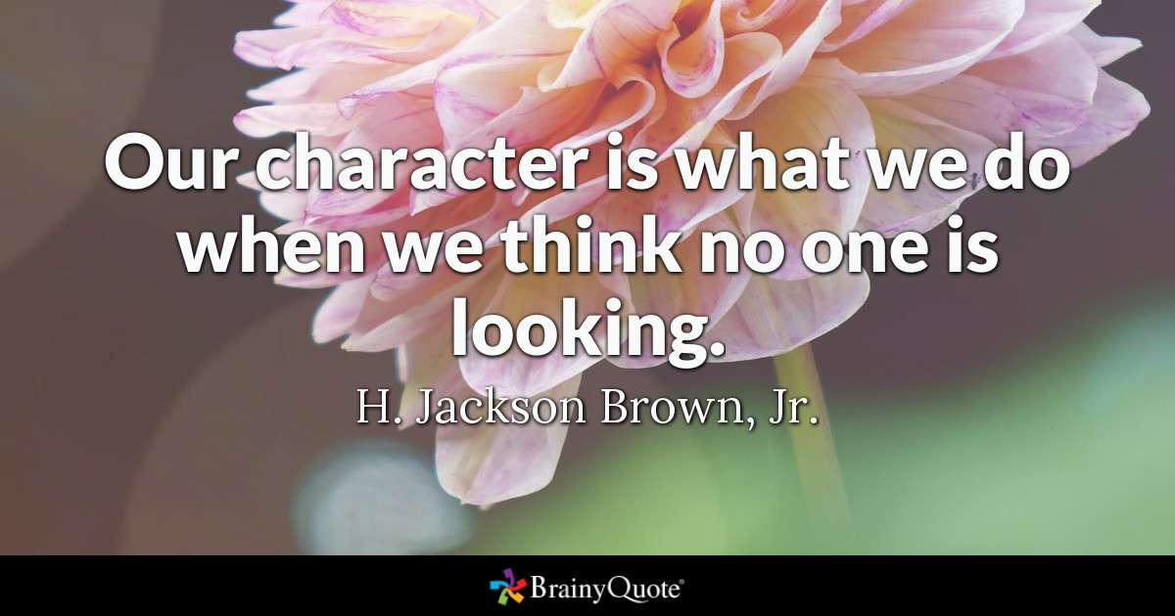

Ex. 1 Look at the words and translate them into Russian
https://quizlet.com/325518368/english_intermediate_lesson_30_character-flash-cards/?new

Ex. 2 Choose the correct word in each sentence.
1) When her bicycle was stolen, Jill became extremely angry/nervous.
2) Peter felt ashamed/embarrassed when he had to make a speech.
3) I always write thank-you letters, just to be gentle/polite.
4) You never do anything to help me! You're so lazy/tired.
5) Penny never does anything silly. She's very sensible/sensitive.
6) The children had to stay in the house all day and felt bored/tired.
7) Jackie doesn't worry about anything and is always cheerful/sympathetic.
8) Mr Jackson is very annoyed/bad-tempered and often shouts at people.
9) When he heard about the accident, Alan was very damaged/upset.
10) I've got an important exam tomorrow and I'm a bit jealous/nervous.

Ex. 3. Match right Column with left column

1 feeling sure about your own ability
2 boring
3 likely to fight or argue
4 thinking you are better than others
5 always telling the truth
6 ability to laugh at things
7 feeling happy
8 unhappy to give money or help people
9 able to accept ideas you don't agree with
aggressive
cheerful
self-confident
tolerant
sense of humour
dull
arrogant
honest
mean

Ex 4. Complete the words in each sentence.
(перемешать)
aggressive
crazy
easy-going
sense of humour
modest
self-confident
hard-working
responsible
energy

1. If you disagree with Matthew, he can get a bit ...
2. My brother's a bit irresponsible and does some … but he's OK.
3. Keiko's a good person to share a flat with: she's very …
4 I like Zoltan; he's got a great ...
5 Hamdi is a fantastic musician, but very few people realize this because he's so ...
6 Since Katy got a new job and a boyfriend, she's become more ...
7 My brother's lazy, but my sisters have always been very ...
8 Idon't think young Andy is … enough to drive a car.
9 Andrea has so much …; she's always doing something.

Ex 5 Complete the words in each sentence.
(перемешать)
arrogant
cautious
cowardly
frank
self-conscious
vain
witty
stubborn

1 Everyone thought it was … of him not to help his than friend when he was being attacked.
2 He's so …! He behaves as if he's so much better or more important than the rest of us! I can't stand him!
3 Maureen's so … . She's always coming out with clever and amusing remarks. I wish I could make people laugh the way she does.
4 Once his mind is made up, he won't listen to a word you say. He's so …
5 Joanna spends hours looking at and admiring herself in the mirror. She's so ...
6 He always wore a hat because he was very … about his bald patch.
7 Mark is very … person and never makes any decisions without looking into things very carefully first.
8 I always try to be … with my friends. If they ask for my opinion, then I give it to them straight, even though they might not like it.

Ex 6. Answer the questions.
1 Are you ambitious? If so, in what way?
2 Would you say you're hard-working or a bit lazy?
3 Are you intolerant of anything? If so, what?
4 When do you get impatient?
5 How do you see yourself? Name three adjectives and explain why.
6 Which two qualities do you think are the most important: honesty. patience, tolerance, or generosity?

Ex. 1 Look at the words and translate them into Russian
https://quizlet.com/325518368/english_intermediate_lesson_30_character-flash-cards/?new

Ex. 2 Choose the correct word in each sentence.
1) When her bicycle was stolen, Jill became extremely angry/nervous.
2) Peter felt ashamed/embarrassed when he had to make a speech.
3) I always write thank-you letters, just to be gentle/polite.
4) You never do anything to help me! You're so lazy/tired.
5) Penny never does anything silly. She's very sensible/sensitive.
6) The children had to stay in the house all day and felt bored/tired.
7) Jackie doesn't worry about anything and is always cheerful/sympathetic.
8) Mr Jackson is very annoyed/bad-tempered and often shouts at people.
9) When he heard about the accident, Alan was very damaged/upset.
10) I've got an important exam tomorrow and I'm a bit jealous/nervous.

Ex. 3. Match right Column with left column

1 feeling sure about your own ability
2 boring
3 likely to fight or argue
4 thinking you are better than others
5 always telling the truth
6 ability to laugh at things
7 feeling happy
8 unhappy to give money or help people
9 able to accept ideas you don't agree with
aggressive (3)
cheerful (7)
self-confident (1)
tolerant (9)
sense of humour (6)
dull (2)
arrogant (4)
honest (5)
mean (8)

Ex 4. Complete the words in each sentence.

aggressive
crazy
easy-going
sense of humour
modest
self-confident
hard-working
responsible
energy

1. If you disagree with Matthew, he can get a bit aggressive.
2. My brother's a bit irresponsible and does some crazy but he's OK.
3. Keiko's a good person to share a flat with: she's very easy-going
4 I like Zoltan; he's got a great sense of humour.
5 Hamdi is a fantastic musician, but very few people realize this because he's so modest.
6 Since Katy got a new job and a boyfriend, she's become more self-confident.
7 My brother's lazy, but my sisters have always been very hard-working.
8 Idon't think young Andy is responsible enough to drive a car.
9 Andrea has so much energy; she's always doing something.

Ex 5 Complete the words in each sentence.

arrogant
cautious
cowardly
frank
self-conscious
vain
witty
stubborn

1 Everyone thought it was cowardly of him not to help his than friend when he was being attacked.
2 He's so arrogant! He behaves as if he's so much better or more important than the rest of us! I can't stand him!
3 Maureen's so witty . She's always coming out with clever and amusing remarks. I wish I could make people laugh the way she does.
4 Once his mind is made up, he won't listen to a word you say. He's so stubborn
5 Joanna spends hours looking at and admiring herself in the mirror. She's so vain.
6 He always wore a hat because he was very self-conscious about his bald patch.
7 Mark is very cautious person and never makes any decisions without looking into things very carefully first.
8 I always try to be frank with my friends. If they ask for my opinion, then I give it to them straight, even though they might not like it.

Ex 6. Answer the questions.
1 Are you ambitious? If so, in what way?
2 Would you say you're hard-working or a bit lazy?
3 Are you intolerant of anything? If so, what?
4 When do you get impatient?
5 How do you see yourself? Name three adjectives and explain why.
6 Which two qualities do you think are the most important: honesty. patience, tolerance, or generosity?

