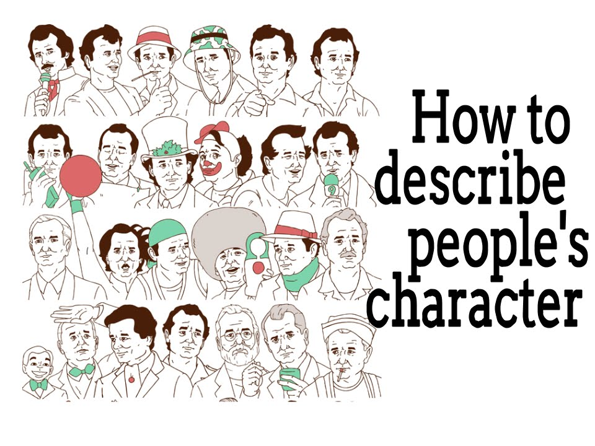
Task 1
Listen to six people talking about whether or not they are shy.
http://www.elllo.org/english/Mixer076/T077-Shy.htm

Task 2
Choose the correct variant:
1) Is Katia shy?
a) Yes, sometimes.
b) It depends.
c) No, never.
2) Is Jeff shy?
a) Absolutely
b) Just a little
c) Not at all
3) Is Fred shy?
a) Yes, a lot.
b) It depends.
c) No, never.
4) Is Shibika shy?
a) Yes, sometimes.
b) It depends.
c) No, not really.
5) Is Sabriya shy?
a) Absolutely
b) Just a little
c) Not at all
6) Is Lupe shy?
a) Absolutely
b) Sometimes
c) Not really

Task 3
Choose the correct variant:
1) Who said they were 'reserved'?
a) Jeff
b) Fred
c) Sabriya
2) Who mentions 'socializing'?
a) Shibika
b) Sabriya
c) Lupe
3) Who said they were 'quiet' sometimes?
a) Sabriya
b) Katia
c) Lupe
4) Who mentions speaking in public?
a) Jeff
b) Fred
c) Katia
5) Who mentions 'interacting with people'?
a) Shibika
b) Sabriya
c) Lupe
6) Whose answers are most similar?
a) Jeff's and Fred's
b) Lupe's and Shibika's
c) Sabriya's and Katia's

Task 4
Listen to the audio about leadership:
http://www.elllo.org/english/Mixer076/T088-Leadership.htm

Task 5
Choose the correct variant:
1) Paul says they should be ______ .
a) stressful
b) important
c) adaptable
2) Lindsay thinks they should be ______ .
a) hopeful
b) responsible
c) careful
3) Jeff thinks a leader should be _____ .
a) mistake proof
b) confident
c) courageous
4) Helen says they must be able to _____ the laws?
a) follow
b) draft
c) enforce
5) Eoin thinks they _____ decisive.
a) should be
b) should not be
6) Lori thinks it ____ to have charisma.
a) helps
b) hurts

Task 6
Choose the correct variant:
1) How many people mention 'compassion' ?
a) one
b) two
c) three
2) How many people mention 'confidence' ?
a) one
b) two
c) three
3) How many people mention 'charisma' ?
a) one
b) two
c) three
4) How many people mention being 'open-minded' ?
a) one
b) two
c) three
5) Who talks about the legal system?
a) Helen
b) Lindsay
c) Lori
6) What word is similar to 'adaptable' ?
a) decisive
b) compassionate
c) open-minded

Task 7
Listen to the audio about the worst qualities of six people.
http://www.elllo.org/english/Mixer051/T067-WorstQ.htm

Task 8
Choose the correct variant:
1) Adrienne is stubborn ________.
a) only when she's right
b) even when she's wrong
2) Peter says he doesn't have patience for _____.
a) making music
b) anything
3) Lisa says she always _______.
a) waits until the last minute
b) does things right away
4) How does Phil know he's impatient.
a) He gets angry on the street
b) A doctor told him
5) Simone's room is probably _____.
a) a disaster
b) well organized
6) Chip thinks that he ____ too often
a) volunteers to do things
b) doesn't say what he means
7) What bad trait is NOT mentioned?
a) impatience
b) procrastination
c) punctuality
d) organization
ANSWERS
Task 2
1) Is Katia shy?
a) Yes, sometimes.
b) It depends.
c) No, never.
2) Is Jeff shy?
a) Absolutely
b) Just a little
c) Not at all
3) Is Fred shy?
a) Yes, a lot.
b) It depends.
c) No, never.
4) Is Shibika shy?
a) Yes, sometimes.
b) It depends.
c) No, not really.
5) Is Sabriya shy?
a) Absolutely
b) Just a little
c) Not at all
6) Is Lupe shy?
a) Absolutely
b) Sometimes
c) Not really
Task 3
1) Who said they were 'reserved'?
a) Jeff
b) Fred
c) Sabriya
2) Who mentions 'socializing'?
a) Shibika
b) Sabriya
c) Lupe
3) Who said they were 'quiet' sometimes?
a) Sabriya
b) Katia
c) Lupe
4) Who mentions speaking in public?
a) Jeff
b) Fred
c) Katia
5) Who mentions 'interacting with people'?
a) Shibika
b) Sabriya
c) Lupe
6) Whose answers are most similar?
a) Jeff's and Fred's
b) Lupe's and Shibika's
c) Sabriya's and Katia's
Task 5
1) Paul says they should be ______ .
a) stressful
b) important
c) adaptable
2) Lindsay thinks they should be ______ .
a) hopeful
b) responsible
c) careful
3) Jeff thinks a leader should be _____ .
a) mistake proof
b) confident
c) courageous
4) Helen says they must be able to _____ the laws?
a) follow
b) draft
c) enforce
5) Eoin thinks they _____ decisive.
a) should be
b) should not be
6) Lori thinks it ____ to have charisma.
a) helps
b) hurts
Task 6
1) How many people mention 'compassion' ?
a) one
b) two
c) three
2) How many people mention 'confidence' ?
a) one
b) two
c) three
3) How many people mention 'charisma' ?
a) one
b) two
c) three
4) How many people mention being 'open-minded' ?
a) one
b) two
c) three
5) Who talks about the legal system?
a) Helen
b) Lindsay
c) Lori
6) What word is similar to 'adaptable' ?
a) decisive
b) compassionate
c) open-minded
Task 8
1) Adrienne is stubborn ________.
a) only when she's right
b) even when she's wrong
2) Peter says he doesn't have patience for _____.
a) making music
b) anything
3) Lisa says she always _______.
a) waits until the last minute
b) does things right away
4) How does Phil know he's impatient.
a) He gets angry on the street
b) A doctor told him
5) Simone's room is probably _____.
a) a disaster
b) well organized
6) Chip thinks that he ____ too often
a) volunteers to do things
b) doesn't say what he means
7) What bad trait is NOT mentioned?
a) impatience
b) procrastination
c) punctuality
d) organization

