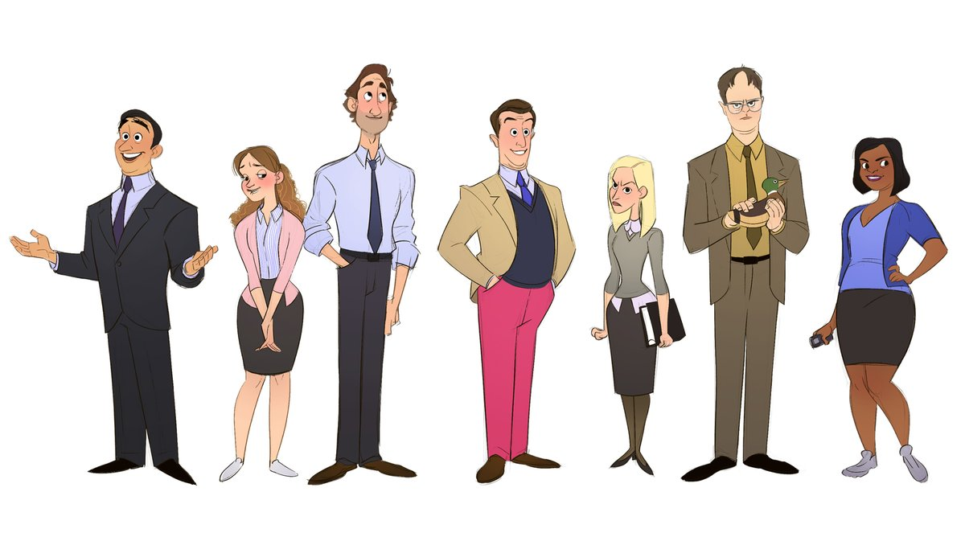

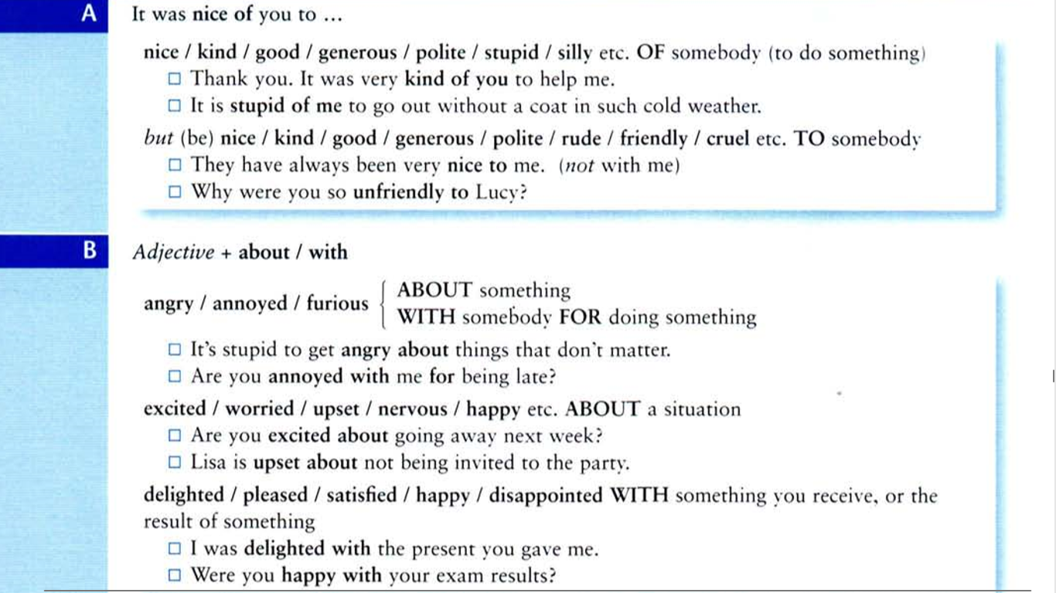
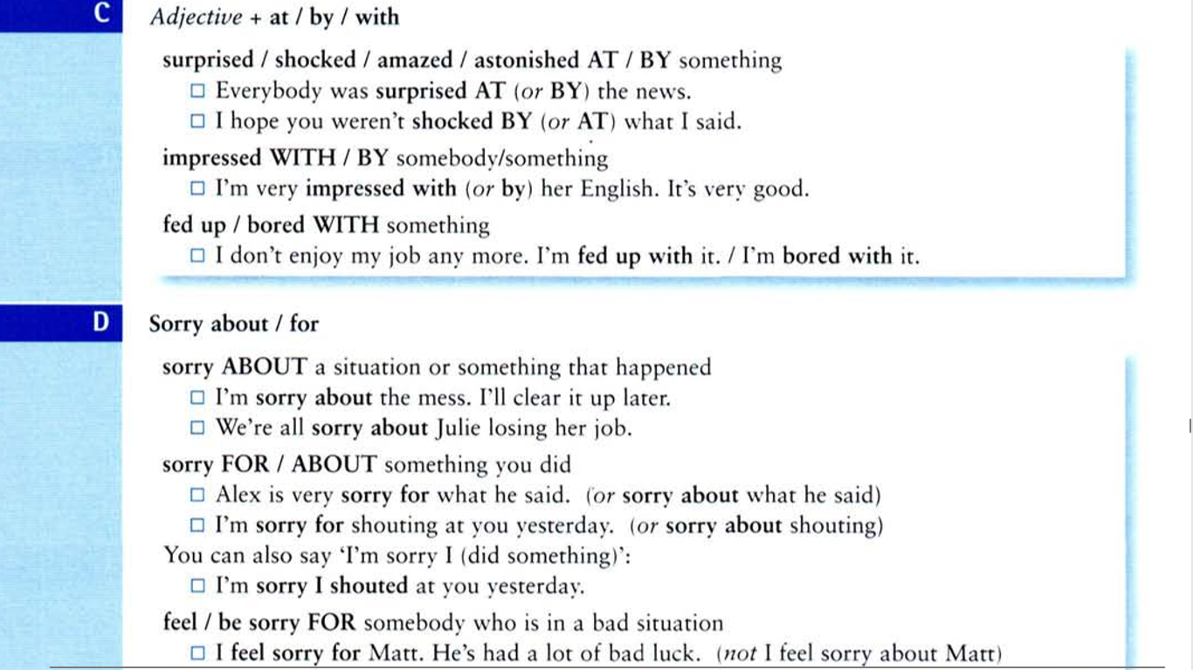
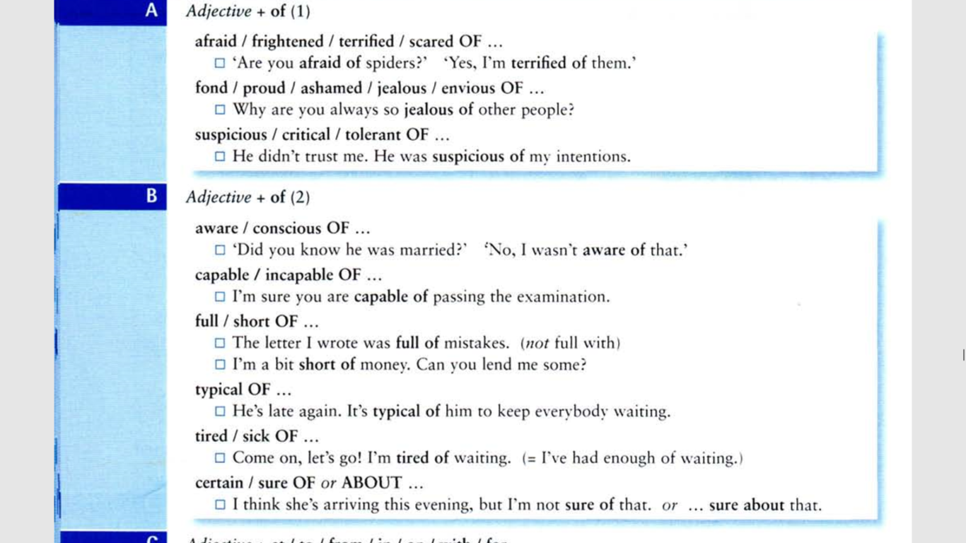
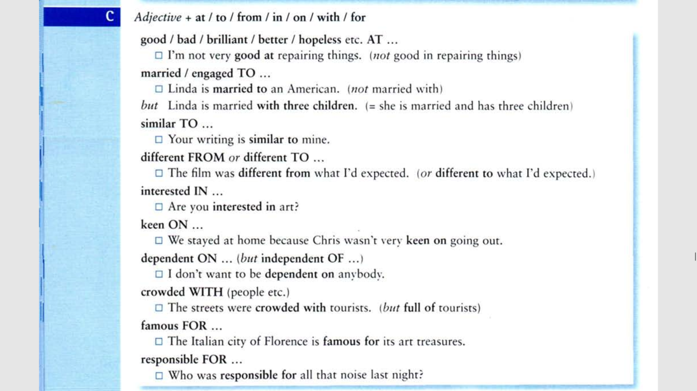

Task 1
Choose the correct variant:
1. They are excited _____ their trip to Rome next June.
about
at
by
for
from
2. I feel sorry _____ Jack. He is so lonely these days. Are you good at golf?
about
at
by
for
from
3. That house is different _____ the one I was looking for.
about
at
by
for
than
4. Cezanne is famous _____ his landscapes.
about
at
by
for
from
5. I must admit I was shocked _____ her behavior at the party.
about
at
by
for
from
6. She's rather worried _____ her son's studies.
from
about
at
by
for
7. I'm just hopeless _____ playing the guitar.
about
at
by
for
from
8. She's furious _____ her son's grades in school.
about
at
by
for
from
9. They were surprised _____ their good fortune.
about
at
by
for
from
10. I'm upset _____ my health.
about
at
by
for
from
11. She was annoyed _____ Tom for ignoring their agreement.
about
at
by
for
with
12. Peter was angry _____ Jack because he came late to the party.
about
at
by
for
from

Task 2
Choose the correct variant:
1. It was very kind ____ you to buy me such a wonderful present. Thank you!
of
on
to
with
2. The store was crowded _____ people.
of
on
to
with
3. I have been married _____ Barbara for over ten years.
of
on
to
with
4. She was very good _____ Jack while he was visiting.
of
on
to
with
5. It was very good _____ you to come.
of
on
to
with
6. They are very keen _____ stamp collecting.
of
on
to
with
7. Their house is quite similar _____ ours.
of
on
to
with
8. I'm afraid I'm rather disappointed _____ my new computer.
of
on
to
with
9. His teachers were cruel _____ him when he was young.
of
on
to
with
10. She is proud _____ her high marks on the exam.
of
on
to
with
11. Unfortunately, he is quite jealous _____ his neighbor's new car.
of
on
to
with
12. It was rather clever _____ George to combine his business trip with a visit to his favorite museum.
of
on
to
with
13. He's become bored _____ his latest hobby.
of
on
to
with
14. I'm afraid he is incapable _____ understanding the most basic concepts.
of
on
to
with
15. Alice! Don't be rude _____ your grandmother.
of
on
to
with

Task 3
Fill the gaps with the necessary preposition:
1. I love new experiences - I am always eager … the next thing.
2. Don't be angry … me, please.
3. I have been kept very busy … these exercises.
4. She is capable … great things!
5. He was very cruel … his girl-friend when he broke up with her.
6. The thief said he was also guilty … murder.
7. Italy is south … Switzerland.
8. I am conscious … the difficulty of learning these prepositions.
9. My students are very dear … me.
10. He is very efficient … what he does.
11. I think the people of the former colony are happy to be independent … the colonial power.
12. My old dog is very faithful … me.
13. Are you sure … what you are saying?
14. France lies to the west … Switzerland.
15. Tennis stars are very popular … young people.
16. Some people are unfortunately ignorant … geography.
17. The president of the country became very angry … the Google map changes.
18. I am ready ... help you now.
19. I am grateful … you for all you have done for me.
20. I am sad … the situation in the world.
Task 4
Put in the correct preposition:
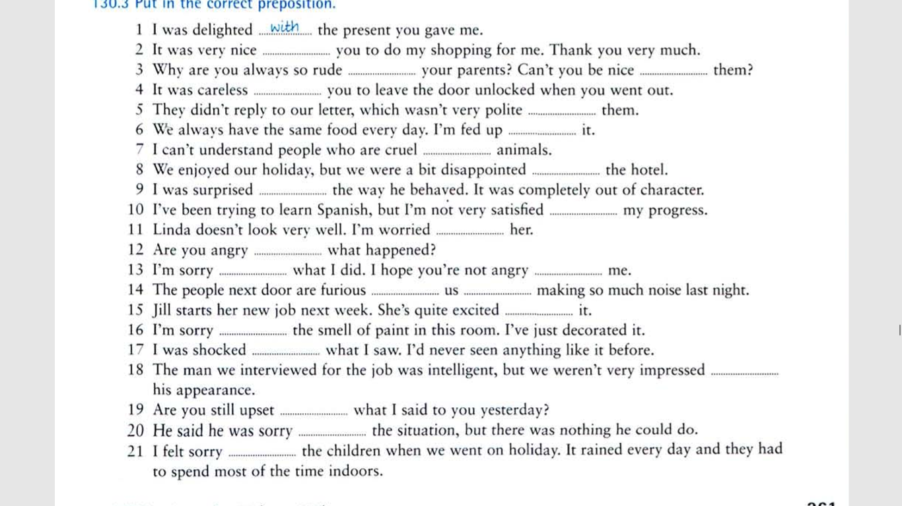

ANSWERS
Task 1
1. They are excited _____ their trip to Rome next June.
about
at
by
for
from
2. I feel sorry _____ Jack. He is so lonely these days. Are you good at golf?
about
at
by
for
from
3. That house is different _____ the one I was looking for.
about
at
by
for
than
4. Cezanne is famous _____ his landscapes.
about
at
by
for
from
5. I must admit I was shocked _____ her behavior at the party.
about
at
by
for
from
6. She's rather worried _____ her son's studies.
from
about
at
by
for
7. I'm just hopeless _____ playing the guitar.
about
at
by
for
from
8. She's furious _____ her son's grades in school.
about
at
by
for
from
9. They were surprised _____ their good fortune.
about
at
by
for
from
10. I'm upset _____ my health.
about
at
by
for
from
11. She was annoyed _____ Tom for ignoring their agreement.
about
at
by
for
with
12. Peter was angry _____ Jack because he came late to the party.
about
at
by
for
from
Task 2
1. It was very kind ____ you to buy me such a wonderful present. Thank you!
of
on
to
with
2. The store was crowded _____ people.
of
on
to
with
3. I have been married _____ Barbara for over ten years.
of
on
to
with
4. She was very good _____ Jack while he was visiting.
of
on
to
with
5. It was very good _____ you to come.
of
on
to
with
6. They are very keen _____ stamp collecting.
of
on
to
with
7. Their house is quite similar _____ ours.
of
on
to
with
8. I'm afraid I'm rather disappointed _____ my new computer.
of
on
to
with
9. His teachers were cruel _____ him when he was young.
of
on
to
with
10. She is proud _____ her high marks on the exam.
of
on
to
with
11. Unfortunately, he is quite jealous _____ his neighbor's new car.
of
on
to
with
12. It was rather clever _____ George to combine his business trip with a visit to his favorite museum.
of
on
to
with
13. He's become bored _____ his latest hobby.
of
on
to
with
14. I'm afraid he is incapable _____ understanding the most basic concepts.
of
on
to
with
15. Alice! Don't be rude _____ your grandmother.
of
on
to
with
Task 3
1. I love new experiences - I am always eager for the next thing.
2. Don't be angry with me, please.
3. I have been kept very busy with these exercises.
4. She is capable of great things!
5. He was very cruel to his girl-friend when he broke up with her.
6. The thief said he was also guilty of murder.
7. Italy is south of Switzerland.
8. I am conscious of the difficulty of learning these prepositions.
9. My students are very dear to me.
10. He is very efficient at what he does.
11. I think the people of the former colony are happy to be independent from the colonial power.
12. My old dog is very faithful to me.
13. Are you sure of what you are saying?
14. France lies to the west of Switzerland.
15. Tennis stars are very popular with young people.
16. Some people are unfortunately ignorant of geography.
17. The president of the country became very angry at the Google map changes.
18. I am ready to help you now.
19. I am grateful to you for all you have done for me.
20. I am sad about the situation in the world.
Task 4

