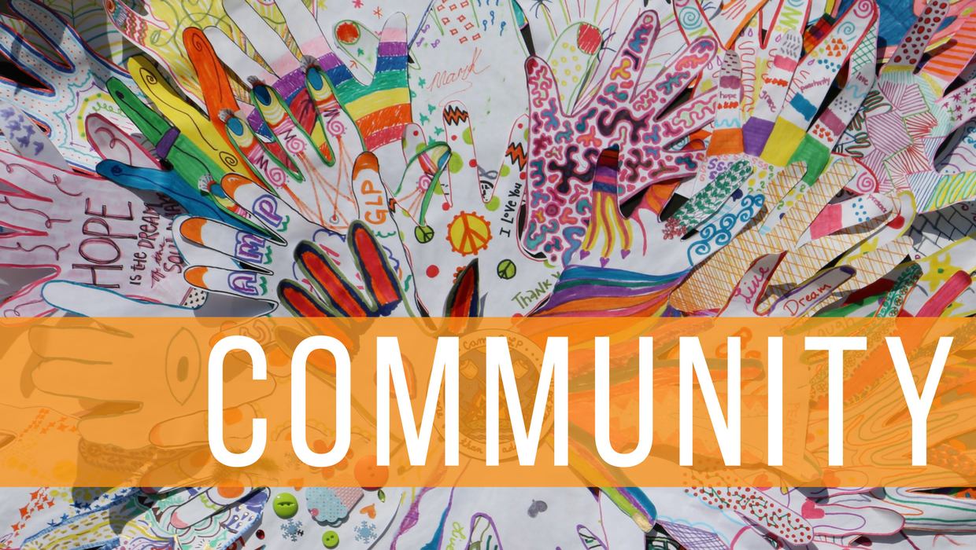
Pre-discussion:
- What is community?
“community” is a group of people living in the same place or having particular characteristics, attitudes, beliefs or interests in common.
2. What communities can you name?
Here are the examples of some communities - school, university, group of friends, religion, sporting club and nation.

- What roles do we have as members of some communities?
- Do we have any rights within any community?
- What do we have in common within our different communities?
Watch the video on a SILENT mode pause once in a while and comment on every group that comes into the room.
Discuss your ideas about the appearance, background, nationalities, jobs, positions in community, marital and financial status, religious confessions, hobbies and interests etc.
Try to guess why they are all in one room.
https://www.youtube.com/watch?v=jD8tjhVO1Tc&feature=player_embedded
After 1:00 watch and answer the question each time the people come forward:
- Why are they doing so?
Post – discussion:
- What is the message of the video?
- Why do we put people in boxes?
- Do you think it’s true that there’s more that brings us together than we think? Why/why not?
- How can we discover what we have in common?

