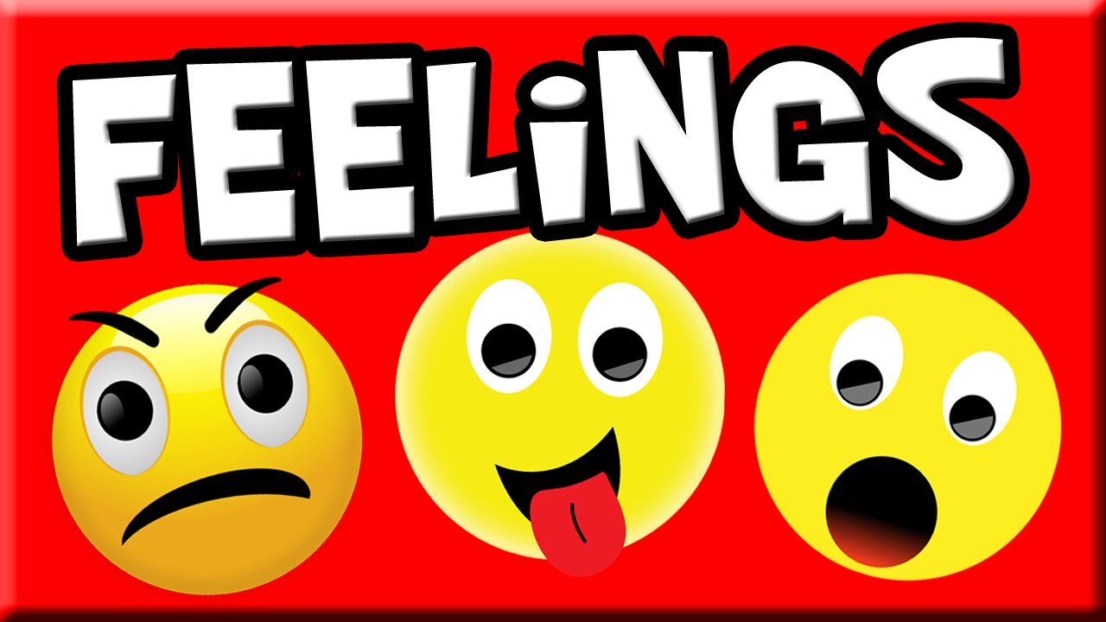

Ex 1. Look at the words and translate them into Russian

https://quizlet.com/327933292/english-intermediate-lesson-31-feelings-flash-cards/?new

Ex 2. Choose the correct answer

1. Try not to hurt/upset his feelings.
2. Sarah's not very emotional, and tends to show/hide her feelings.
3. You can talk to Gary easily about your problems, he's very sympathetic/moody.
4. Be careful what you say to Susan because she's very sympathetic/sensitive.
5. You never know what Karen will be like because she's so moody/supportive.
6. Brian is the most emotional/insensitive man I know, he upsets everyone.
7. Love, anger, and fear are all emotions/moods.

Ex 3. Complete the sentences with a suitable word.

sensitive
in a bad mood
upset
sympathetic
supportive
in a good mood
hurt

1. Caroline is very sensitive. She seems to know when someone has a problem
2. Keep away from Eiton- he's in a bad mood.
3. He upset his parents because he was so rude to them.
4. My children cooked all my meals when I was ill. They were very sympathetic.
5. I broke my leg and it was really painful, but my friends weren't very supportive.
6. I'm in a good mood today. I think it's the fantastic weather.
7. Paul tends to upset people and hurt their feelings.

Ex. 4 Write synonyms for these words and phrases.
1. worried terrified (4)
2. thrilled jealous (6)
3. fed up amazed (5)
4. scared stiff anxious (1)
5. astonished miserable (3)
6. envious delighted (2)

Ex 5. Choose the correct answer

1. I'm not angry. I'm just … that you didn't think you could trust me to look after your flat while you were away.
a. hurt
b. confused
c. restless
d. helpless

2. I can never stay in the same job or place for more than five or six years. I start to get … and want a change.
a. in a good mood
b. restless
c. shocked
d. proud

3. That's the last time I run a marathon! I'm absolutely … !
a. exhausted
b. confused
c. upset
d. envious

4. Looking down from the top of high buildings always made him feel very …
a. proud
b. frustrated
c. giddy
d. in a good mood

5. He was very … about losing his wallet as, apart from money, it also contained his driving licence and credit cards.
a. shocked
b. proud
c. upset
d. hurt

6. She felt very… when she first moved to Paris. Everything was so different and she didn't speak the language very well
a. exhausted
b. envious
c. confused
d. confused

7. You're … today.
Yes, I know. Pete's just asked me to marry him.'
a. in a good mood
b. in a bad mood
c. hurt
d. helpless

8. We were … when we saw how dirty the bathroom was and complained to the hotel manager.
a. proud
b. frustrated
c. confused
d. disgusted

9. You're looking very … Jane. Come on, try to relax.
a. in a good mood
b. giddy
c. tense
d. helpless

10. They felt very … as their daughter stepped on to the stage to receive her prize.
a. helpless
b. proud
c. hurt
d. envious

11. Everyone in the village was deeply … to hear that the postman had been murdered.
a. shocked
b. tense
c. proud
d. restless

12. He felt very … when his neighbour bought a new car.
a. envious
b. disgusted
c. frustrated
d. upset

13. 'Sheila's … What's wrong?'
'Oh, her car was stolen last night, so she's had to come to work by bus today'
a. in a good mood
b. tense
c. proud
d. in a bad mood

14. She felt so … as she watched the child struggling in the river. There was nothing she could do. She couldn't swim.
a. confused
b. helpless
c. disgusted
d. envious

15. I feel really … I've been trying to phone the theatre all morning but, every time I do, the line's engaged
a. hurt
b. in a bad mood
c. frustrated
d. shocked

PDF

Ex 1. Look at the words and translate them into Russian

https://quizlet.com/327933292/english-intermediate-lesson-31-feelings-flash-cards/?new

Ex 2. Choose the correct answer

1. Try not to hurt/upset his feelings
2. Sarah's not very emotional, and tends to show/hide her feelings
3. You can talk to Gary easily about your problems, he's very sympathetic/moody.
4. Be careful what you say to Susan because she's very sympathetic/sensitive.
5. You never know what Karen will be like because she's so moody/supportive.
6. Brian is the most emotional/insensitive man I know, he upsets everyone.
7. Love, anger, and fear are all emotions/moods.

Ex 3. Complete the sentences with a suitable word.

sensitive
in a bad mood
upset
sympathetic
supportive
in a good mood
hurt

1. Caroline is very … . She seems to know when someone has a problem
2. Keep away from Eiton- he's … .
3. He … his parents because he was so rude to them.
4. My children cooked all my meals when I was ill. They were very ….
5. I broke my leg and it was really painful, but my friends weren't very ….
6. I'm … today. I think it's the fantastic weather.
7. Paul tends to upset people and … their feelings.

Ex. 4 Write synonyms for these words and phrases.
1. worried terrified
2. thrilled jealous
3. fed up amazed
4. scared stiff anxious
5. astonished miserable
6. envious delighted

Ex 5. Choose the correct answer

1. I'm not angry. I'm just … that you didn't think you could trust me to look after your flat while you were away.
a. hurt
b. confused
c. restless
d. helpless

2. I can never stay in the same job or place for more than five or six years. I start to get … and want a change.
a. in a good mood
b. restless
c. shocked
d. proud

3. That's the last time I run a marathon! I'm absolutely … !
a. exhausted
b. confused
c. upset
d. envious

4. Looking down from the top of high buildings always made him feel very …
a. proud
b. frustrated
c. giddy
d. in a good mood

5. He was very … about losing his wallet as, apart from money, it also contained his driving licence and credit cards.
a. shocked
b. proud
c. upset
d. hurt

6. She felt very… when she first moved to Paris. Everything was so different and she didn't speak the language very well
a. exhausted
b. envious
c. confused
d. confused

7. You're … today.
Yes, I know. Pete's just asked me to marry him.'
a. in a good mood
b. in a bad mood
c. hurt
d. helpless

8. We were … when we saw how dirty the bathroom was and complained to the hotel manager.
a. proud
b. frustrated
c. confused
d. disgusted

9. You're looking very … Jane. Come on, try to relax.
a. in a good mood
b. giddy
c. tense
d. helpless

10. They felt very … as their daughter stepped on to the stage to receive her prize.
a. helpless
b. proud
c. hurt
d. envious

11. Everyone in the village was deeply … to hear that the postman had been murdered.
a. shocked
b. tense
c. proud
d. restless

12. He felt very … when his neighbour bought a new car.
a. envious
b. disgusted
c. frustrated
d. upset

13. 'Sheila's … What's wrong?'
'Oh, her car was stolen last night, so she's had to come to work by bus today'
a. in a good mood
b. tense
c. proud
d. in a bad mood

14. She felt so … as she watched the child struggling in the river. There was nothing she could do. She couldn't swim.
a. confused
b. helpless
c. disgusted
d. envious

15. I feel really … I've been trying to phone the theatre all morning but, every time I do, the line's engaged
a. hurt
b. in a bad mood
c. frustrated
d. shocked

