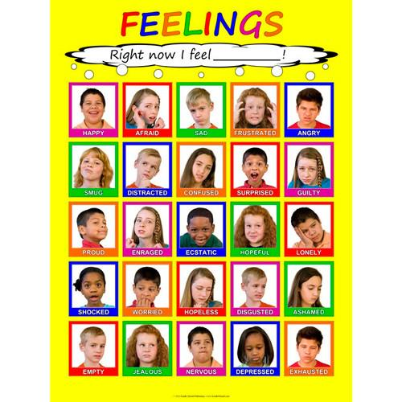
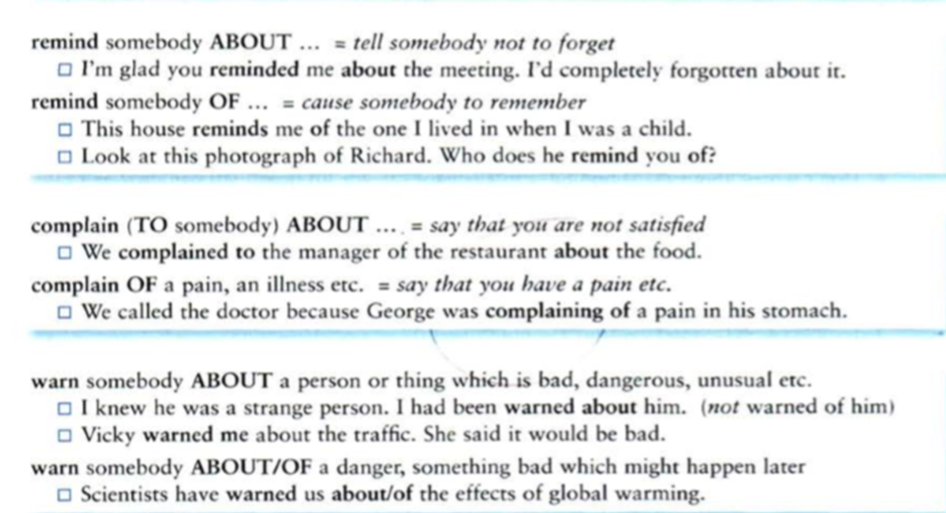

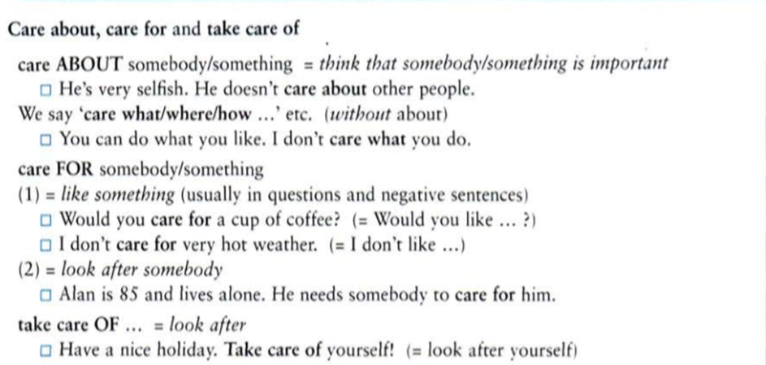
Task 1
Choose the correct variant:
1. Do you believe ... ghosts?
in
on
about
2. She spent years caring ... her sick husband.
about
for
of
3. This spray will protect you ... most insects.
of
from
with
4. He has yet to recover ... his illness.
of
from
with
off
5. He won the national bravery award for saving his friend ... drowning.
from
of
at
6. He worked hard to succeed ... life.
at
in
on
7. I don't approve ... your conduct, young man.
with
of
off
about
8. He suffers ... asthma.
of
from
with
9. That shampoo smells ... jasmine.
about
of
off
10. Please don't make a noise. I want to concentrate ... my studies.
of
on
from
11. My husband and I can't agree ... anything but we love each other.
on
with
about
12. Please refer ... the glossary for more information.
at
with
to

Task 2
Put the correct preposition into the gaps:
1. She accused me … telling lies.
2. You can always borrow a dictionary … the library.
3. Do you believe … ghosts?
4. The history teacher asked us to comment … the events taking place in Afghanistan.
5. I am accustomed … having a lot of money.
6. When the guests arrived … my house they gave me a bottle of wine.
7. Some people stupidly believe that we are in school to prepare … our future jobs.
8. The old woman suffered … lumbago.
9. Oh, you are so right! I agree … you completely!
10. She is very dependable. I always know I can count … her absolutely.
11. I want to congratulate you … your success.
12. You won't always be able to rely … your parents.
13. When you are a mountain guide, you sometimes have to wait a long time … the tourists.
14. My banker told me not to draw all the money … of my bank account.
15. I must insist … your learning these verbs!
16. Are you accusing me … being too strict?
17. How does the man account … having all that money in his pocket?
18. The workmen would like to speak … the manager.
19. The visitors objected … the horrible rooms.
20. I always try to agree … my twin sister, because it makes her angry if I don't.
21. I just couldn't agree … his plan, it was much too dangerous!
22. Young people today can communicate … each other using a lot of different machines.
23. It was your fault! Don't try to blame me … the accident!!
24. The head teacher threatened me … expulsion if I didn't behave better.
25. Don't forget to thank your parents … putting up with you all these years!

Task 3
Choose the correct preposition:

1 He's a good friend and very helpful – you can always rely him.
2 Accommodation was so expensive in Switzerland. I spent all my money hotels.
3 You can confide me if you have a personal problem you need to discuss.
4 He's always boasting how good a guitarist he is.
5 My boss has just resigned. I don't think he could cope the pressure.
6 The online game is aimed teenagers and young adults.
7 My wife has passed her driving test and has applied her license.
8 My grandfather suffered arthritis.
9 Do you believe life after death?
10 I liked English at school, but I was terrible French.
11 The careers officer will provide you all the relevant information about the job.
12 I always turn my father for advice. He's like a wise owl.

Task 4
Put the correct preposition into the gaps:
to, for, of, from, about, with, on, -
1. I need you to explain … Peter the updated process.
2. I'm waiting … your answer.
3. We're keeping … the money until next week.
4. I thought … you when I heard that song.
5. They are thinking … going to Rome at Easter.
6. Don't worry … it. It'll go according to plan.
7. Have you heard … your mother recently?
8. Have you heard the news … the merger?
9. It's a bad situation, we really should do something … it. (to resolve something)
10. We've paid for it, so we should do something … it. (to use something)
11. Everybody blamed me … the accident.
12. Everybody blamed the accident … me.
13. They will provide us … all the necessary documents at the service desk.
14. We need to arrange … the meeting soon.
15. I don't trust … him at all!

Answers
Task 1
1. Do you believe in ghosts?
2. She spent years caring for her sick husband.
3. This spray will protect you from most insects.
4. He has yet to recover from his illness.
5. He won the national bravery award for saving his friend from drowning.
6. He worked hard to succeed in life.
7. I don’t approve of your conduct, young man.
8. He suffers from asthma.
9. That shampoo smells of jasmine.
10. Please don’t make a noise. I want to concentrate on my studies.
11. My husband and I can’t agree on anything but we love each other.
12. Please refer to the glossary for more information.
Task 2
1. She accused me of telling lies.
2. You can always borrow a dictionary from the library.
3. Do you believe in ghosts?
4. The history teacher asked us to comment on the events taking place in Afghanistan.
5. I am accustomed to having a lot of money.
6. When the guests arrived at my house they gave me a bottle of wine.
7. Some people stupidly believe that we are in school to prepare for our future jobs.
8. The old woman suffered from lumbago.
9. Oh, you are so right! I agree with you completely!
10. She is very dependable. I always know I can count on her absolutely.
11. I want to congratulate you on your success.
12. You won't always be able to rely on your parents.
13. When you are a mountain guide, you sometimes have to wait a long time for the tourists.
14. My banker told me not to draw all the money out of my bank account.
15. I must insist on your learning these verbs!
16. Are you accusing me of being too strict?
17. How does the man account for having all that money in his pocket?
18. The workmen would like to speak to the manager.
19. The visitors objected to the horrible rooms.
20. I always try to agree with my twin sister, because it makes her angry if I don't.
21. I just couldn't agree to his plan, it was much too dangerous!
22. Young people today can communicate with each other using a lot of different machines.
23. It was your fault! Don't try to blame me for the accident!!
24. The head teacher threatened me with expulsion if I didn't behave better.
25. Don't forget to thank your parents for putting up with you all these years!
Task 3
1 He's a good friend and very helpful – you can always rely on him.
2 Accommodation was so expensive in Switzerland. I spent all my money on hotels.
3 You can confide in me if you have a personal problem you need to discuss.
4 He's always boasting about how good a guitarist he is.
5 My boss has just resigned. I don't think he could cope with the pressure.
6 The online game is aimed at teenagers and young adults.
7 My wife has passed her driving test and has applied for her license.
8 My grandfather suffered from arthritis.
9 Do you believe in life after death?
10 I liked English at school, but I was terrible at French.
11 The careers officer will provide you with all the relevant information about the job.
12 I always turn to my father for advice. He's like a wise owl.
Task 4
1. I need you to explain to Peter the updated process.
2. I'm waiting for your answer.
3. We're keeping - the money until next week.
4. I thought of you when I heard that song.
5. They are thinking about going to Rome at Easter.
6. Don't worry about it. It'll go according to plan.
7. Have you heard from your mother recently?
8. Have you heard the news about the merger?
9. It's a bad situation, we really should do something about it. (to resolve something)
10. We've paid for it, so we should do something with it. (to use something)
11. Everybody blamed me for the accident.
12. Everybody blamed the accident on me.
13. They will provide us with all the necessary documents at the service desk.
14. We need to arrange - the meeting soon.
15. I don't trust - him at all!

