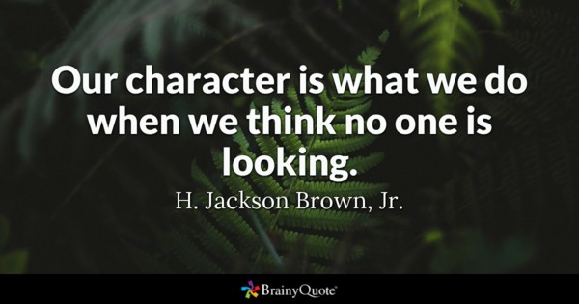

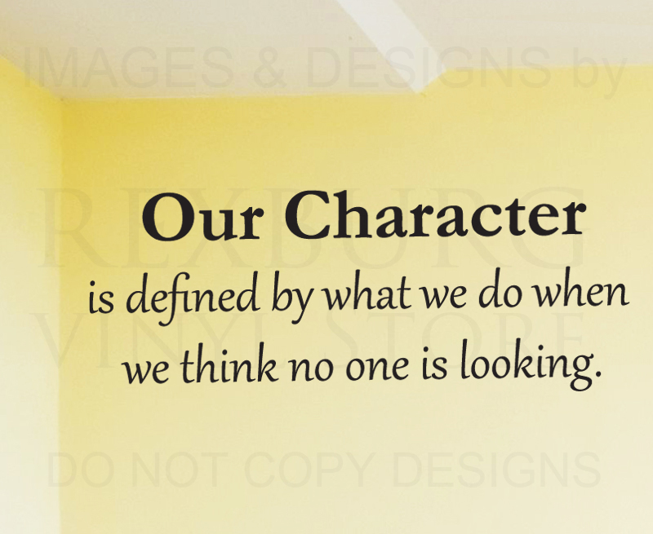
Ex. 1 Look at the words and translate them into Russian
https://quizlet.com/331879485/english-intermediate-lesson-32-idioms-character-flash-cards/?new

Ex. 2 Choose whether the idiom positive or negative.

1 I was on cloud nine all day. P
2 The boss was in a really black mood this morning. N
3 He's been going round like a bear with a sore head all day. N
4 Everyone seems to be in high spirits tonight. P
5 She seems to be keeping her chin up. P
6 You're looking down in the dumps. What happened? N
7 He had a face as long as a fiddle. N
8 Lily's as happy as the day is long. P
9 She was over the moon when she heard the news. P

Ex. 3 Match the idiom with its definition
1. as happy as the day is long D
2. to be on cloud nine H
3. to keep her chin up C
4. to be like a bear with a sore head E
5. feeling all in A
6. to be under the weather G
7. at death's door F
8. to frighten the life out of B

a. exhausted
b. very scared indeed
c. happy despite bad things
d. extremely content
e. extremely irritable
f. very sick or ill
g. not very well /ill
h. extremely pleased/happy

Ex 4 Complete the idioms in these sentences with the most suitable word.

1 Don't creep up behind me like that! You …
- frightened the life out of me
- were at death's door
- were like a bear with a sore head
- were on cloud nine
2 I don't need a doctor, I just feel a bit …
- like a bear with a sore head
- scared stiff
- under the weather
- as happy as the day is long

3 As long as he has his car to work on, he is …
- shaking in his shoes
- as happy as the day is long
- feeling all in
- at death's door
4 Last year, when I won that medal, I really was …
- keeping my chin up
- scared stiff
- on cloud nine
- scared out of my wits
5 I wasn't expecting such a loud bang; I nearly …
- jumped out of my skin
- could eat a horse
- was looking a bit under the weather
- was like a bear with a sore head
6 I've had nothing since lunch; I …
- kept my chin up
- could eat a horse
- felt as if my head was going round
- was on cloud nine
7 I feel a bit down this week; last week I was…
- in high spirits
- all shaking in my shoes
- looking a bit under the weather
- feeling all in

Ex. 5 Complete the sentences with suitable idiom

scared stiff
as happy as the day is long
at death's door
to be on cloud nine
as if my head was going round
like a bear with a sore head
a bit under the weather

1. Jo has bought a new car. He doesn’t have to go to work by bus any more, he is as happy as the day is long.
2. Mary had to rewrite her article for the third time. She was like a bear with a sore head.
3. Jack has proposed to Sue. She seems to be on cloud nine these days.
4. You look very pale. Is everything OK? You're looking a bit under the weather.
5. Ambulance took Will to the hospital. He was almost at death's door! But eventually everything became better.
6. I was scared stiff when I was watching that new horror movie.
7. I suddenly felt as if my head was going round. That’s because I drank too little water.

Ex 6 Using the idioms from 79.1 and from A opposite, say how you would probably feel if...
1 you were told you had just won a vast sum of money.
2 your boss said you had to do again a piece of work you'd already done three times.
3 you were told you'd got a very high mark in an exam.
4 you had a bad toothache and your neighbor was making a lot of noise late at night.
5 nothing seemed to have gone right for you that day
6 someone you were secretly in love with told you they were in love with you.
PDF

Ex. 1 Look at the words and translate them into Russian
https://quizlet.com/331879485/english-intermediate-lesson-32-idioms-character-flash-cards/?new

Ex. 2 Choose whether the idiom positive or negative.

1 I was on cloud nine all day.
2 The boss was in a really black mood this morning.
3 He's been going round like a bear with a sore head all day.
4 Everyone seems to be in high spirits tonight.
5 I felt browned off with the situation
6 She seems to be keeping her chin up.
7 You're looking down in the dumps. What happened?
8 He had a face as long as a fiddle.
9 Lily's as happy as the day is long.
10 She was over the moon when she heard the news.

Ex. 3
1. as happy as the day is long
2. to be on cloud nine
3. to keep her chin up
4. to be like a bear with a sore head
5. feeling all in
6. to be under the weather
7. at death's door
8. to frighten the life out of

a. exhausted
b. very scared indeed
c. happy despite bad things
d. extremely content
e. extremely irritable
f. very sick or ill
g. not very well /ill
h. extremely pleased/happy

Ex 4 Complete the idioms in these sentences with the most suitable word.
1 Don't creep up behind me like that! You …
- frightened the life out of me
- were at death's door
- were like a bear with a sore head
- were on cloud nine
2 I don't need a doctor, I just feel a bit
- like a bear with a sore head
- scared stiff
- under the weather
- as happy as the day is long

3 As long as he has his car to work on, he is
- shaking in his shoes
- as happy as the day is long
- feeling all in
- at death's door
4 Last year, when I won that medal, I really was
- keeping my chin up
- scared stiff
- on cloud nine
- scared out of my wits
5 I wasn't expecting such a loud bang; I nearly
- jumped out of my skin
- could eat a horse
- was looking a bit under the weather
- was like a bear with a sore head
6 I've had nothing since lunch; I …
- kept my chin up
- could eat a horse
- felt as if my head was going round
- was on cloud nine
7 I feel a bit down this week; last week I was
- in high spirits
- all shaking in my shoes
- looking a bit under the weather
- feeling all in

Ex. 5 Complete the sentences with suitable idiom

scared stiff
as happy as the day is long
at death's door
to be on cloud nine
as if my head was going round
like a bear with a sore head
a bit under the weather

1. Jo has bought a new car. He doesn’t have to go to work by bus any more, he is ...
2. Mary had to rewrite her article for the third time. She was...
3. Jack has proposed to Sue. She seems … these days.
4. You look very pale. Is everything OK? You're looking ….
5. Ambulance took Will to the hospital. He was almost …! But eventually everything became better.
6. I was … when I was watching that new horror movie.
7. I suddenly felt …. That’s because I drank too little water.

Ex 6 Using the idioms from 79.1 and from A opposite, say how you would probably feel if...
1 you were told you had just won a vast sum of money.
2 your boss said you had to do again a piece of work you'd already done three times.
3 you were told you'd got a very high mark in an exam.
4 you had a bad toothache and your neighbor was making a lot of noise late at night.
5 nothing seemed to have gone right for you that day
6 someone you were secretly in love with told you they were in love with you.

