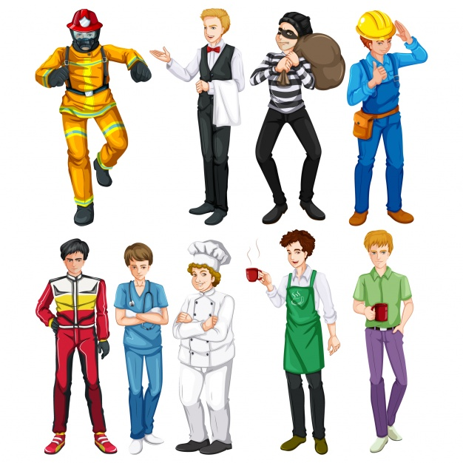

Task 1
Choose the correct variant.
1. Visitors are asked to abstain ___________ smoking on the premises.
(a) from (b) on
2. She is unavailable at the moment as she is attending _________ an urgent issue.
(a) on (b) to
3. I believe _________ him – he is such a talented and hard-working artist.
(a) with (b) in
4. She took some time off work to care ________ her sick son.
(a) for (b) of
5. I totally agree _______ your opinion – everything you say about this is true!
(a) with (b) for
6. The schoolboy was blamed _______ the broken window.
(a) about (b) for
7. He annoys me because he is always boasting __________ his achievements!
(a) about (b) with
8. I had to choose ____________ going to the cinema or out to dinner as I couldn’t afford to do both.
(a) between (b) for
9. The management team is meeting this afternoon to decide ___________ the best solution.
(a) on (b) for
10. He forgave me __________ my mistake.
(a) about (b) for

Task 2
Choose the correct variant.
1. I am so excited ____________ the upcoming concert!
(a) about (b) with
2. Take no notice of what she says she is just envious ___________ you!
(a) with (b) of
3. I am doubtful ___________ the likely success of this project.
(a) with (b) about
4. He is so ashamed __________ what he did and sends his apologies!
(a) of (b) in
5. The company is aware _________ the problem and is working hard to fix it soon.
(a) of (b) in
6. We were so dissatisfied ___________ the service, we won’t eat at that restaurant again.
(a) with (b) at
7. It is good that the whole team is so enthusiastic __________ the changes.
(a) to (b) about
8. He is so good ___________ public speaking.
(a) at (b) of
9. She was so kind __________ me when I was having problems.
(a) to (b) with
10. I am so tired __________ my job, I need a change I think.
(a) of (b) about

Task 3
Choose the correct variant.
1. It was an unjustified attack ________ an innocent party.
(a) of (b) on
2. His attitude ____________ the subject is very narrow-minded.
(a) in (b) towards
3. The manager thanked the staff on behalf _________ the directors.
(a) of (b) on
4. There is no need ___________ violence in any circumstances.
(a) of (b) for
5. The reason __________ the accident is still to be established.
(a) of (b) for
6. Conditions are much better but there is still room __________ further improvement.
(a) for (b) in
7. The rise ____________ crime levels has been attributed to lower employment opportunities.
(a) in (b) of
8. There was a public outcry in reaction ___________ the government’s proposals.
(a) with (b) to
9. He has extensive knowledge ___________ the subject.
(a) of (b) with
10. The teacher let them finish class early __________ condition that they arrived early the next day.
(a) in (b) on

Task 4
Choose the correct variant.
1. I am interested ... learning to fly.
in
on
at
for
2. John's criticism … the plan made him unpopular.
for
of
about
3. He has always been critical … me.
with
of
about
4. I resent ... on weekends.
working
for working
about working
5. My resentment ... working on holidays made me unpopular with my boss.
of
for
with
6. I feel resentful ... working on Sundays.
for
of
about
7. She ignored our worries ... her health.
of
about
for
8. I can only sympathize ... you.
for
with
at
9. I feel great sympathy ... her.
with
at
for
about
10. I feel sympathetic ... the poor.
for
with
at
towards
11. I had given up hope ... seeing her again.
for
to
of
12. She ... the station last night.
arrived
arrived at
arrived to

Task 5
Choose the correct preposition.
1 I completely agree on/to/with Jack about the changes at work.
2 Joel is an expert with/at/of fixing computer problems.
3 You will get a better price if you pay by/in/for cash.
4 What was his reason over/with/for being late?
5 The boy threw a rock at/to/in the window trying to break it.
6 Ian blamed Fred on/for/with the mistakes in the report.
7 She died in/by/from a heart attack.
8 Sheila felt guilty about/of/to taking the money.
9 The boy looked familiar with/to/for David; he knew he had seen him somewhere before.
10 This coupon is valid only in/on/to certain supermarkets.
11 Alex survived only from/with/on water for three days.
12 Phillip takes pleasure at/in/of helping others.
13 We are all confused about/for/with the time of the meeting.
14 The customer complained to the manager of/for/about the poor service.
15 Have you heard of/from/about Mina recently?
16 There is a huge demand for/from/against the software program; everyone is buying it.
17 Fortunately, Daniel’s part-time job doesn’t interfere on/with/at his studies.

ANSWERS
Task 1
1. Visitors are asked to abstain ___________ smoking on the premises.
(a) from (b) on
2. She is unavailable at the moment as she is attending _________ an urgent issue.
(a) on (b) to
3. I believe _________ him – he is such a talented and hard-working artist.
(a) with (b) in
4. She took some time off work to care ________ her sick son.
(a) for (b) of
5. I totally agree _______ your opinion – everything you say about this is true!
(a) with (b) for
6. The schoolboy was blamed _______ the broken window.
(a) about (b) for
7. He annoys me because he is always boasting __________ his achievements!
(a) about (b) with
8. I had to choose ____________ going to the cinema or out to dinner as I couldn’t afford to do both.
(a) between (b) for
9. The management team is meeting this afternoon to decide ___________ the best solution.
(a) on (b) for
10. He forgave me __________ my mistake.
(a) about (b) for

Task 2
1. I am so excited ____________ the upcoming concert!
(a) about (b) with
2. Take no notice of what she says she is just envious ___________ you!
(a) with (b) of
3. I am doubtful ___________ the likely success of this project.
(a) with (b) about
4. He is so ashamed __________ what he did and sends his apologies!
(a) of (b) in
5. The company is aware _________ the problem and is working hard to fix it soon.
(a) of (b) in
6. We were so dissatisfied ___________ the service, we won’t eat at that restaurant again.
(a) with (b) at
7. It is good that the whole team is so enthusiastic __________ the changes.
(a) to (b) about
8. He is so good ___________ public speaking.
(a) at (b) of
9. She was so kind __________ me when I was having problems.
(a) to (b) with
10. I am so tired __________ my job, I need a change I think.
(a) of (b) about

Task 3
1. It was an unjustified attack ________ an innocent party.
(a) of (b) on
2. His attitude ____________ the subject is very narrow-minded.
(a) in (b) towards
3. The manager thanked the staff on behalf _________ the directors.
(a) of (b) on
4. There is no need ___________ violence in any circumstances.
(a) of (b) for
5. The reason __________ the accident is still to be established.
(a) of (b) for
6. Conditions are much better but there is still room __________ further improvement.
(a) for (b) in
7. The rise ____________ crime levels has been attributed to lower employment opportunities.
(a) in (b) of
8. There was a public outcry in reaction ___________ the government’s proposals.
(a) with (b) to
9. He has extensive knowledge ___________ the subject.
(a) of (b) with
10. The teacher let them finish class early __________ condition that they arrived early the next day.
(a) in (b) on

Task 4
1. I am interested in learning to fly.
2. John’s criticism of the plan made him unpopular.
3. He has always been critical of me.
4. I resent working on weekends.
5. My resentment of working on holidays made me unpopular with my boss.
6. I feel resentful about working on Sundays.
7. She ignored our worries about her health.
8. I can only sympathize with you.
9. I feel great sympathy for her.
10. I feel sympathetic towards the poor.
11. I had given up hope of seeing her again.
12. She arrived at the station last night.

Task 5
1 I completely agree on/to/with Jack about the changes at work.
2 Joel is an expert with/at/of fixing computer problems.
3 You will get a better price if you pay by/in/for cash.
4 What was his reason over/with/for being late?
5 The boy threw a rock at/to/in the window trying to break it.
6 Ian blamed Fred on/for/with the mistakes in the report.
7 She died in/by/from a heart attack.
8 Sheila felt guilty about/of/to taking the money.
9 The boy looked familiar with/to/for David; he knew he had seen him somewhere before.
10 This coupon is valid only in/on/to certain supermarkets.
11 Alex survived only from/with/on water for three days.
12 Phillip takes pleasure at/in/of helping others.
13 We are all confused about/for/with the time of the meeting.
14 The customer complained to the manager of/for/about the poor service.
15 Have you heard of/from/about Mina recently?
16 There is a huge demand for/from/against the software program; everyone is buying it.
17 Fortunately, Daniel’s part-time job doesn’t interfere on/with/at his studies.

