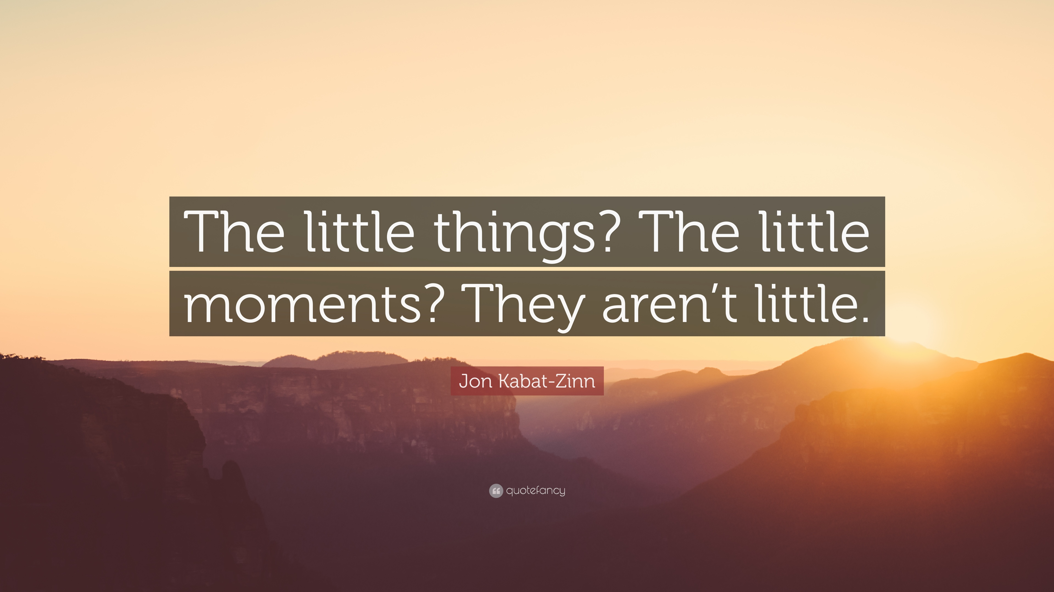
Look at the photo below and discuss the following questions:
- What does the woman look like?
- What kind of person do you think she is?
- What has she done in her life?
- How is she feeling right now?
- What’s she looking at?
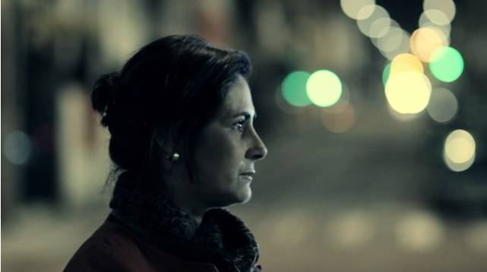

Now looka at the other photo below and talk about it:
- What does the man look like?
- What kind of person do you think he is?
- What has he done in his life?
- How is he feeling now?
- What’s he looking at?

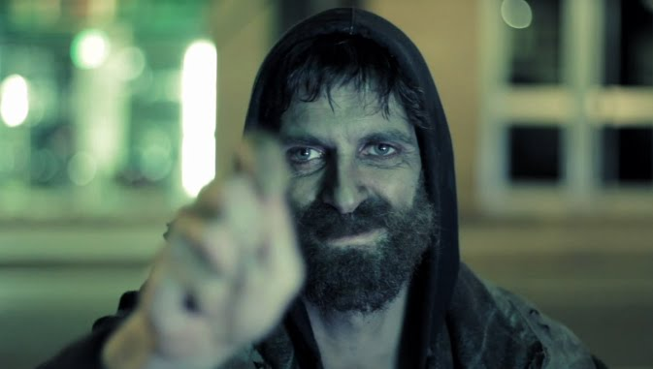

The two photos are taken from a short film. Create a story in which the man and woman are characters.
Now you are going to watch the film and compare your story with the story you see in the film.
https://vimeo.com/17896628
- How does the man feel when he sees images of his daughter on the TV screen?
- How does the wife feel when she sees her daughter?
- How does the daughter feel when she sees her father?
- How does the father feel when he sees his daughter and wife?
- How does the film make you feel?
Discuss the following question:
- What do you think happens after the film finishes?

