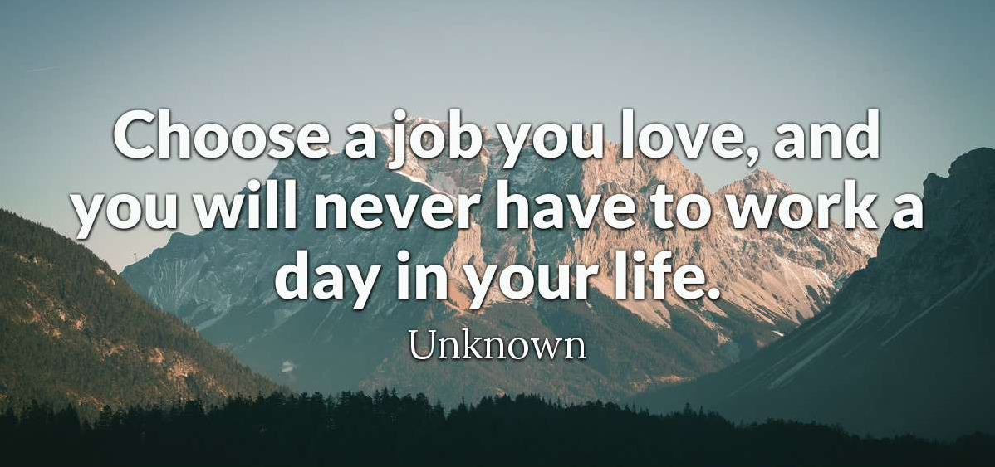

Quizlet:
https://quizlet.com/334743813/flashcards

I. Complete the sentences with a single word.
1. You can't use this visa any longer – it's not .
2. I work in lots of places, but I’m in Bristol.
3. She was angry because they didn’t that they had received her letters
4. He offered me the job on the phone, but I haven't had written yet.
5. They said they would me by phone when they’ve made a decision.
6. You don't need to ask for confirmation; they will reply .
7. They interviewed four other for the job as well as me.
8. Val wrote to the company for a job, but there are no at the moment.
9. I hope they’ll me feedback after the interview.
10. He wants to for the job, but he still has to fill in the form.
11. You have to do tests and have several interviews; it’s quite a long .
II. Replace the underlined words with a more formal word or phrase with the same meaning.
1. Has the company asked for references?

2. They offered me the job on Thursday.

3. I went for an interview last week

4. If you need more information, please contact me.

5. We’re going to give him the job, depending on satisfactory references.

III. Complete the conversation with the correct words.
A: Did you have to fill in an (1) to get your job?
B: No. I saw an (2) in the newspaper for a job as a runner for a TV company and I wrote them a letter. I also sent them my (3) with details of my education and other work experience. In my letter I said that I had always wanted a
(4) in TV and was happy to start at the bottom.
A: Were you nervous when you went for your (5) ?
B: Yes, I was a bit. But they were very friendly and gave me a coffee.
A: What questions did they ask you?
B: They asked if I had a clean (6) because I might have to do some driving. They also wanted to know about my computer (7) and I told them I knew Word and Excel.
A: Did you need any other (8) for the job?
B: No. But I think you have to be well (9) - for this kind of work, or you can‘t get everything done In time And you also need a good (10) .
A: Really?
B: Yes. Because sometimes, if you didn’t laugh, you'd cry!
A: Did they (11) you the job straightaway?
B: No. They asked me for (12) . They wanted the name and address of my boss at my last company. And I also gave them the name of a woman I worked for in Italy.
A: Is it a (13) job?
B: Yes. I work forty hours a week.
A: Do you make good money? Is it (14) ?
B: No, but I don’t mind. I’m not doing it for the money. My (15) was really low but it went up after two months.
A: Is it a permanent job or is it (16) ?
B: Well. We got a twelve-month contract. They might renew it after that.
A: Do you find the work (17) ?
B: No. It's hard work but the atmosphere is very relaxed. Anyway tell me about you. Are you still (18) ?
A: No, I‘ve got a job at last, but it's only (19) -twenty hours a week. But they're sending me on a (20) next week to improve my computer skills and after that they may offer me more hours.

IV. Answer the questions.
1. What jobs have you applied for in the past?
2. How many interviews have you had?
3. Have any interviewers given you feedback after the interview?
4. How many times have you been the successful candidate?
5. Who were your referees?
6. Have you ever had to get a work permit? If so, where?

Answers:

I. Complete the sentences with a single word.
1. You can't use this visa any longer – it's not valid.
2. I work in lots of places, but I’m based in Bristol.
3. She was angry because they didn’t acknowledge that they had received her letters
4. He offered me the job on the phone, but I haven't had written confirmation yet.
5. They said they would contact me by phone when they’ve made a decision.
6. You don't need to ask for confirmation; they will reply automatically.
7. They interviewed four other candidates for the job as well as me.
8. Val wrote to the company for a job, but there are no vacancies at the moment.
9. I hope they’ll give me feedback after the interview.
10. He wants to apply for the job, but he still has to fill in the application form.
11. You have to do tests and have several interviews; it’s quite a long process.

II. Replace the underlined words with a more formal word or phrase with the same meaning.
1. Has the company requested references?

2. They offered me the position on Thursday.

3. I attended an interview last week

4. If you require more information, please contact me.

5. We’re going to give him the job, subject to satisfactory references.

III. Complete the conversation with the correct words.
A: Did you have to fill in an (1) application form to get your job?
B: No. I saw an (2) advertisement in the newspaper for a job as a runner for a TV company and I wrote them a letter. I also sent them my (3) CV with details of my education and other work experience. In my letter I said that I had always wanted a
(4) career in TV and was happy to start at the bottom.
A: Were you nervous when you went for your (5) interview?
B: Yes, I was a bit. But they were very friendly and gave me a coffee.
A: What questions did they ask you?
B: They asked if I had a clean (6) driving license because I might have to do some driving. They also wanted to know about my computer (7) skills and I told them I knew Word and Excel.
A: Did you need any other (8) qualifications for the job?
B: No. But I think you have to be well (9) organized - for this kind of work, or you can‘t get everything done In time And you also need a good (10) sense of humor.
A: Really?
B: Yes. Because sometimes, if you didn’t laugh, you'd cry!
A: Did they (11) offer you the job straightaway?
B: No. They asked me for (12) references. They wanted the name and address of my boss at my last company. And I also gave them the name of a woman I worked for in Italy.
A: Is it a (13) full-time job?
B: Yes. I work forty hours a week.
A: Do you make good money? Is it (14) well-paid?
B: No, but I don’t mind. I’m not doing it for the money. My (15) starting salary was really low but it went up after two months.
A: Is it a permanent job or is it (16) temporary?
B: Well. We got a twelve-month contract. They might renew it after that.
A: Do you find the work (17) stressful?
B: No. It's hard work but the atmosphere is very relaxed. Anyway tell me about you. Are you still (18) unemployed?
A: No, I‘ve got a job at last, but it's only (19)part-time - twenty hours a week. But they're sending me on a (20) training course next week to improve my computer skills and after that they may offer me more hours.

