Lesson 33 – Grammar – Future in the past/ Sequence of Tenses (part2)

Future in the past

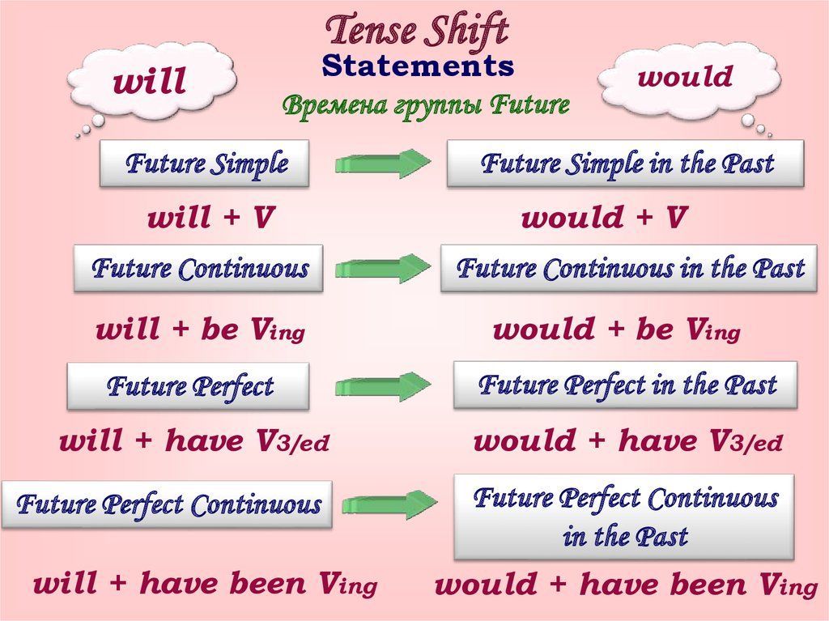
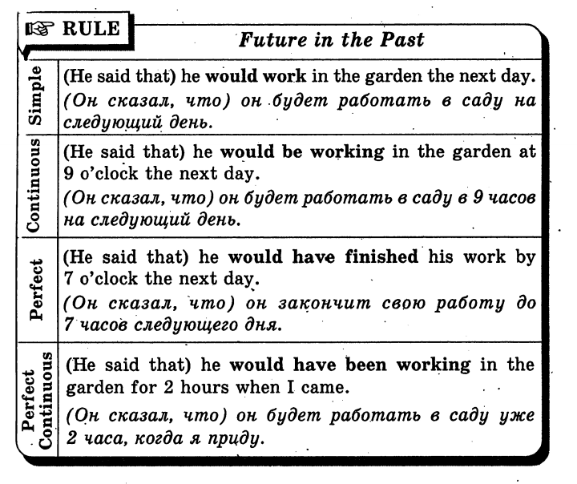

Sequence of Tenses
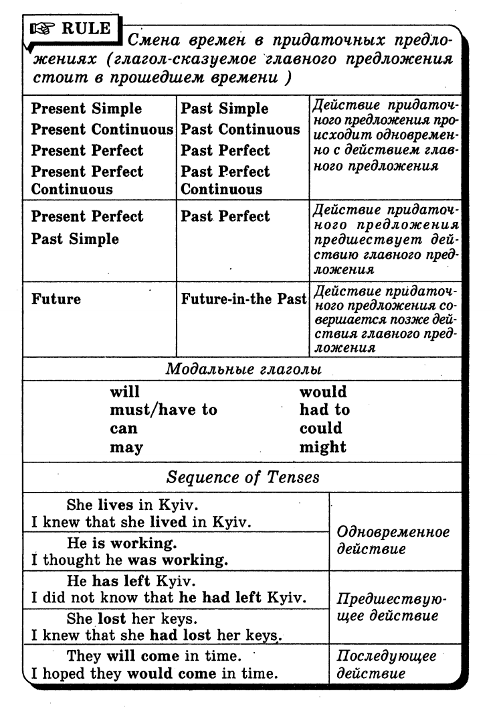

Exercise 1
Read the sentences and choose the best answer.
- I thought she ... everything by our arrival, but I was wrong.
  - ? would have prepared
  - ? would be preparing
  - ? would prepare
- I ... the report when I noticed some alarming details.
  - ? was to sign
  - ? was about to sign
  - ? would sign
- When I got to the station, the train ...
  - ? would leave
  - ? was to leave
  - ? was about to leave
- We couldn't be at that party, because we ... abroad the following day.
  - ? would go
  - ? were going
  - ? went
- We ... with them, but they finally convinced us.
  - ? weren't going to travel
  - ? wouldn't travel
  - ? weren't to travel
- I was sure that after midnight I ...
  - ? would be sleeping
  - ? would sleep
  - ? was sleeping
- He was almost sure he ... his exam.
  - ? was passing
  - ? was to pass
  - ? would pass
- I knew his aunt ... him any money.
  - ? wouldn't be lending
  - ? wouldn't lend
  - ? didn't lend
- I was sure that Kate ... by the time I arrived.
  - ? would leave
  - ? would be leaving
  - ? would have left
- All the problems ... be solved during yesterday's meeting.
  - ? would
  - ? were to
  - ? were about to
- I ... to the party, but Peter made me come.
  - ? wouldn't go
  - ? wasn't going
  - ? wasn't going to go
- I ... this letter yesterday, but I didn't have enough time.
  - ? would send
  - ? was supposed to send
  - ? was about to
- Peter decided he ... to France on holidays.
  - ? will go
  - ? would go
  - ? went

Exercise 2
Choose the most appropriate form to refer to the future in the past to complete the sentences below.
- I saw he had a gun, but I didn't think he...
  - ? will shoot
  - ? was going to shoot
  - ? was shooting
- I knew you... the exam. You didn't make any effort!
  - ? were failing
  - ? would fail
  - ? are going to fail
- I lost my passport the day before we... for our honeymoon.
  - ? left
  - ? were leaving
  - ? would leave
- Sorry, I... you today, but I forgot.
  - ? was calling
  - ? would call
  - ? was going to call
- She promised she... an end to the situation, but failed to do so.
  - ? would put
  - ? would have put
  - ? was putting
- He asked whether I... him, but there was nothing I could do.
  - ? will help
  - ? would help
  - ? was helping
- He... to Iraq, but he came down with an infection before the trip.
  - ? would be sent
  - ? was going to be sent
  - ? was sending
- That night I was very excited because the next morning I... back home on the first train.
  - ? went
  - ? would go
  - ? was going
- I told him not to call me that evening, because I... for my finals all night.
  - ? was studying
  - ? studied
  - ? would be studying
- I... the car, but I thought I didn't really need it and decided not to do it.
  - ? was buying
  - ? would buy
  - ? was going to buy

Exercise 3
Open the brackets using an appropriate tense form.
1. She noticed she (to be) already late.
2. She said that it (to take) her an hour to finish the report.
3. She asked him if he (to know) her name.
4. What did you do with the money you (to borrow) from me?
5. When I opened the door, the cat (to jump) out.
6. When I was ten I already (to know) I wanted to be a scientist.
7. I went to see if she (to wake) up yet.
8. I (to weigh) 80 kilos three months ago.
9. As soon as I (to put) the phone down, it rang again.
10. I (to hope) that I would get the promotion but it is beginning to look difficult now.
11. When I arrived at the party, they (to go) already home.
12. I was hot because I (to walk) in the sun for a long time.
Exercise 4
Rewrite sentences using Past Tenses.
1. Christy says he will tell you the truth.
2. Nobody knows what she means.
3. We think that he is joking.
4. John says he knows how I feel.
5. Harry doesn’t know when his cousin will come.
6. I can’t believe she has done it.
7. He thinks they are driving to the country.
8. She is sure we will be glad to meet her.
9. I don’t know where she is.
10. I don’t think they will be having breakfast so early.
11. We hope they have noticed us.
12. He doesn’t suppose she speaks so much.
13. He says he has left his bicycle in the yard.
14. I think he came in a taxi.
15. They are sure we will be waiting for them in the bar

Exercise 5
Translate the following sentences from Russian into English.
1. Она сказала, что будет рада увидеть нас вновь.
2. Он сказал, что знает, как я себя чувствую.
3. Я сказал, что он только что вернулся из командировки.
4. Мы не заметили, как дети вышли из комнаты.
5. Она пообещала, что пришлет нам письмо.
6. Он не хотел верить, что они не понимают его.
7. Он не сказал, что не любит ходить в театр.
8. Мы надеялись, что он уже вернулся домой.
9. Она сказала, что живет в Киеве уже двадцать лет.
10. Мой брат сказал, что не согласен со мной.

Keys:
Exercise 1:
1.A 2.B 3.C 4. B 5.A 6.A 7.C 8.B 9.C 10.B 11.C 12.B 13.B

Exercise 2:
1.was going to shoot 2.would fail 3.were leaving 4.was going to call 5.would put 6.would help 7.was going to be sent 8.was going 9.would be studying 10.was going to buy

Exercise 3:
1. She noticed she was already late.
2. She said that it took her an hour to finish the report.
3. She asked him if he knew her name.
4. What did you do with the money you had borrowed from me?
5. When I opened the door, the cat jumped out.
6. When I was ten I already knew I wanted to be a scientist.
7. I went to see if she had woken up yet.
8. I weighed 80 kilos three months ago.
9. As soon as I put / had put the phone down, it rang again.
10. I had hoped that I would get the promotion but it is beginning to look difficult now.
11. When I arrived at the party, they had already gone home.
12. I was hot because I had been walking in the sun for a long time.

Exercise 4:
1. Christy said he would tell you the truth.
2. Nobody knew what she meant.
3. We thought that he was joking.
4. John said he knew how I felt.
5. Harry did not know when his cousin would come.
6. I could not believe she had done it.
7. He thought they were driving to the country.
8. She was sure we would be glad to meet her.
9. I did not know where she was.
10. I did not think they would be having breakfast so early.
11. We hoped they had noticed us.
12. He did not suppose she spoke so much.
13. He said he had left his bicycle in the yard.
14. I thought he had come in a taxi.
15. They were sure we would be waiting for them in the bar.

