Quizlet:

Professions:
https://quizlet.com/36553389/flashcards

Describe a job:
https://quizlet.com/337010165/flashcards

Exercise I. Match the jobs to their definitions.
1. designs buildings | a. plumber
2. represents people with legal problems | b. mechanic
3. plans the buildings of roads, bridges, machines | c. electrician
4. controls the financial situation of people, companies | d. carpenter
5. teaches in a university | e. nanny
6. buys and sells stocks and shares | f. travel agent
7. installs and repairs water pipes, taps, baths, etc. | g. estate agent
8. repairs engines, especially in vehicles | h. importer
9. installs, connects or repair electrical wiring | i. priest
10. makes or repairs parts of a building and other objects made of wood | j. civil servant
11. takes care of / care for children in their own home | k. sales representative
12. makes travel arrangements for people | l. architect
13. buys and sells houses or land for people | m. lawyer
14. imports goods | n. engineer
15. performs religious ceremonies in some religions | o. accountant
16. works for the civil service | p. university lecturer
17. travels to different places and sells the products of a particular company | q. broker (stock market)

Exercise II. Are these sentences true or false?
1. An importer exports goods to sell.
2. An estate agent sells holidays.
3. A carpenter makes wooden objects.
4. A civil servant works for a company.
5. A priest conducts religious ceremonies.
6. A mechanic can repair vehicles.
7. An electrician fixes electrical wiring.
8. A plumber can fix your central heating.

Exercise III. Complete the sentences in the text.
I’ve just left university and I’m hoping to have a (1) in the private (2) , and eventually I’d like to be in (3) and have my own business. I had a couple of jobs in small companies in my holidays, so I have a little (4) . I’m hoping to work for a large company to start with: they do a lot of (5) , and I’ll be able to get some extra (6) too. My father’s in the legal (7) , but for some reason, he wants me to have some experience in the (8) as a soldier. I’ve no idea why, though.

Exercise IV. Complete the sentences.
1. I haven’t got central heating; I need a plumber to a new system.
2. Our agent made the arrangements, e.g. buying tickets, booking hotels.
3. The agent sold the land which belonged to the farm.
4. What does that company make?
5. My sister does quite a lot training for the civil .
6. I believe he silver jewelry from abroad.
7. A nanny for children.
8. Sales have to travel a lot.

Exercise V. Complete the sentences with the correct words from the box.
astronaut caretaker cashier chef diver driving instructor
engineer estate agent farmer lawyer lifeguard model
pilot speech therapist surgeon
1. Elana is very beautiful and slim. You've probably seen her wearing expensive clothes on the covers of magazines. She's a .
2. Naomi is a ____. She helps people who have problems speaking. Sometimes they've had an accident or an illness, and sometimes they were born with the problem.
3. Jo’s a . He's got a lot of fruit trees and he also keeps sheep and cows.
4. Steve is a in a bank. He loves counting money!
5. Tony looks after a big block of flats. He says being a is great because he gets his own free ﬂat with the job.
6. Sandra is always in her car. She's a . Everyone she teaches passes their test first time.
7. Rose is a . At the moment she flies a small plane from London to Paris three times a week.
8. Bob has the most unusual job. He’s an . His ambition is to set up a new space station.
9. Tom is an . He helps people to buy and sell houses and flats.
10. Katie is a in a big hotel. I’ve never eaten there but people say the food is amazing.
11. Alex repairs oil rigs underwater. He is a deep-sea .
12. Karen is a . She used to spend a lot of time in court but now she helps people sort out property and money when they get divorced.
13. Glenn is an with a big telephone company. When people have problems with their phones, they call him.
14. I had to have an operation on my knee last year. My friend Luisa is a at the Fleming Hospital and she did it.
15. Ben loves the sea. He owns a surfing shop and also works as a on a big beach in Cornwall. Last summer he saved a little boy from drowning.

Exercise VI. Complete the sentences according to the description.
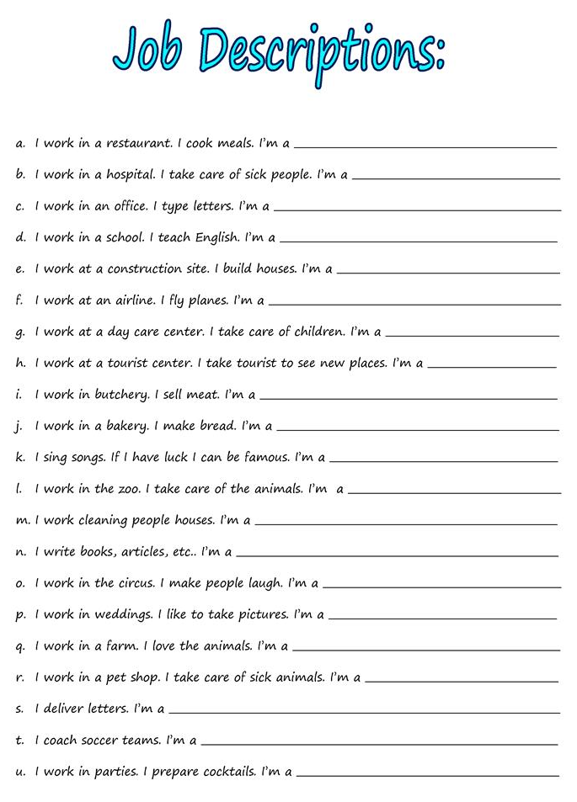

Answers:

Exercise I. Match the jobs to their definitions.
1. designs buildings | a. plumber
2. represents people with legal problems | b. mechanic
3. plans the buildings of roads, bridges, machines | c. electrician
4. controls the financial situation of people, companies | d. carpenter
5. teaches in a university | e. nanny
6. buys and sells stocks and shares | f. travel agent
7. installs and repairs water pipes, taps, baths, etc. | g. estate agent
8. repairs engines, especially in vehicles | h. importer
9. installs, connects or repair electrical wiring | i. priest
10. makes or repairs parts of a building and other objects made of wood | j. civil servant
11. takes care of / care for children in their own home | k. sales representative
12. makes travel arrangements for people | l. architect
13. buys and sells houses or land for people | m. lawyer
14. imports goods | n. engineer
15. performs religious ceremonies in some religions | o. accountant
16. works for the civil service | p. university lecturer
17. travels to different places and sells the products of a particular company | q. broker (stock market)
1. l 2. m 3. n 4. o 5. p 6. q 7. a 8. b 9. c 10. d 11. e 12. f 13. g 14. h 15. i 16. j 17. k

Exercise II. Are these sentences true or false?
1. An importer exports goods to sell. False
2. An estate agent sells holidays. True
3. A carpenter makes wooden objects. False
4. A civil servant works for a company. False
5. A priest conducts religious ceremonies. True
6. A mechanic can repair vehicles. True
7. An electrician fixes electrical wiring. True
8. A plumber can fix your central heating. True

Exercise III. Complete the words in the text.
I’ve just left university and I’m hoping to have a (1) career in the private (2) sector, and eventually I’d like to be in (3) management and have my own business. I had a couple of jobs in small companies in my holidays, so I have a little (4) experience. I’m hoping to work for a large company to start with: they do a lot of (5) training, and I’ll be able to get some extra (6) qualifications too. My father’s in the legal (7) profession but for some reason, he wants me to have some experience in the (8) military as a soldier. I’ve no idea why, though.

Exercise IV. Complete the sentences.
1. I haven’t got central heating; I need a plumber to install a new system.
2. Our travel agent made the arrangements, e.g. buying tickets, booking hotels.
3. The estate agent sold the land which belonged to the farm.
4. What products does that company make?
5. My sister does quite a lot training for the civil service.
6. I believe he imports silver jewellery from abroad.
7. A nanny takes care / cares for children.
8. Sales representatives / reps have to travel a lot.

Exercise V. Complete the sentences with the correct words from the box.
astronaut caretaker cashier chef diver driving instructor
engineer estate agent farmer lawyer lifeguard model
pilot speech therapist surgeon
1. Elana is very beautiful and slim. You've probably seen her wearing expensive clothes on the covers of magazines. She's a model.
2. Naomi is a speech therapist. She helps people who have problems speaking. Sometimes they've had an accident or an illness, and sometimes they were born with the problem.
3. Jo’s a farmer. He's got a lot of fruit trees and he also keeps sheep and cows.
4. Steve is a cashier in a bank. He loves counting money!
5. Tony looks after a big block of flats. He says being a caretaker is great because he gets his own free ﬂat with the job.
6. Sandra is always in her car. She's a driving instructor. Everyone she teaches passes their test first time.
7. Rose is a pilot. At the moment she flies a small plane from London to Paris three times a week.
8. Bob has the most unusual job. He’s an astronaut. His ambition is to set up a new space station.
9. Tom is an estate agent. He helps people to buy and sell houses and flats.
10. Katie is a chef in a big hotel. I’ve never eaten there but people say the food is amazing.
11. Alex repairs oil rigs underwater. He is a deep-sea diver.
12. Karen is a lawyer. She used to spend a lot of time in court but now she helps people sort out property and money when they get divorced.
13. Glenn is an engineer with a big telephone company. When people have problems with their phones, they call him.
14. I had to have an operation on my knee last year. My friend Luisa is a surgeon at the Fleming Hospital and she did it.
15. Ben loves the sea. He owns a surfing shop and also works as a lifeguard on a big beach in Cornwall. Last summer he saved a little boy from drowning.

Exercise VI. Complete the sentences according to the description.
