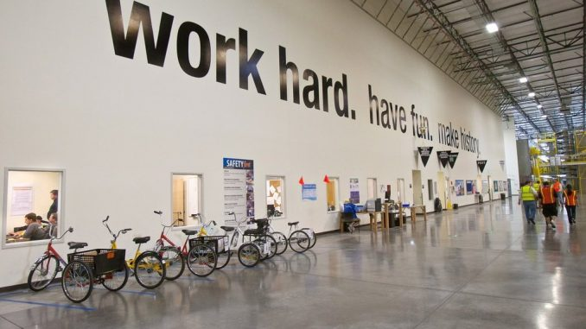

Quizlet:
https://quizlet.com/73066034/flashcards

I. Match the words and phrases to the definitions.
1. money that is earned from doing work or received from investments | a. salary
2. working at different times: days one week, nights the next | b. to work flexi-time
3. the money a retired person receives | c. wages
4. to work regular daytime hours | d. to run a business
5. money paid every month for work | e. fee
6. to manage or be responsible for a company | f. to have a nine-to-five job
7. extra money paid to employees e.g. as a reward for good work | g. income
8. to do routine work such as writing letters, filling in forms | h. to do paperwork
9. money paid per hour or per week of work | i. profit
10. to be able to start and finish work at different times each day | j. to do shift work
11. payment for professional services e.g. of a doctor or lawyer | k. bonus
12. money that is earned in trade or business after paying the costs of producing and selling goods and services | l. pension

II. Complete the sentences.
1. I often do work.
2. I belong to a union.
3. We went on last year.
4. Do you get an annual ?
5. Our working are good.
6. I often have to work time.
7. She two weeks off in summer.
8. Does he suffer from in his job?

III. Choose the correct word in each sentence.
1. Most people would prefer a job / work which was near home.
2. Every Friday, the building workers are given their salary / wages.
3. The manager told David t make an application / invitation for the job.
4. When he retired he received a monthly pension / reward.
5. Would you like to come into my bureau / office?
6. I’m in charge of / deal with all deliveries out of the factory.
7. I run / lead the coffee bar and restaurant in the museum.
8. I have to deal with / charge of any complaints.
9. Ann works in advertising and earns / wins a very high salary.
10. I have to run / attend a lot of meetings.

IV. Match the questions with the answers.
1. What do you do for a living? | a. Yes, if we are very busy.
2. How much do you earn? | b. Yes, up to six months’ full salary
3. Do you have to pay income tax? | c. £40,000 per year
4. How much holiday do you get? | d. Yes, I pay 40% a year to the government
5. Do you have to work overtime in your job? | e. I deal with overseas clients, mainly.
6. Do you get holiday pay? | f. 28 days.
7. Do you get sick pay? | g. I work for an international bank.
8. What does your job involve? | h. Yes, it’s included in my salary

V. Complete the sentences.
1. I work bank.
2. He always looks worried because he has such a job.
3. Everyone has the to a lunch break – it’s the law.
4. I don’t belong to a any longer.
5. Are you to sick pay in your job?
6. I often have to work nights, but I don’t really like work.
7. Bus drivers have a basic 35-hour week, but many of them work .
8. A lot of people get in addition to their salaries.
9. Some of the workers went on last year for higher pay.
10. I work Fiat.

VI. Answer the questions.
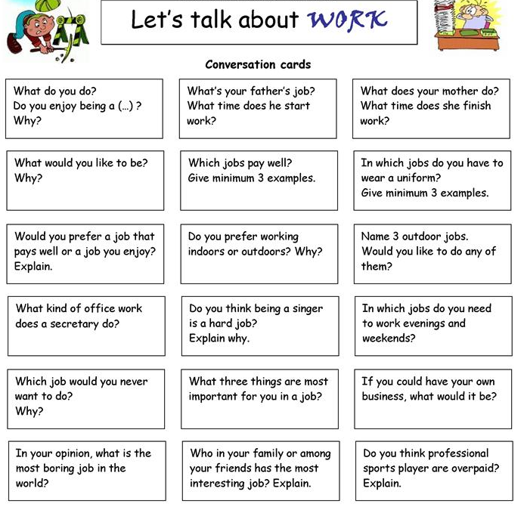
Answers:
I. Match the words and phrases to the definitions.
1. money that is earned from doing work or received from investments | a. salary
2. working at different times: days one week, nights the next | b. to work flexi-time
3. the money a retired person receives | c. wages
4. to work regular daytime hours | d. to run a business
5. money paid every month for work | e. fee
6. to manage or be responsible for a company | f. to have a nine-to-five job
7. extra money paid to employees e.g. as a reward for good work | g. income
8. to do routine work such as writing letters, filling in forms | h. to do paperwork
9. money paid per hour or per week of work | i. profit
10. to be able to start and finish work at different times each day | j. to do shift work
11. payment for professional services e.g. of a doctor or lawyer | k. bonus
12. money that is earned in trade or business after paying the costs of producing and selling goods and services | l. pension
1. g 2. j 3. l 4. f 5. a 6. d 7. k 8. h 9. c 10. b 11. e 12. i

II. Complete the sentences.
1. I often do work. shift
2. I belong to a union. trade
3. We went on last year. strike
4. Do you get an annual ? bonus
5. Our working are good. conditions
6. I often have to work time. over
7. She two weeks off in summer. takes
8. Does he suffer from in his job? stress

III. Choose the correct word in each sentence.
1. Most people would prefer a job / work which was near home.
2. Every Friday, the building workers are given their salary / wages.
3. The manager told David t make an application / invitation for the job.
4. When he retired he received a monthly pension / reward.
5. Would you like to come into my bureau / office?
6. I’m in charge of / deal with all deliveries out of the factory.
7. I run / lead the coffee bar and restaurant in the museum.
8. I have to deal with / charge of any complaints.
9. Ann works in advertising and earns / wins a very high salary.
10. I have to run / attend a lot of meetings.

IV. Match the questions with the answers.
1. What do you do for a living? | a. Yes, if we are very busy.
2. How much do you earn? | b. Yes, up to six months’ full salary
3. Do you have to pay income tax? | c. £40,000 per year
4. How much holiday do you get? | d. Yes, I pay 40% a year to the government
5. Do you have to work overtime in your job? | e. I deal with overseas clients, mainly.
6. Do you get holiday pay? | f. 28 days.
7. Do you get sick pay? | g. I work for an international bank.
8. What does your job involve? | h. Yes, it’s included in my salary
1. g 2. c 3. d 4. f 5. a 6. h 7. b 8. e

V. Complete the sentences.
1. I work bank. in
2. He always looks worried because he has such a job. stressful
3. Everyone has the to a lunch break – it’s the law. right
4. I don’t belong to a any longer. trade union
5. Are you to sick pay in your job? entitled
6. I often have to work nights, but I don’t really like work. shift
7. Bus drivers have a basic 35-hour week, but many of them work . overtime
8. A lot of people get in addition to their salaries. bonus
9. Some of the workers went on last year for higher pay. strike
10. I work Fiat. for

