Lesson 35 – Grammar - Questions in Indirect Speech
Read and remember
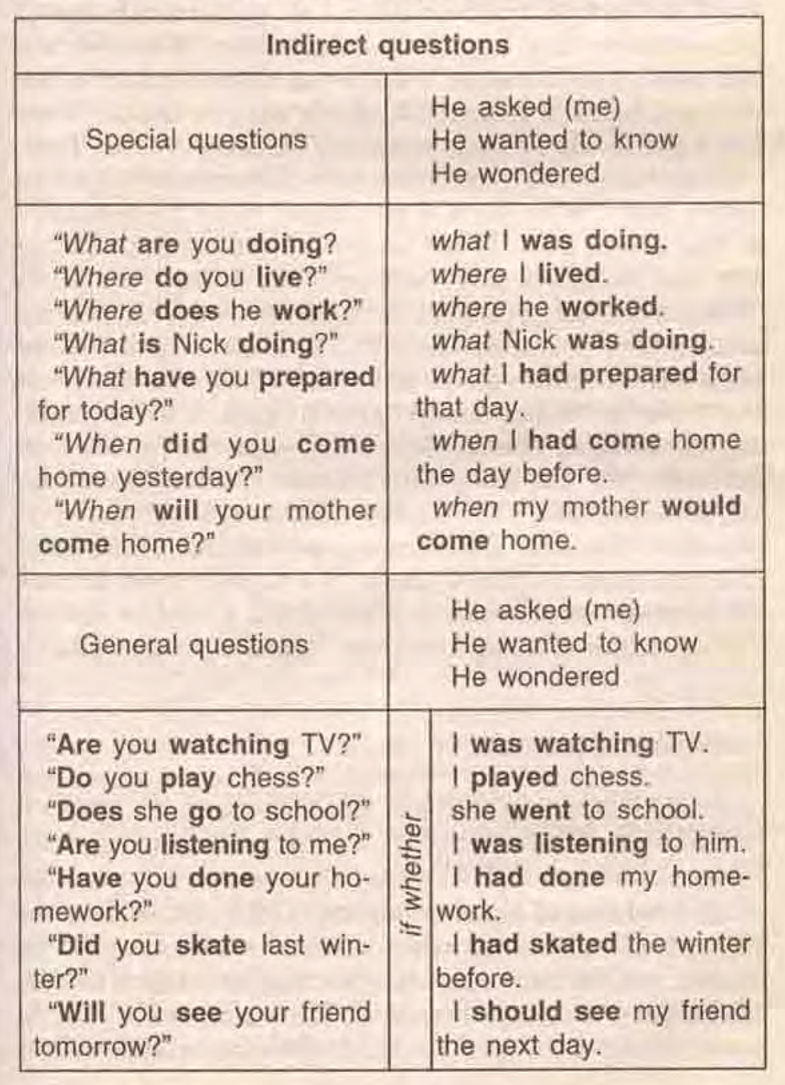

Exercise 1
Turn the following questions into questions in Indirect Speech.
- Christopher: "Do you want to dance?"
- Betty: "When did you come?"
- Mark: "Has John arrived?"
- Ronald: "Where does Maria park her car?"
- Elisabeth: "Did you watch the latest film?"
- Mandy: "Can I help you?"
- Andrew: "Will Mandy have lunch with Sue?"
- Justin: "What are you doing?"
- Frank: "How much pocket money does Lisa get?"
- Anne: "Must I do the shopping?"

Exercise 2

Turn special questions into questions in Indirect Speech. Start each sentence with the words listed in brackets.
1. Why did not he come to the yacht-club? (He didn’t tell
us...)
2. Where has she been? (We didn’t know...).
3. Do you often play basketball? (She asked me...).
4. Why doesn’t she come early? (He wanted to know...).
5. When will the next train leave? (We asked...).
6. What are you doing? (My friend asked me...).
7. How long have his parents worked for the company?
(They didn’t know...)
8. When did Jack phone me? (He wanted to know...)
9. How often does she visit them? (He asked me...).
10. Who borrowed him money? (She didn’t know...).
11. How many times have they seen this film? (He wondered...).
12. Why will not she come to the party? (He asked...).
13. What is the little boy playing with? (She wanted to
know...).
14. What will they be doing at 5 o’clock? (My friend
asked...).
15. What are your hobbies? (He asked me...).

Exercise 3
Choose the correct answer to complete the sentence.
- Did you meet each other at school?' He asked them …
  - ? if did they meet at school.
  - ? if they'd met at school.
  - ? had they met at school.
- 'Why are you wearing sunglasses?' She wondered …
  - ? why he was wearing sunglasses.
  - ? why was he wearing sunglasses.
  - ? if he was wearing sunglasses.
- 'Who else have you told?' They asked me …
  - ? who else we'd told.
  - ? if have we told.
  - ? who had we told else.
- 'Were you listening to me?' She asked us …
  - ? why we'd been listening to her.
  - ? whether we'd been listening to her.
  - ? if we were listening to her.
- 'How will you get to France?' I asked them …
  - ? how will they get to France.
  - ? how would they get to France.
  - ? how they would get to France.
- 'Had you already met him?' She asked me ...
  - ? whether had I already met him.
  - ? if I already met him.
  - ? if I'd already met him.
- 'What can we do about this?' We wanted to know …
  - ? whether we could do about it.
  - ? what we could do about it.
  - ? what could we do about it.
- 'Can I get you a coffee?' I offered ...
  - ? if I could get him a coffee.
  - ? getting him a coffee.
  - ? to get him a coffee.
- 'Where will you stay?' I asked her …
  - ? if she would stay.
  - ? where would she stay.
  - ? where she would stay.
- 'Have you eaten ALL the cake?' She asked me …
  - ? if had I eaten all the cake.
  - ? when I'd eaten all the cake.
  - ? if I'd eaten all the cake.
- 'How often do you use public transport?' She wanted to know …
  - ? how often I used public transport.
  - ? how I used often public transport.
  - ? how often did I use public transport.
- 'Did you see the parade?' She asked us …
  - ? where we'd seen the parade.
  - ? whether we'd seen the parade.
  - ? if did we see the parade.
- 'When had you last spoken?' I asked her ...
  - ? whether they had last spoken.
  - ? when they had last spoken.
  - ? when have they last spoken.
- 'What were you doing at the time?' She asked me …
  - ? what I'd been doing at the time.
  - ? what was I doing at the time.
  - ? what had I been doing at the time.
- 'Can she walk yet?' I wondered …
  - ? could she walk yet.
  - ? if can she walk yet.
  - ? if she could walk yet.
- 'What about having the party outside?' She suggested …
  - ? about having the party outside.
  - ? having the party outside.
  - ? to have the party outside.

Exercise 4
Turn special questions into questions in Indirect Speech.
1. I said: “Did you become a manager five years ago?
2. He asked me: “Does your sister study at school?”
3. She said: “Is he working on his report?”
4. Jack said: “Did you meet anybody at the party?”
5. Kate said to him: “Do you like modern art?”
6. Pat said to Nick: “Are you busy?”
7. Jane asked me: “Have you already found the keys?”
8. My friend said: “Have you already chosen a book to read?”
9. They asked us: “Are you tired?”
10. We asked: “Will you come to see us on Friday?”

Exercise 5

Restore Direct Speech in the following sentences.

1. She asked me if I liked Coke.
2. My friend asked me if he could borrow my car.
3. John wanted to know if that had not caused any problem.
4. She asked me if I would not mind about it.
5. They wanted to know where I was going.
6. Kate asked Mike whether he preferred eating at home
7. We wanted to know, when he would tell us the truth.
8. I asked her where her father was.
9. They wanted to know if the results of that experiment
were exciting.
10. Susan asked Ann when she would give her new telephone number.

Keys:
Exercise 1:
1.Christopher asked me if I wanted to dance.
2.Betty wanted to know when I had come.
3.Mark asked me if John had arrived.
4.Ronald asked me where Maria parked her car.
5.Elisabeth asked me if I had watched the latest film.
6.Mandy wanted to know if she could help me.
7.Andrew asked me if Mandy would have lunch with Sue.
8.Justin asked me what I was doing.
9.Frank wanted to know how much pocket money Lisa got.
10. Anne asked if she had to do the shopping.

Exercise 2:

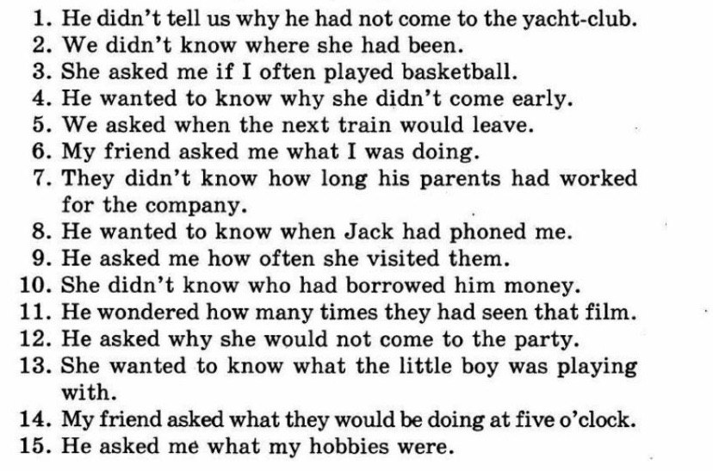

Exercise 3:
1.Did you meet each other at school?' He asked them …
if did they meet at school.
if they'd met at school.
had they met at school.

2.'Why are you wearing sunglasses?' She wondered …

why he was wearing sunglasses.
why was he wearing sunglasses.
if he was wearing sunglasses.
3. 'Who else have you told?' They asked me …

who else we'd told.
if have we told.
who had we told else.

4. 'Were you listening to me?' She asked us …

why we'd been listening to her.
whether we'd been listening to her.
if we were listening to her.

5. 'How will you get to France?' I asked them …

how will they get to France.
how would they get to France.
how they would get to France.

6. 'Had you already met him?' She asked me ...

whether had I already met him.
if I already met him.
if I'd already met him.

7. 'What can we do about this?' We wanted to know …

whether we could do about it.
what we could do about it.
what could we do about it.

8. 'Can I get you a coffee?' I offered ...

if I could get him a coffee.
getting him a coffee.
to get him a coffee.
9.'Where will you stay?' I asked her …

if she would stay.
where would she stay.
where she would stay.
10. 'Have you eaten ALL the cake?' She asked me …

if had I eaten all the cake.
when I'd eaten all the cake.
if I'd eaten all the cake.

11. 'How often do you use public transport?' She wanted to know …

how often I used public transport.
how I used often public transport.
how often did I use public transport.

12. 'Did you see the parade?' She asked us …

where we'd seen the parade.
whether we'd seen the parade.
if did we see the parade.

13.
'When had you last spoken?' I asked her ...

whether they had last spoken.
when they had last spoken.
when have they last spoken.

14. 'What were you doing at the time?' She asked me …

what I'd been doing at the time.
what was I doing at the time.
what had I been doing at the time.

15. 'Can she walk yet?' I wondered …

could she walk yet.
if can she walk yet.
if she could walk yet.

16. 'What about having the party outside?' She suggested …

about having the party outside.
having the party outside.
to have the party outside.

Exercise 4:

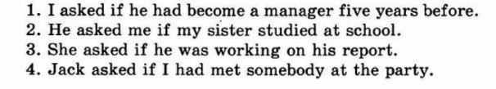
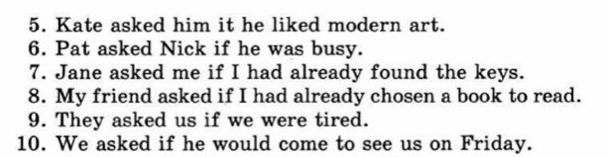

Exercise 5:
