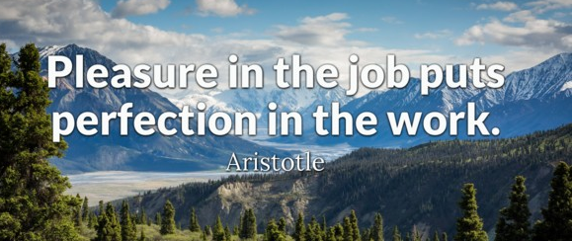
intermediate_lesson_35_working_conditions_and_pay_reading_part_3

Exercise 1
Read the text and choose the correct answers afterwards

JOB DESCRIPTION
Positions: PART-TIME LIBRARY ASSISTANT
Duties and Responsibilities:
- Lending books to customers
- Helping people find books
- Answering telephone calls
- Replying to emails
Days of work: Monday, Tuesday, Thursday
Hours of work: 9 a.m. to 5 p.m.

Answer the questions
- This text is:
- An application form
- A letter
- A job description

- This text has been written to:
- Say yes to a job offer
- Offer someone a job
- Tell people about a job

- The job is full-time.
- True
- False

- Which of these working conditions is not mentioned?
- working hours
- position
- salary

- Which of these conditions is correct?
- The potential employee must be fit
- This position requires communicative skills
- There might be business trips abroad

Exercise 2
Choose the correct answer
- An employer is…
- A person who does paid work
- A person who does unpaid work
- A person or a company who pays people to work for them

- Promotion is..
- When someone quits their job to work somewhere else
- When someone gets a better job
- When someone is moved to a less paid job

- Working part-time means:
- Being unemployed
- Working the whole day
- Working only several hours a day

- What is wages?
- Money paid for month`s work
- Money paid per hour, day or week

- A person who has the same responsibilities as you do is..
- An employer
- A colleague
- An unemployed
Exercise 3
Read the passages and choose TRUE or FALSE

Special Clothing (Uniforms)
Many employees in the restaurant and food service industry are required to wear uniforms when they are at work. If you must wear a uniform or a specific brand of clothing, the employer must provide, clean, and maintain it. For example, many cooks must wear white jackets and hats and checked trousers. Your employer must buy the uniform. You cannot be charged for the uniform or for damages to it. Your employer cannot require you to pay a deposit for the uniform or withhold your wages.
- An employee has to buy a uniform.
- True
- False
- If an employee has damaged a uniform the money is withhold from the wages.
- True
- False
Shift changes
In the food service industry, work schedules are often developed with different start and end times for different employees. A restaurant may be unexpectedly busy on a day that is normally quiet. Employees must be given 24 hours’ notice of a change in shift. If the employee has not been given the required notice, he or she cannot be penalized for failing to show up for work.
- An employer must inform an employee about shift changes in advance
- True b) False

Overtime
The standard work day is eight hours and the standard work week is 40 hours. If employees work over eight hours in a day or over 40 hours in a week, they must be paid overtime. In addition, the hours worked should not be excessive to the employee’s health or safety.
- The standard work day is..
- 10 hours
- 9 hours
- 8 hours
- The money paid for extra working hours is called..
- Overmoney
- Overtime
- Extra wages

Exercise 4
Watch the video and answer the questions
https://www.youtube.com/watch?v=PCs8aNV2FuI

- What professions did you see in the video?
- What were these employees doing?
- What are the dangerous working conditions shown in the video? Why are they harmful?
- What are the benefits of these jobs to the society?

