Quizlet:
https://quizlet.com/141597114/flashcards

I. Is the meaning the same or different? Choose Same or Different.
1. a challenge / a reward
2. out of work / unemployed
3. be promoted / be appointed
4. get the sack / sack someone
5. fire someone / dismiss someone
6. prospects / chances of success
7. hand in your notice / resign
8. be sacked / be promoted
9. transfer somebody / move somebody to another office
10. make someone redundant / fire someone

II. Complete the sentences with a single word.
1. I was glad Io be to the job I have. (chosen for the job)
2. My job's very . (difficult but interesting)
3. I want to transfer to another . (section of the business)
4. I have good in my job. (chances of success)
5. I'd really love to be . (given a better job In the company)
6. I’m bored at work, so I’m going to look .(in another place)
7. I’ve never been . (out of work)
8. I’d hate to have to someone. (dismiss)
9. If I hated my job, I would definitely . (hand in my notice)

III. Complete each sentence with a suitable ending.
1. If you work hard, the company will give you | a) qualifications for a job of this kind.
2. In different job I could get higher | b) advertisement in the local press on Friday.
3.The best way to find new staff is to put a/an | c) application for the job as soon as possible.
4. Because he had stolen the money, we decided that | d) promotion to a more responsible position.
5. She has a pleasant personality but hasn’t got the right | e)references from your previous employer.
6. In the meeting we are going to discuss the | f) dismissing him was the only possible action we could take.
7. I think it would be a good idea to send in your | g)salary and better conditions of employment
8. We cannot give you the job without | h)appointment of a new sales representative.

IV. Choose the correct answer.
1. We threw a big party for my father when he __________ after 35 years in the company.
a) hired an employee
b) laid off
c) retired
2. "Good news - I __________!"
"Congratulations!"
a) got a raise
b) was fired
c) got demoted
3. The employee with the best work will ___________.
a) get laid off
b) get a boss
c) get a bonus
4. A lot of people ________________ during the global financial crisis.
a) got promotions
b) were laid off
c) earned a salary
5. After six months looking for a job, she was finally ________ by the country's biggest TV station.
a) hired
b) fired
c) retired
6. I __________ because I didn't like working such long hours.
a) got a raise
b) quit my job
c) fired my colleague
7. I get along well with all of my __________. They're great to work with.
a) employers
b) colleagues
c) retires
8. You need to get approval from the _________ before signing that contract.
a) resign
b) pay raise
c) supervisor
9. I'm ______-employed; I do freelance web design.
a) auto
b) owner
c) self
10. Helping kids learn to read is very ___________ because it's a skill they'll use for the rest of their lives.
a) demanding
b) rewarding
c) repetitive

V. Complete the text.
promoted challenging department out of work appointed prospects reward transferred got the sack made redundant
handed in his notice
Two years ago, I got a (1) job with good (2) in local radio. I worked hard and, as a (3) , I was (4) . I was delighted. I was quickly (5) to a different (6) . Then things went wrong: one colleague (7) , and
another (8) . After that, ten people were (9) . I didn’t want
to be (10) , so I decided to look elsewhere. I applied for a job in TV and was(11) assistant director. Amazing!

VI. Find the logical answer on the right for each of questions on the left.
1.Why did they sack him? | a. Because he was nearly 65.
2. Why did they promote him? | b. Because he was late for work every day.
3. Why did he apply for the job? | c. Because he needed more training.
4. Why did he retire? | d. Because he was out of work.
5. Why did he resign? | e. Because he was the best person in the department.
6. Why did he go on the course? | f. Because he didn’t like his boss.

VII. Complete the sentences with the words WORK, JOB or CAREER.
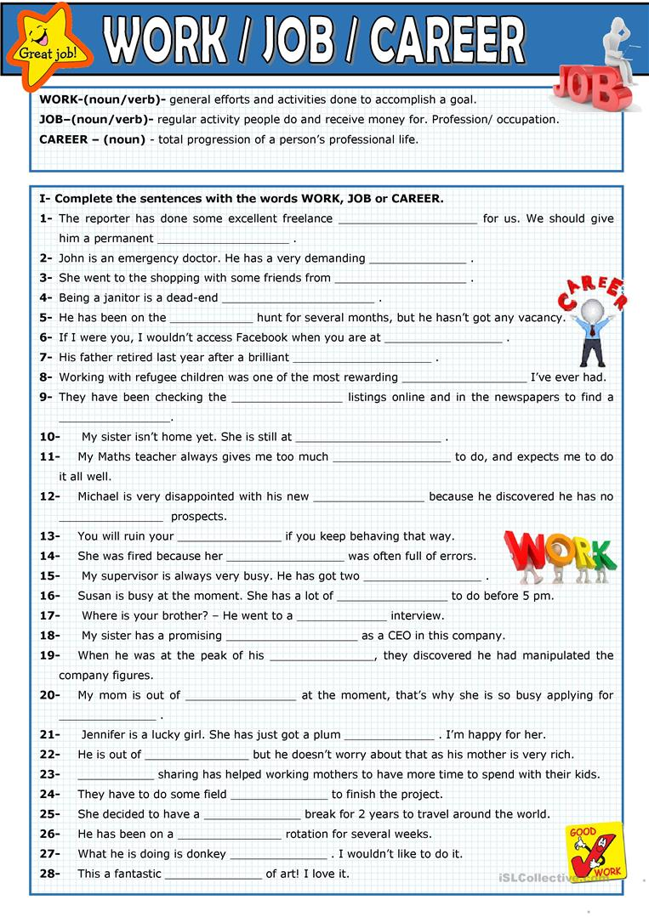

Answers:
I. Is the meaning the same or different? Choose S or D.
1. a challenge / a reward Different
2. out of work / unemployed Same
3. be promoted / be appointed Different
4. get the sack / sack someone Different
5. fire someone / dismiss someone Same
6. prospects / chances of success Same
7. hand in your notice / resign Same
8. be sacked / be promoted Different
9. transfer somebody / move somebody to another office Same
10. make someone redundant / fire someone Different

II. Complete the sentences with a single word.
1. I was glad Io be appointed to the job I have. (chosen for the job)
2. My job's very challenging. (difficult but interesting)
3. I want to transfer to another department. (section of the business)
4. I have good prospects in my job. (chances of success)
5. I'd really love to be promoted. (given a better job In the company)
6. I’m bored at work, so I’m going to look elsewhere.(in another place)
7. I’ve never been unemployed. (out of work)
8. I’d hate to have to sack/fire someone. (dismiss)
9. If I hated my job, I would definitely resign/quit. (hand in my notice)

III. Complete each sentence with a suitable ending.
1. If you work hard, the company will give you | a) qualifications for a job of this kind.
2. In different job I could get higher | b) advertisement in the local press on Friday.
3.The best way to find new staff is to put a/an | c) application for the job as soon as possible.
4. Because he had stolen the money, we decided that | d) promotion to a more responsible position.
5. She has a pleasant personality but hasn’t got the right | e)references from your previous employer.
6. In the meeting we are going to discuss the | f) dismissing him was the only possible action we could take.
7. I think it would be a good idea to send in your | g)salary and better conditions of employment
8. We cannot give you the job without | h)appointment of a new sales representative.
1. e 2. c 3. g 4. a 5. h 6. d 7. b 8. f

IV. Choose the correct answer.
1. We threw a big party for my father when he __________ after 35 years in the company.
a) hired an employee
b) laid off
c) retired
2. "Good news - I __________!"
"Congratulations!"
a) got a raise
b) was fired
c) got demoted
3. The employee with the best work will ___________.
a) get laid off
b) get a boss
c) get a bonus
4. A lot of people ________________ during the global financial crisis.
a) got promotions
b) were laid off
c) earned a salary
5. After six months looking for a job, she was finally ________ by the country's biggest TV station.
a) hired
b) fired
c) retired
6. I __________ because I didn't like working such long hours.
a) got a raise
b) quit my job
c) fired my colleague
7. I get along well with all of my __________. They're great to work with.
a) employers
b) colleagues
c) retires
8. You need to get approval from the _________ before signing that contract.
a) resign
b) pay raise
c) supervisor
9. I'm ______-employed; I do freelance web design.
a) auto
b) owner
c) self
10. Helping kids learn to read is very ___________ because it's a skill they'll use for the rest of their lives.
a) demanding
b) rewarding
c) repetitive

V. Complete the text.
promoted challenging department out of work appointed prospects reward transferred got the sack made redundant
handed in his notice
Two years ago, I got a challenging job with good prospects in local radio. I worked hard and, as a reward, I was promoted. I was delighted. I was quickly transferred to a different department. Then things went wrong: one colleague got the sack, and another handed in his notice. After that, ten people were made redundant. I didn’t want to be out of work, so I decided to look elsewhere. I applied for a job in TV and was appointed assistant director. Amazing!

VI. Find the logical answer on the right for each of questions on the left.
1.Why did they sack him? | a. Because he was nearly 65.
2. Why did they promote him? | b. Because he was late for work every day.
3. Why did he apply for the job? | c. Because he needed more training.
4. Why did he retire? | d. Because he was out of work.
5. Why did he resign? | e. Because he was the best person in the department.
6. Why did he go on the course? | f. Because he didn’t like his boss.
1. b 2. e 3. d 4. a 5. f 6. c

VII. Complete the sentences with the words WORK, JOB or CAREER.
