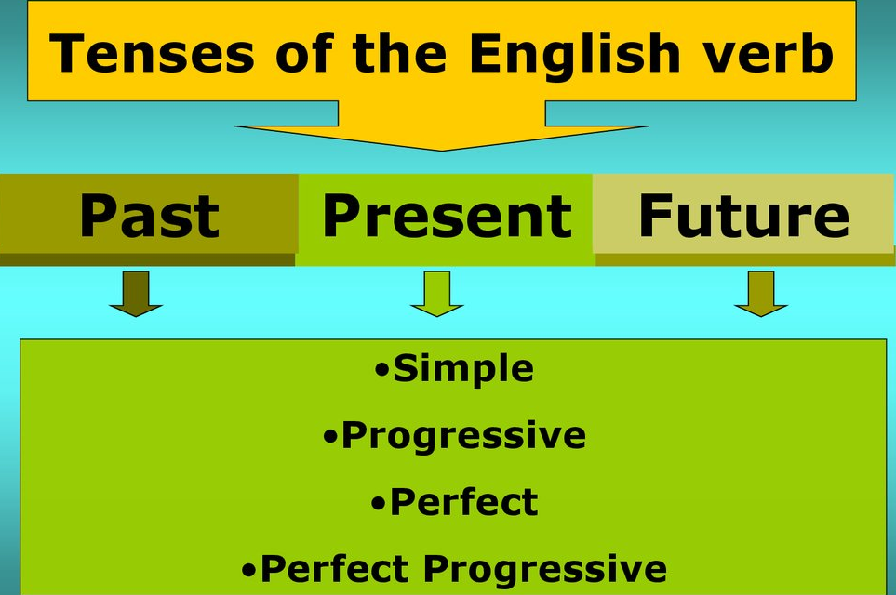
intermediate_lesson_81_active_tenses_part_2

Exercise 1
Put the verbs into the correct form of Past Simple, Past Perfect or Past Continuous

1) When he (to leave) the house, Peter (to forget) that he ( to put) his passport and wallet in his other jacket.
2) A few days before leaving for his summer holiday, Peter ( to phone) the airport to check his flight.
3) While Peter ( to pack) his suitcase, he ( to realize) that he ( not to check) his flight.
4) While Peter (to pack) his suitcase, the phone ( to ring).
5) I suddenly (to remember) that I ( to forget) my keys.
6) While Diana ( to watch) her favorite program, there was a power-cut.
7) Who ( to drive) the car at the time of the accident?
8) By the time Sheila got back, Chris ( to go).
9) David (to eat) Japanese food before, so he knew what to order.
10) I (to do) some shopping yesterday, when I saw that friend of yours.
11) What exactly ( to do) you when I came into your office yesterday?
12) While I (to try) to get my car started, a passing car (to stop) and the driver (to offer) to help me.
13) The police (to pay) no attention to Clare's complaint because she (to phone) them so many times before.
14 ) Mary (not wear) her glasses at the time, so she (not notice)
what kind of car the man (to drive).
15) Tony (to admit) that he (to hit) the other car, but said that he (not damage) it.

Exercise 2
Correct the mistakes in the sentences

1) Sorry, I didn`t listen to you. I had thought about something else.
2) Helen feel very tired, and when she will finishes her work, she will sleep.
3) The police gotten to Clare's house as fast as they could, but the burglars disappeared.
4) I phone you last night but you not answered. What was you doing ?
5) We not went out yesterday because it rained.
6) I was seeing you yesterday when you went home.

Exercise 3
Choose the correct answer

1) ________my bag anywhere? I can't find it. a) Did you see b) Have you seen
2) Larry ________ his novel for the last two years. a) is writing b)has been writing c) has written
3) From the minute he got up this morning Gary ________ silly questions! a) asked b) has asked c) has been asking
4) Sorry, could you say that again? I ______ to you. a) didn't listen b) haven't listened c) wasn`t listening
5) The police think that they _____ your wallet, so call this number. a) found b) have found
6) _________ my sister before? a) Did you meet b) Have you met
7) Sее you in thе morning _______ now. a) I leаve b) I` m leаviпg
8) Whаt _______ this еvеning? I`m rеally hungтy! a) do we eаt b) аre we eаting
9) Сhеmistry is hard. I _______ . a) doп`t uпderstand it b) am not understanding
10) How ________ yеstеrday aftеrnoon? a) did you felt b) did уou feel
11) Don`t worry about the сat. It _____ onсе a daу. A) is eating b) eats c) eat
12) I сan`t work out thе answеr. __________ what it is? A) Are you knowing b) Do you know

Exercise 4
Describe the pictures using the tenses in brackets
(Present Perfect Continuous)

(Present Simple)

(Past Simple+Past Perfect)

(Past Continuous)

( Present Perfect)

( Future Continuous)

