083_intermediate_grammar
Passive Voice
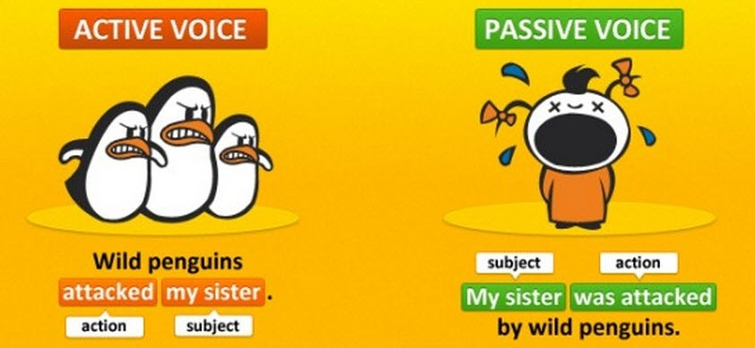
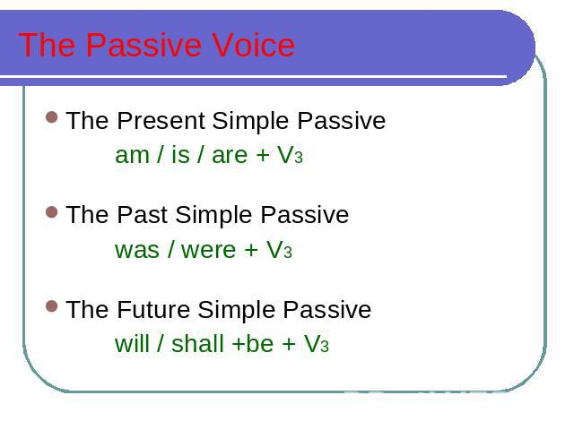
Exercise 1
Translate the following word combinations into English using Present, Past or Future Simple Passive.
Мне рассказали - Мне рассказывают - Мне расскажут
Мне показали - Мне показывают - Мне покажут
Ее привели - Ее приводят - Ее приведут
Нас спросили - Нас спрашивают - Нас спросят
Нам ответили - Нам отвечают - Нам ответят
Нас послали - Нас посылают - Нас пошлют
Им дали - Им дают - Им дадут
Ему помогли Ему помогают - Ему помогут
Ему посоветовали - Ему советуют - Ему посоветуют
Его забыли - Его забывают - Его забудут
Его вспомнили - Его вспоминают - Его вспомнят
Нас пригласили - Нас приглашают - Нас пригласят
Нас поправили - Нас поправляют - Нас поправят
Его позвали - Его зовут - Его позовут
Exercise 2
Open up the brackets using Present, Past or Future Simple Passive.
1. My question (to answer) yesterday.
2. Hockey (to play) in winter.
3. Mushrooms (to gather) in fall.
4. Many houses (to burn) during the Great Fire of London.
5. His new book (to finish) next year.
6. Flowers (to sell) in shops and in the streets.
7. St. Petersburg (to found) in 1703.
8. Bread (to eat) every day.
9. The letter (to receive) yesterday.
10. Nick (to send) to Kiev next week.
11. I (to ask) at the lesson yesterday.
12. I (to give) a very interesting book at the library last Friday.
13. Many houses (to build) in our town every year.
14. This work (to do) tomorrow.
15. This text (to translate) at the last lesson.
16. These trees (to plant) last fall.

Exercise 3
Rewrite the following sentences using Passive Voice.
1. The doctor prescribed her new medicine.
2. They often speak about him.
3. Everybody laughed at this funny animal.
5. We will insist on strict discipline.
6. They teach three foreign languages at this school.
7. We received this letter after his departure.
9. Bees gather honey from flowers.
10. The storm drove the ship against a rock.

Exercise 4
Choose the right answer
- We ... by a loud noise during the night.
woke up
are woken up
were woken up
were waking up
- A new supermarket is going to ... next year.
build
be built
be building
building
- ‘Where ...?’ ‘In London’.
were you born
are you born
have you been born
did you born
- There was a fight at the party, but nobody ... .
was hurt
were hurt
hurt
- Jane ... to phone me last night, but she didn’t.
supposed
is supposed
was supposed
- ... during the storm.
They were collapsed the fence
The fence was collapsed
They collapsed the fence
The fence collapsed
- ... chair the meeting.
John was decided to
There was decided that John should
It was decided that John should
John had been decided to
- This car is not going ... in the race.
to drive
to be drive
to driven
to be driven
- Will these clothes ... by Saturday?
make
made
be make
be made
- When a student I ... to the discos every Friday night.
used to go
are used to go
use to go
were used to go
- Neither Jim nor Jack ... there.
was invited
was been invited
were invited
were been invited
- After the volcanic eruption of 1957 the railway station ... .
destroyed completely
was completely destroyed
has been destroyed
has destroyed

