083_intermediate_grammar
Passive Voice
Keys
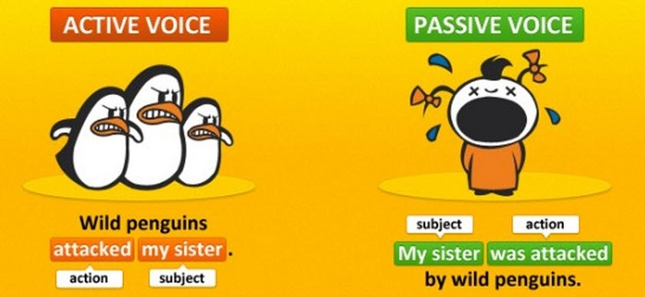
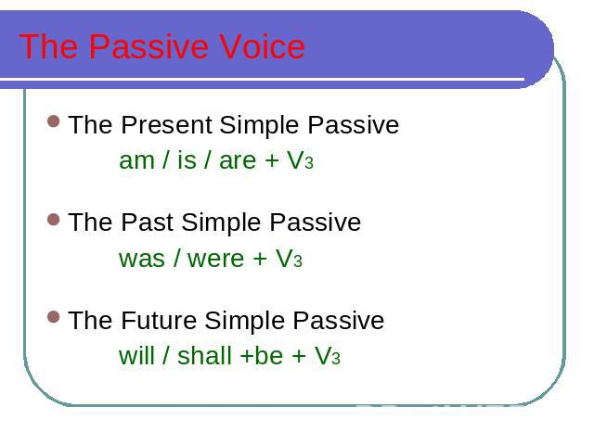
Exercise 1
Translate the following word combinations into English using Present, Past or Future Simple Passive.
I was told –I am told-I will be told
I was shown-I am shown-I will be shown
She was brought-she is brought-she will be brought
We were asked-we are asked-we will be asked
We were answered-we are answered-we will be answered
We were sent-we are sent-we will be sent
They were given-they are given-they will be given
He was helped-he is helped-he will be helped
He was advised-he is advised-he will be advised
He was forgotten-he is forgotten-he will be forgotten
He was remembered-he is remembered-he will be remembered
We were invited-we are invited-we will be invited
We were corrected-we are corrected-we will be corrected
He was called-he is called-he will be called
Exercise 2
Open up the brackets using Present, Past or Future Simple Passive.
1. My question was answered yesterday.
2. Hockey is played in winter.
3. Mushrooms are gathered in fall.
4. Many houses were burnt during the Great Fire of London.
5. His new book will be finished next year.
6. Flowers are sold in shops and in the streets.
7. St. Petersburg was founded in 1703.
8. Bread is eaten every day.
9. The letter was received yesterday.
10. Nick will be sent to Kiev next week.
11. I was asked at the lesson yesterday.
12. I was given a very interesting book at the library last Friday.
13. Many houses are built in our town every year.
14. This work will be done tomorrow.
15. This text was translated at the last lesson.
16. These trees were planted last fall.

Exercise 3
Rewrite the following sentences using Passive Voice.
1. The new medicine was prescribed by the doctor to her.
2. He is often spoken about.
3. This funny animal was laughed at by everybody.
4. Strict discipline will be insisted on.
5. Three foreign languages are taught at this school.
6. This letter was received by us after his departure.
7. The honey is gathered by the bees from the flowers.
8. The ship was driven against a rock by the storm.

Exercise 4
Choose the right answer
- We ... by a loud noise during the night.
woke up
are woken up
were woken up
were waking up
- A new supermarket is going to ... next year.
build
be built
be building
building
- ‘Where ...?’ ‘In London’.
were you born
are you born
have you been born
did you born
- There was a fight at the party, but nobody ... .
was hurt
were hurt
hurt
- Jane ... to phone me last night, but she didn’t.
supposed
is supposed
was supposed
- ... during the storm.
They were collapsed the fence
The fence was collapsed
They collapsed the fence
The fence collapsed
- ... chair the meeting.
John was decided to
There was decided that John should
It was decided that John should
John had been decided to
- This car is not going ... in the race.
to drive
to be drive
to driven
to be driven
- Will these clothes ... by Saturday?
make
made
be make
be made
- When a student I ... to the discos every Friday night.
used to go
are used to go
use to go
were used to go
- Neither Jim nor Jack ... there.
was invited
was been invited
were invited
were been invited
- After the volcanic eruption of 1957 the railway station ... .
destroyed completely
was completely destroyed
has been destroyed
has destroyed

