084_intermediate_grammar
Passive Voice
Keys
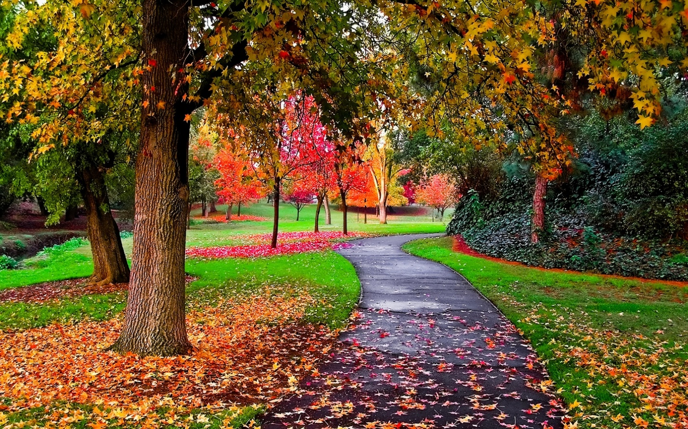
Exercise 1
Transform the following sentences into Passive
1. A lot of money was stolen from the shop.
2. By six o'clock the work had been finished.
3. At twelve o'clock the trucks were being loaded.
4. By three o'clock the trucks had been loaded.
5. Our daughter is sent to rest in the south every year.
6. This film will be shown on TV.
7. A new concert hall is being built in our street.
8. Potatoes were bought yesterday.
9. The books will be brought tomorrow.
10. The clock is being repaired now.

Exercise 2
Transform the following sentences into Passive
1. Milk is sold in this shop.
2. The whole text has been translated..
3. The window was broken last week.
4. When I came home, the sweets had been eaten.
5. The work will be done in the evening.
6. This book was written in the 19th century.
7. Tennis was being played from four till five.
8. The number of important experiments have been made in this laboratory.
9. Central Africa was explored by Livingstone in the 19th century.
10. By the middle of fall all the trees had been planted

Exercise 3
Put the words in the correct order
1. Have all these books been read?
2. Whom were these letters written by?
3. The letter has just been typed.
4. Sue showed me the picture which had been painted by her husband.
5. I will not be allowed to go there.
6. He has been told everything, so he knows what to do now.
7. All the questions must be answered.
8. The door has been left open.
Exercise 4
Fill in the gaps.
1. were made.
2. had been received.
3. have just been introduced.
4. will be taken, will be brought.
5. will be asked.
6. was much spoken.
7. was expected.
8. would be opened.
9. is (being) sold.
10. were looked, was found.

Exercise 5
Choose the correct answer
- Yesterday we ... to the party by our friends.
are invited
were invited
invite
- Our house ... now.
is being repaired
is been repaired
has being repaired
- The message ... by e-mail tomorrow by 10 oclock.
will be sent
will have been sent
will be sended
- Nick ... to be a very interesting person.
has been known
is known
is been known
- Our school conferences ... once a year.
were held
are being held
are held
- Your results ... and found correct.
have been studied
has being stidied
were studied
- This book ... by October 15.
would been published
will have been published
will been published
- He ... in a small Ukrainian village not far from the sea.
was born
am born
has been born
- All the participants of the conference ... about the time-table.
should have been told
should be told
should been told
- All tasty things ... at once. There is nothing on the plates.
have been eaten
has being eaten
were eaten
- My suitcase ... when my friends came to see me off.
was already being packed
had already been packed
was packed
- The text ... translated.
was already
is already
has already been

