Lesson 7

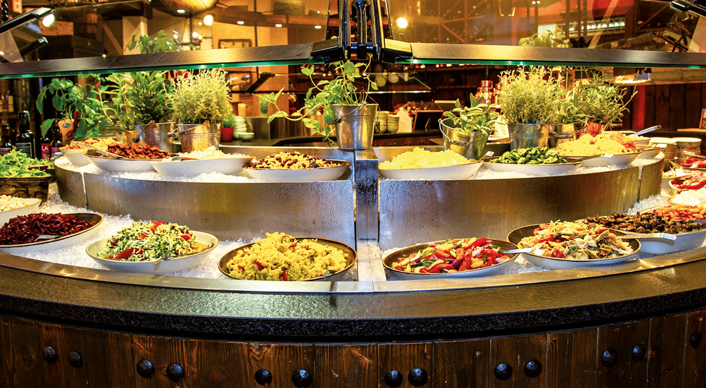

Ex. 1 Put the following items in the correct categories below.

https://learningapps.org/display?v=p5q4yo04k20

Ex. 2 Study the following words. You will see them in the text
https://quizlet.com/496407942/reading-lesson-flash-cards/?new

Ex. 3 Read the text

Diners believe that a meal is tastier if they pay more for it, say researchers
Taste, the sense of overeating and guilty feelings can be controlled by the price of food

People expensive food find that if is tastier than the same meal offered at a lower price, a Cornell University study found. The researchers concluded that price can manipulate our taste and how we feel about eating.
The study looked at the eating habits of 139 people in an Italian restaurant. The price of the food was set by the researchers at either $4 of $8 for the all-you-can-eat meal.
The people who paid $8 for the food enjoyed their meal 11 per cent more than people who ate from the cheaper buffet, although both ate the same amount of food. Participants who ate from the cheaper buffet did not enjoy their meal as much. They reported frequent feelings of overeating and felt guilty about filling their plates.

«It’s very interesting that pricing has little impact on how much we eat, but a big impact on how you feel,» said Brian Wansink, a professor at the Dyson School of Applied Economics and Management. «Simply reducing the price of food at a restaurant changes how customers evaluate and appreciate the food.»
He added: «If you want to eat a buffet, the best thing to do is eat most expensive buffet that you can afford. You won’t eat more, but you’ll have better experience.“
In another experiment, scientists found that people who eat in darker places consume 175 less calories than people who eat in bright areas.
Wansink said the study was „an example of how a really small change can transform a person interacts with food.“

Ex. 4 Decide if the statements below are true or false.

1. Food is usually tastier if it is more expensive.
2. People eat more food if it is cheaper.
3. People feel that they are overeating if food is more expensive.
4. It is better to eat from more expensive buffet.
5. People consume more calories if they eat in the dark places.

Ex. 5

Match the word with its definition

diner guilty impact consume
overeat manipulate appreciate

1. ashamed because you have done something wrong
2. control or influence someone in a clever way
3. customers in a restaurant
4. eat more food than your body needs
5. eat or drink
6. effect, influence
7. valued or recognised the quality of something

Ex 6. Fill in the gaps with suitable words
diner guilty impact consume
overeat manipulate appreciate

1. At lunchtime, the restaurant is usually full of(diners)
2. When food is free, it’s very easy to(overeat)
3. Julia ate too much chocolate at the party. She felt very(guilty)later.
4. Kate knows how to(manipulate)her parents to get what she wants.
5. The bad economic situation will have a negative (impact) on small businesses.
6. The food at the restaurant was fantastic. The customers really (appreciated) it.
7. It’s unhealthy to (consume) less than 500 calories a day.

Ex. 7 Answer the questions.
1. Do you often eat out? If yes, what kind of restaurants do you prefer?
2. When was the last time when you really enjoyed your meal? Where was it and what did you have?
3. Do you know what all-you-can-eat buffet is? Have you eaten there?
4. Do you agree with the idea of the text?

