Lesson 19, Reading, PI
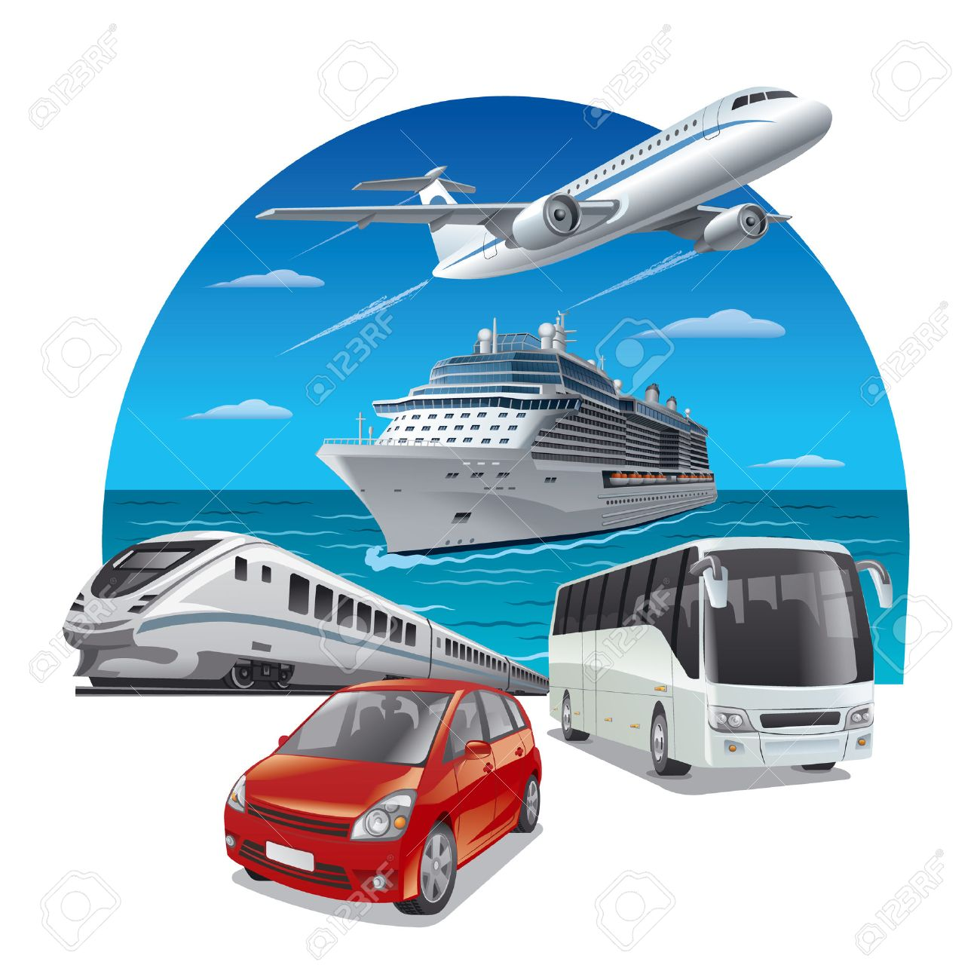
Exercise 1
Look at the words and then do the task.
https://quizlet.com/493499163/lesson-19-reading-pre-intermediate-exercise-1-flash-cards/?new

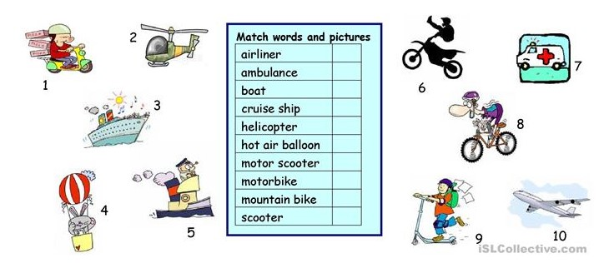

Exercise 2
Look at the words and translate them.
https://quizlet.com/492753110/lesson-19-reading-pre-intermediate-exercise-2-flash-cards/

Exercise 3
Read the text and answer the following questions.
Henry Ford
Henry Ford was born in 1863 in the state of Michigan. He grew up on a farm but he did not want to become a farmer. He left school when he was sixteen. He wanted to make cars so he went to work as a mechanic.
In 1896 Ford built his first car. This car was very different from the cars of today. For example, its wheels were bicycle wheels.
In 1902 Ford built a car that won an important race. This car was the fastest car that had ever been built. It went seventy miles per hour. By then Ford had enough money to start the Ford Motor Company.
At this time cars cost a lot of money. Only very rich people bought cars. Ford had a dream. He wanted to build a car that many people could afford. Ford was sure that, if people could afford cars, they would buy them. He said, "everybody wants to be somewhere he isn't."
Ford's plan was to make all his cars the same. Cars that are all the same take less time and less money to make. Then Ford could charge less money for these cars. In 1908 Ford produced his famous Model T Ford. The Model T sold for $850. This was much cheaper than other cars but still more than most people could pay.
One day Ford visited a meat-packing factory. There he saw beef carcasses being moved from one worker to another. Each worker had particular job to do when the beef carcasses reached him. Ford realized that he could use this assembly line method to build cars.
It took less than two hours to build a car on the assembly line. Before, it took fourteen hours. Ford was able to drop the price of the Model T to $265.
Ford's dream had come true. The Model T was now a car that many people could afford. By 1927, when Ford stopped making the Model T, over 15 million of these cars had been sold.

QUESTIONS
1. At what age did Ford finish his education?
a. When he was 18 years old.
b. When he was 16 years old.
c. When he was 15 years old.
2. Did Henry Ford want to continue a family business?
a. Yes, it was his dream.
b. No, he had another plans.
c. It wasn’t so important for him.
3. Why was 1896 so important for Ford?
a. He finished school.
b. He opened his company.
c. He built his first car.
4. Where did Ford get money for opening his own company?
a. He got inheritance.
b. He worked very hard and earned it.
c. His car won the race.
5. What was Ford’s main goal about car company?
a. To make cheap cars
b. To make the fastest cars
c. To make the most expensive cars
6. Where did Ford find a new technology for building cars?
a. At a meat-packing factory
b. In a shop
c. At a car race
7. What is the synonym for the word ‘particular’ (paragraph 6)?
a. Usual
b. Special
c. Unexpected
d. Ordinary

Exercise 4
Look at the words and translate them.
https://quizlet.com/493479122/lesson-19-reading-pre-intermediate-exercise-4-flash-cards/
Exercise 5
Choose the correct meaning for the following signs.
1. High speed trains pass platform without stopping
Please stand behind the yellow line

The notice tells passengers...
a) where to catch the fast train.
b) to stay away from fast trains.
c) about a change to the train service.

2. ↑ Way Out & Lifts
← Waiting Room & Toilets
Left Luggage →
Turn right if you...
a) want to leave the station.
b) are waiting for a train.
c) want to store your bag.

3. When ticket office is closed please use ticket machine.
Passengers travelling without a ticket may receive a fine.
The sign tells passengers...
a) where to find the ticket office.
b) to buy a ticket before travelling.
c) that the ticket machine is not working.

4. Taxis over bridge
Please cross road for buses to Weston town centre and bus station.
Use this stop for buses to Belgrave and Dorstone.
Stay here if you want to...
a) get a taxi.
b) go to the town centre.
c) go to Dorstone.

5. Delays and cancellations possible because of snow
Please check timetable for updates to your service

The notice tells passengers that...
a) train services may change.
b) the next train is delayed.
c) it will snow soon.

6. ↑ Gates 1-19
All other gates →

The sign tells passengers...
a) where to catch a train.
b) where to board a plane.
c) where to collect luggage.

7. Fasten seatbelt while in your seat.
Life vest is under your seat.

You will see this sign...
a) in a plane.
b) in a train.
c) in a hire car.

8. NOTICE
Because of road works, this stop will move to Fountain Road between 5th and 25th March

The notice tells passengers that...
a) the bus route will change.
b) buses will leave from a different place.
c) buses will run late in March.

9. Buses leave from this stop at 0530, then every 15 minutes until 1800, then hourly until 2200.
a) 0545
b) 1830
c) 2100
10. Maximum Capacity
30 passengers seated
14 passengers standing

The notice describes...
a) how many people can ride the bus.
b) the cost of a bus ticket.
c) how many buses there are per day.

Exercise 6
Answer the following questions.
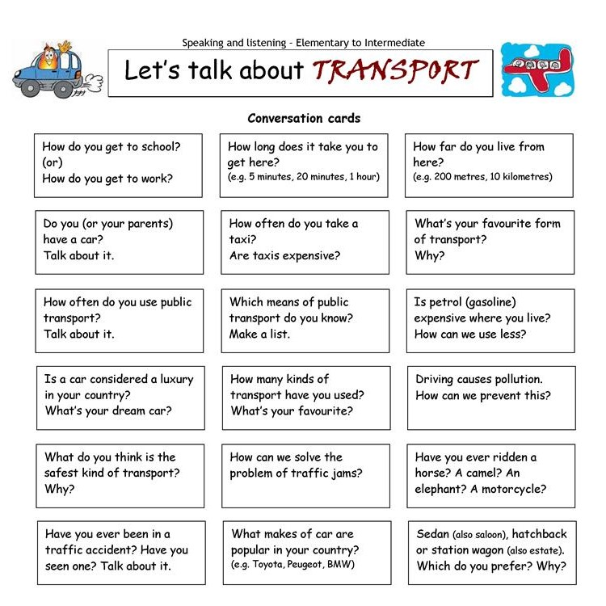

Keys:
Exercise 3:
1.B 2.A 3.C 4.C 5.A 6.A 7.B
Exercise 5:
1.B 2.C 3.B 4.C 5.A 6.B 7.A 8.B 9.B 10.A

