advanced_lesson16_grammar_part_2

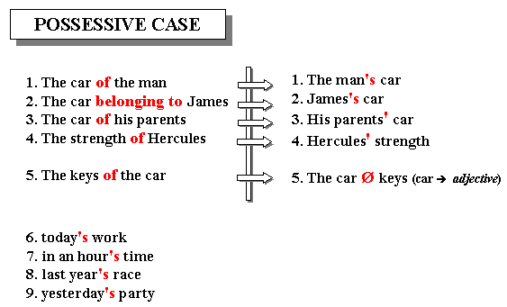



We can use the possessive form of nouns with people or groups of people (e.g. companies),

other living things, places, and times. To make the possessive form of names ending in -s (pronounced /z/) we can add either ' or 's:

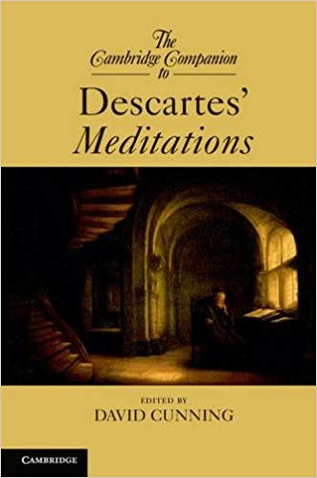• It's Derek **Jones'** *(or* Derek **Jones's)** new sports car.



**Exercise 1**

**Choose the correct the answer**

1. Please don't park there. That is the employee of the _______ parking place.
2. months
3. month
4. month's
5. months'
6. _________ coffee shop is going out of business because Sam and Joe can no longer stand working together.
7. Sams and Joes
8. Sam and Joe
9. Sam and Joe's
10. Sam's and Joe
11. Sam's and Joe's
12. Last _______ meeting was extremely long and boring.
13. Friday
14. Fridays
15. Friday's
16. Fridays'
17. My _______ cooking is really quite amazing.
18. mothers-in-law
19. mother-in-law
20. mother-in-laws
21. mother-in-law's
22. mother's-in-law
23. Mary put the papers on her _______ desk.
24. bosses
25. boss'
26. boss
27. boss's
28. Excuse me. Could you tell me where the _______ restroom is?
29. mens'
30. men
31. mens
32. men's
33. _________ girlfriends are fighting again.
34. Bob's and Jim's
35. Bob and Jim
36. Bob and Jim's
37. Bob's and Jim
38. Bobs and Jims
39. That bicycle belongs to one of the _______.
40. boys
41. boys'
42. boy
43. boy's

**Exercise 2**

**Define if the sentences are correct or incorrect. Change the wrong usage.**

1. Charles has got a new camera. Charles camera is new. A) correct b) incorrect

2) George has got an old mobile phone. George’s mobile phone is old. A) correct b) incorrect

3) I stayed at my aunts house last night. A) correct b) incorrect

4) Her daughter’s-in-law ideas are always unique. A) correct b) incorrect

5) The  part-timers shift ended at 10 pm. A) correct b) incorrect

6) The two teams’ projects tied for first place. A) correct b) incorrect

7) This years’ fashion isn't my cup of tea. A) correct b) incorrect  
  
8) This is the ladies’s room. A) correct b) incorrect  
  
9) Hercules’ power was incredible. A) correct b) incorrect

|  |  |
| --- | --- |
| 10) The two boy's rucksacks were found at the water's edge. A) correct b) incorrect  Начало формы   |  | | --- | |  |   [Check your answer](javascript://)Конец формы |

|  |  |
| --- | --- |
|  | 1. The building had lost all it’s window's and door's.Начало формы A) correct b) incorrect[[Check your answer](javascript://)](javascript://)Конец формы |

|  |  |
| --- | --- |
|  | 1. New York's skyline has lost two of it's most famous buildings. A) correct b) incorrectНачало формы[Check your answer](javascript://)Конец формы |

|  |  |
| --- | --- |
|  | 1. Who has taken Paul's shoes? A) correct b) incorrect 2. The three car's tires were found in the only suspect's flat. A) correct b) incorrect 3. The childrens’ books and pencils were put in their bags. A) correct b) incorrect[Check your answer](javascript://)Конец формы |

|  |  |
| --- | --- |
|  | 1. I would like to see all those actor's together on that theaters famous stage.Начало формы   A) correct b) incorrect  17) All those people's car's make the shop keeper's lives much more difficult.  A) correct b) incorrect  18) All the children's books and their parent's coats' were put in the school's lost property  bags. [Check your answer](javascript://) A) correct b) incorrect  Конец формы |

|  |  |
| --- | --- |
|  | **Exercise 3Начало формы**  Конец формы |

**Choose the correct answer 's or -**

1. I have sold an old (bedside table) a) ‘s b) -   
  
2. He knows (China history) fairly well. a) ‘s b) -  
  
3. We hate (chicken soup). a) ‘s b) -  
  
4. Don't forget to buy a (Mother day) card ! a) ‘s b) -  
  
5. Take this (bath towel). a) ‘s b) -  
  
6. It's my (sister new doll). a) ‘s b) -  
  
7. Here are the (car papers). a) ‘s b) -  
  
8. Do you enjoy (horse races) ? a) ‘s b) -  
  
9. Have you met the (firm boss) ? a) ‘s b) -  
  
11. We never use (computer disks). a) ‘s b) -  
  
12. Don't let the baby play with the (dog  toy). a) ‘s b) -  
  
13. Don't let the baby play with (dog toys). a) ‘s b) -  
  
14. We are going to put (grandfather clock) in the hall. a) ‘s b) –

**Exercise 4**

**Put the possessive case**

1. This is ( Peter and Kate) book.
2. Let's go to the (Smiths).
3. The (children) room is upstairs.
4. (John) sister is twelve years old.
5. (Susan and Steve) schools are old.
6. (Men) shoes are on the second floor.
7. My (parents) car was not expensive.
8. (Charles) CD player is new.
9. These are the (boys**)** pencils.