Cities in Ukraine
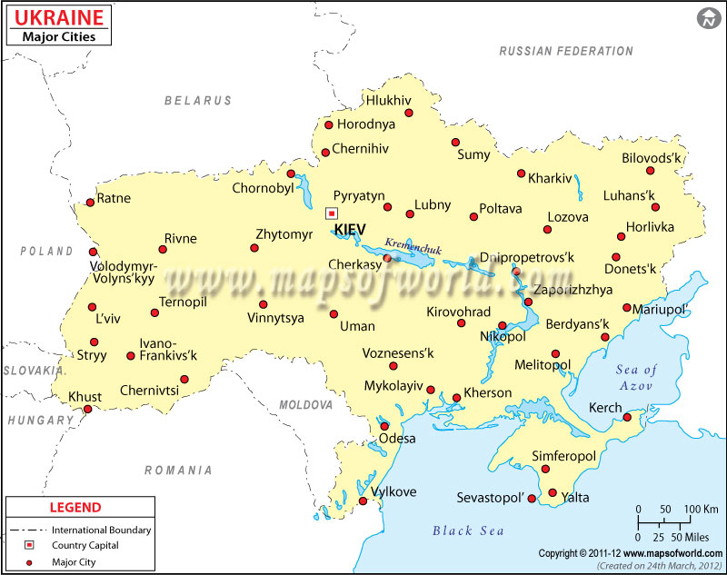

Exercise 1
Translate the following words and expressions
https://quizlet.com/318341363/flashcards
Exercise 2
Fill in the gaps
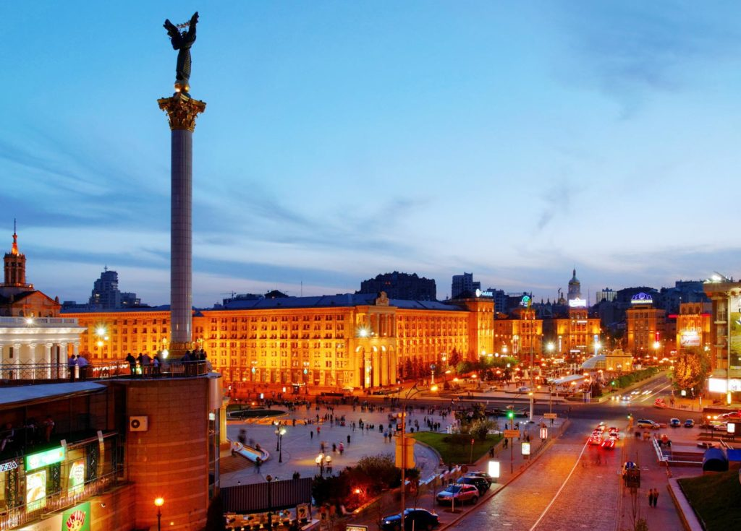

along the way private tour covers languages historical sites
Enjoy a walk through the beautiful parks to the _____ such as Opera House, St. Vladimir Cathedral, St. Sophia Cathedral and of course a walk through the central Maidan Nezalezhnosti. You will have an opportunity to speak with the guide and ask questions _____. The tour _____ most of the historical sites of Kyiv.
Most of the world _____ are available.
Any _____ can be booked by phone or email at least two hours in advance.
Sign in for group tours by phone or email at least one hour in advance.

Exercise 3
Fill in the gaps
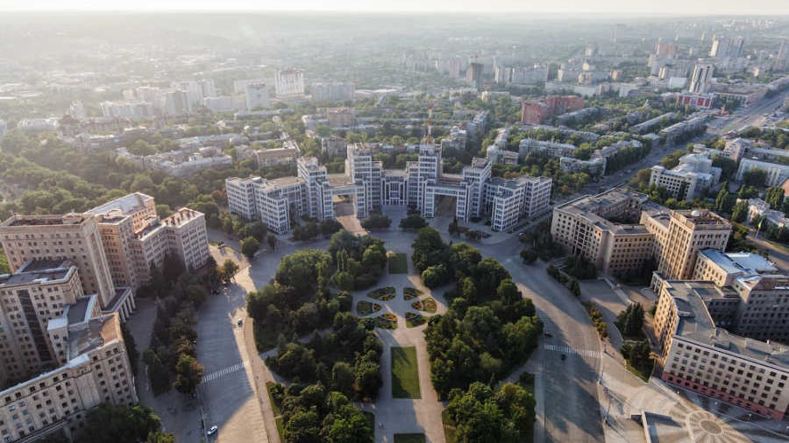
rapid nodal adjacent stronghold
trunk highway satellite towns retains confluence fertile
Kharkiv lies at the _____ of the Uda, Lopan, and Kharkiv rivers. It was founded about 1655 as a military _____ to protect Russia’s southern borderlands. The centre of a region of _____ soils and _____ colonization in the 18th century, it quickly developed important trade and handicraft manufactures. Its _____ position was enhanced in the later 19th century by the opening of the _____ Donets Basin coalfield, first reached by rail from Kharkiv in 1869. Nowadays Kharkiv _____ its role as a communications centre. Kharkiv is also a node on the_____ system, with highways to Moscow, to Kiev and western Ukraine, to Zaporizhzhya and Crimea, and to Rostov-na-Donu and the Caucasus. It has a major airport as well. It is the second largest city in Ukraine and is the centre of a metropolitan area comprising many_____ .

Exercise 4
True of False?
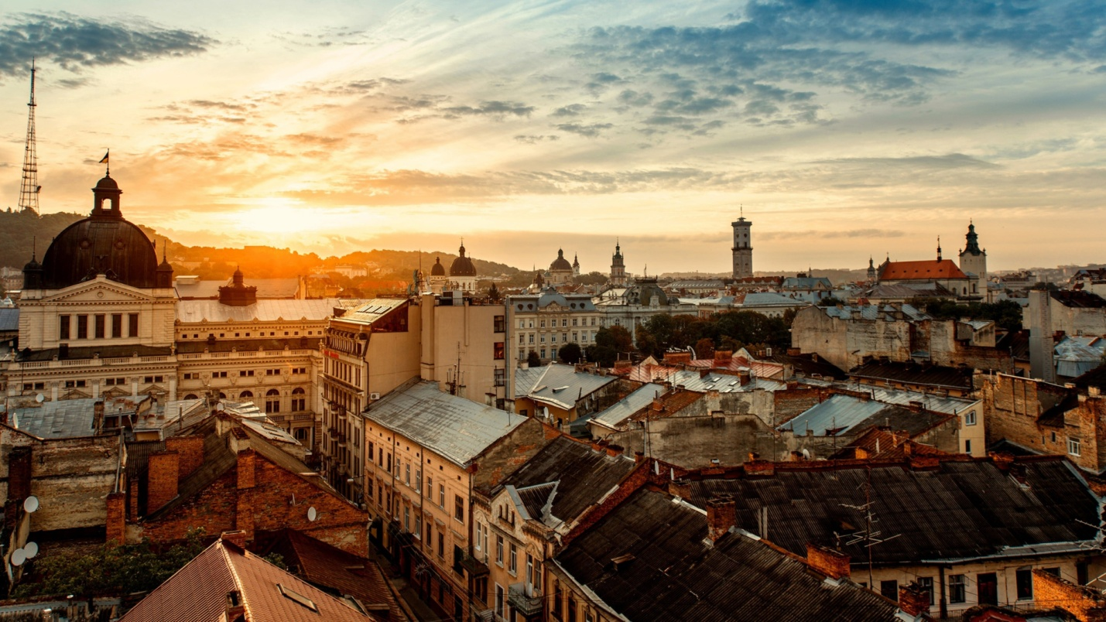
1. Lviv, Polish Lwów, German Lemberg, Russian Lvov, city, western Ukraine was founded in the mid-15th century by Prince Daniel Romanovich of Galicia.
a) true
b) false
2. Lviv has historically been the chief centre of Galicia.
a) true
b) false
3. Lviv was seized briefly by the Cossacks in 1648.
a) true
b) false
4. The government of the short-lived Western Ukrainian National Republic arose in Lviv in 1924.
a) true
b) false
5. After German occupation, Lviv was annexed by the Soviets in 1945.
a) true
b) false
6. Lviv is a major publishing and cultural centre, especially of Ukrainian culture, which flourished there in tsarist times when it was suppressed in Russian Ukraine.
a) true
b) false
7. The university, which was founded in 1661 and named for the Ukrainian poet and journalist Taras Shevchenko under the Soviet regime, is one of the institutions of higher education and research in the city.
a) true
b) false
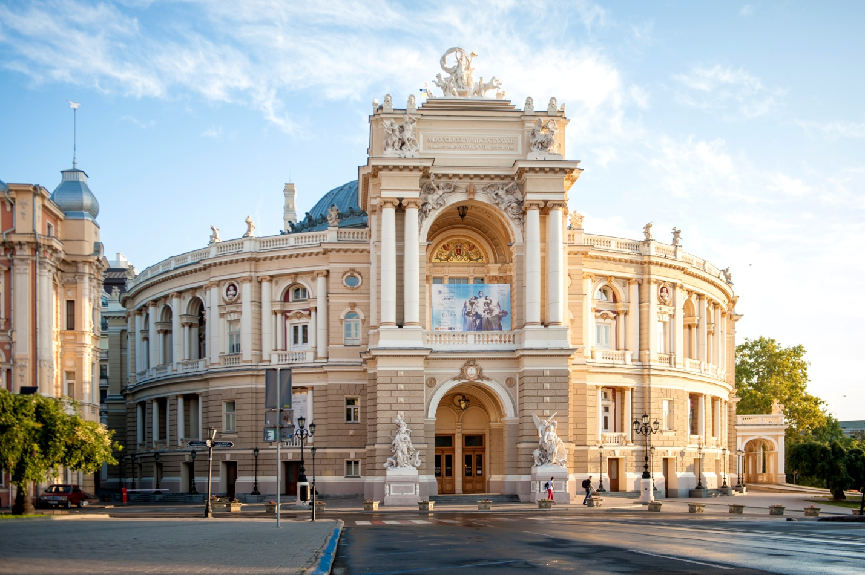
Exercise 5
Read the text. Explain the meaning of the words and expressions in bold
Make your own sentences with the words and expressions in bold
Odessa stands on a shallow indentation of the Black Sea coast at a point approximately 443 km south of Kiev. A settlement existed on the site in ancient times.
During the 19th century Odessa’s growth was rapid, especially after the coming of railways in 1866. Odessa became the third city of Russia and the country’s second most important port, after St. Petersburg; grain was its principal export. The city was one of the chief centres of the Revolution of 1905 and was the scene of the mutiny on the warship Potemkin.
The city remains a major port in Ukraine, with well-equipped docks and ship-repair yards. Odessa is also a large industrial centre, with a wide range of engineering industries; products have included machine tools, cranes, and plows. The chemical industry has produced such materials as fertilizers, paints, and dyes. Odessa also has been the site of oil refining, consumer-goods manufacturing, and food processing. Most factories lie north of the port along the waterfront, with newer plants on the western outskirts.
Odessa is an important cultural and educational centre. It has a university, founded in 1865, and numerous other institutions of higher education. Its most renowned research establishment is the Filatov Institute of Eye Diseases. There are a number of museums and theatres, including the opera house and ballet theatre, dating from 1809. The seashore south of the harbour is a popular resort area, with numerous sanatoriums and holiday camps.

Key
Exercise 2
Enjoy a walk through the beautiful parks to the _____ historical sites such as Opera House, St. Vladimir Cathedral, St. Sophia Cathedral and of course a walk through the central Maidan Nezalezhnosti. You will have an opportunity to speak with the guide and ask questions _____ along the way. The tour _____ covers most of the historical sites of the city.
Most of the world _____ languages are available.
Any _____ private tour can be booked by phone or email at least two hours in advance.
Sign in for group tours by phone or email at least one hour in advance.

Exercise 3
Fill in the gaps
Kharkiv lies at the _____ confluence of the Uda, Lopan, and Kharkiv rivers. It was founded about 1655 as a military _____ stronghold to protect Russia’s southern borderlands. The centre of a region of _____ fertile soils and _____ rapid colonization in the 18th century, it quickly developed important trade and handicraft manufactures. Its _____ nodal position was enhanced in the later 19th century by the opening of the _____ adjacent Donets Basin coalfield, first reached by rail from Kharkiv in 1869. Nowadays Kharkiv _____ retains its role as a communications centre. Kharkiv is also a node on the_____ trunk highway system, with highways to Moscow, to Kiev and western Ukraine, to Zaporizhzhya and Crimea, and to Rostov-na-Donu and the Caucasus. It has a major airport as well. It is the second largest city in Ukraine and is the centre of a metropolitan area comprising many_____ satellite towns.

Exercise 4
True of False?
1. Lviv, Polish Lwów, German Lemberg, Russian Lvov, city, western Ukraine was founded in the mid-15th century by Prince Daniel Romanovich of Galicia.
a) true
b) false
2. Lviv has historically been the chief centre of Galicia.
a) true
b) false
3. Lviv was seized briefly by the Cossacks in 1648.
a) true
b) false
4. The government of the short-lived Western Ukrainian National Republic arose in Lviv in 1924.
a) true
b) false
5. After German occupation, Lviv was annexed by the Soviets in 1945.
a) true
b) false
6. Lviv is a major publishing and cultural centre, especially of Ukrainian culture, which flourished there in tsarist times when it was suppressed in Russian Ukraine.
a) true
b) false
7. The university, which was founded in 1661 and named for the Ukrainian poet and journalist Taras Shevchenko under the Soviet regime, is one of the institutions of higher education and research in the city.
a) true
b) false

