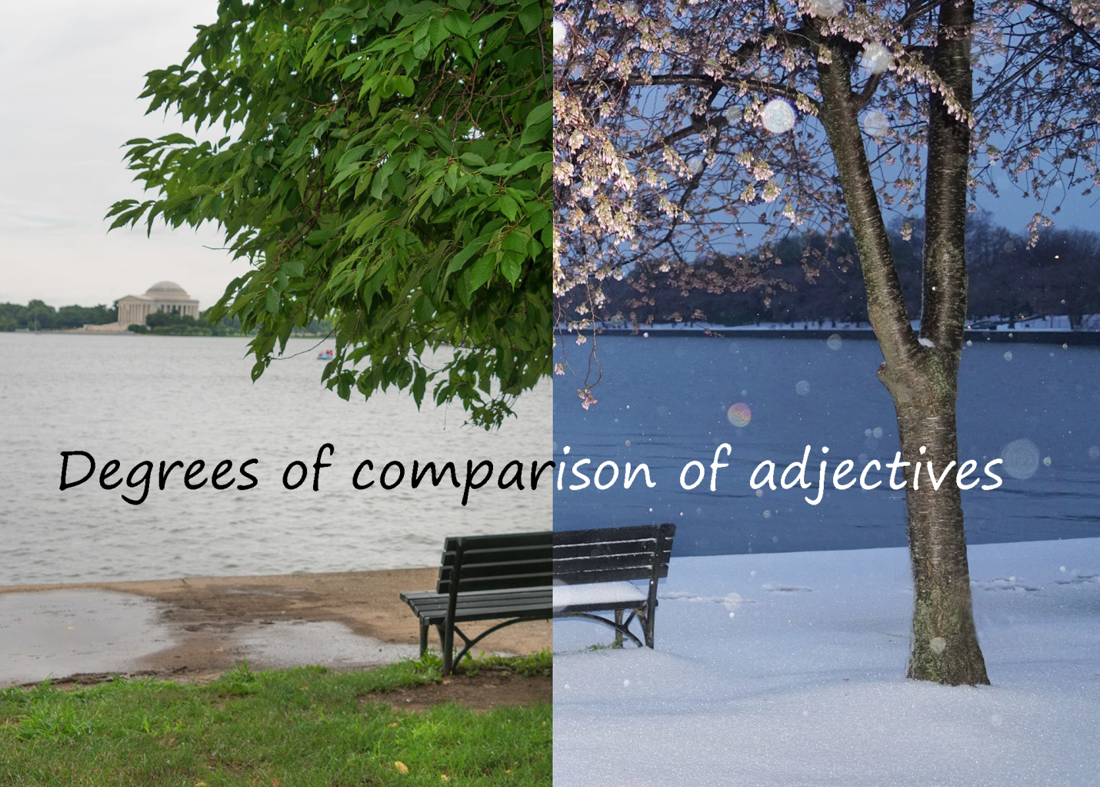

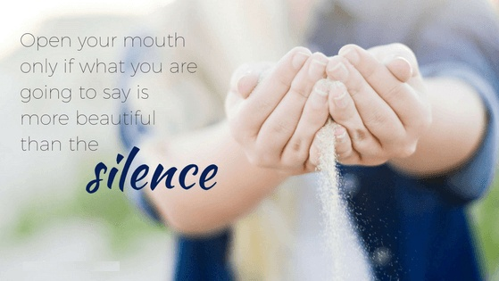
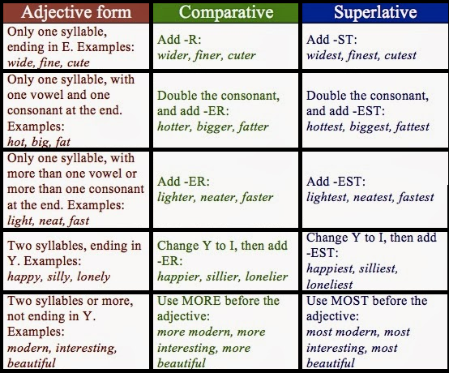
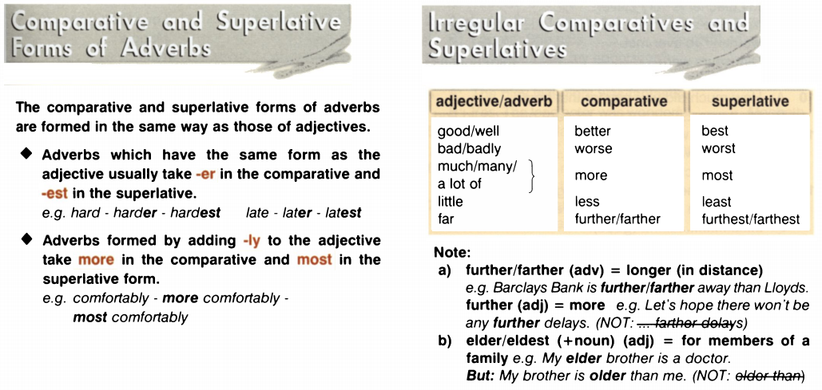

I. Choose the correct answer.
1. She made an even clumsiest / clumsyer / clumsier attempt to apologise.
2. Let's see which group is the most observant / more observant.
3. It is a more indirect / the most indirect route but the scenery is nicer.
4. There will be a most formal / formaler / more formal announcement later.
5. The most urgent / more urgent task is to find the missing keys!
6. We all gave our ideas but Mary's was more original / the most original.
7. Peter's explanation was the most confusing / more confusing than anyone else's.
8. I'll take more full / fuller / the fullest box, you take one that is less full.
9. His behavior was becoming more erratic / erraticer / erratic more.

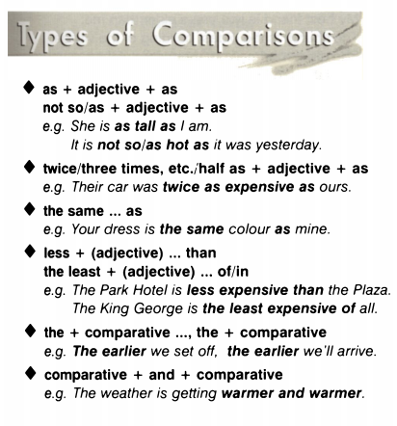

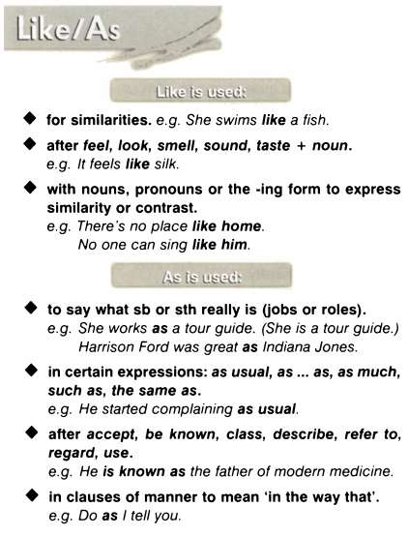

II. Choose the correct answer.
1) The less you listen, __________________.
- the less you understand
- you understand the less
- you understand less

2) The more money you earn, __________________.
- the more rich you are
- you are richer the more
- the richer you are
3) __________________, the best it is.
- Chocolate the more there is
- The more chocolate there is
- There is most chocolate

4) __________________, the more I improve my English.
- I do more exercises
- The more I do exercises
- The more exercises I do

5) The more money you spend, __________________.
- the less you money can spare
- the less money you can spare
- the less you can spare money

6) __________________, the more tired I am.
- The more I run
- The more run I
- I run the more

7) The more he eats, __________________.
- the fatter he gets
- he gets the more fat
- the more fat he gets

8) The more cars there are, __________________.
- the more there is pollution
- the more pollution there is
- there is the more pollution
9) __________________, the more you improve your English.
- With English speakers you speak the more
- The more you speak with English speakers
- You speak the more with English speakers
10) The more interesting books you will read, __________________.
- the more you will know things
- you will know the more things
- the more things you will know

III. Fill in the gaps.
1. Diana was much taller ............... Charles.
- like
- than
- as
2. This one is better ............... that one.
- as
- than
- like
3. London is a long way away but Sydney is ................ .
- father
- further
- more far
4. Of all the sofas I've seen so far, this one is ............... .
- the nicest
- most nice
- nicer
5. I'm not short. I'm just ............... tall as Hans.
- like
- as
- than
6. Samantha is just as rich ............... David.
- as
- than
- like
7. No one can paint ………. her.
- as
- than
- like

IV. Correct the mistakes.
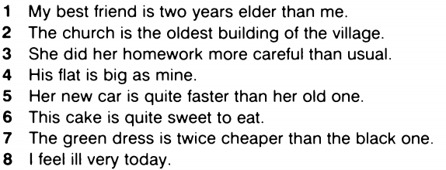

V. Fill in the gaps.
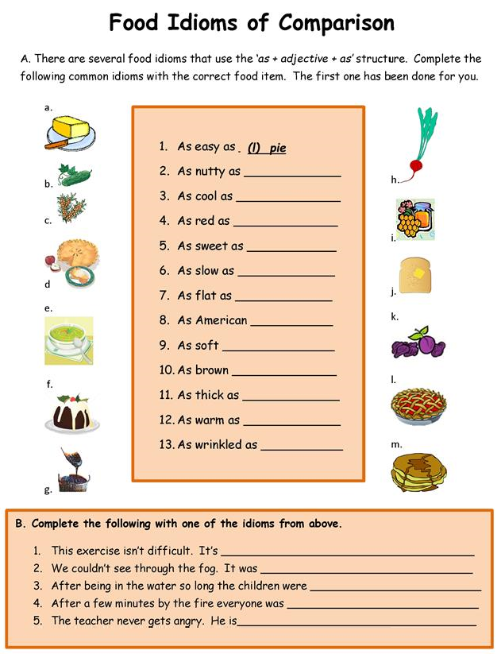

VI. Review on all comparatives and superlatives.
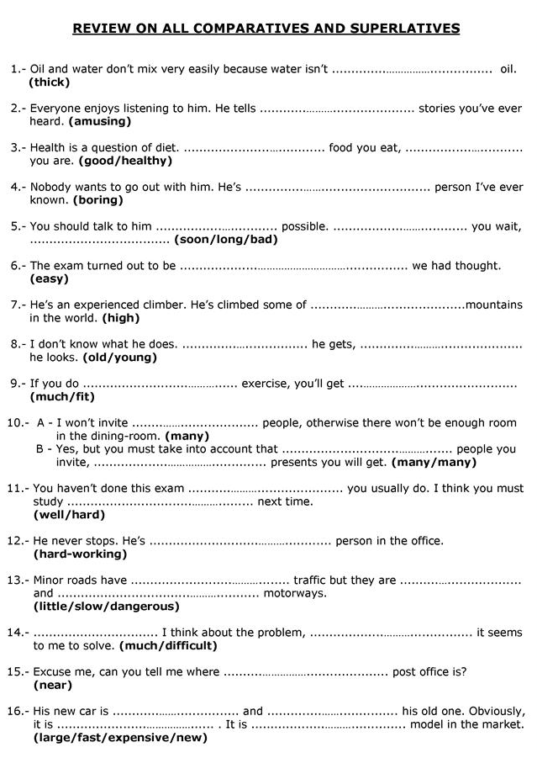

Answers:
I. Choose the correct answer.
1. She made an even clumsiest / clumsyer / clumsier attempt to apologise.
2. Let's see which group is the most observant / more observant.
3. It is a more indirect / the most indirect route but the scenery is nicer.
4. There will be a most formal / formaler / more formal announcement later.
5. The most urgent / more urgent task is to find the missing keys!
6. We all gave our ideas but Mary's was more original / the most original.
7. Peter's explanation was the most confusing / more confusing than anyone else's.
8. I'll take more full / fuller / the fullest box, you take one that is less full.
9. His behavior was becoming more erratic / erraticer / erratic more.

II. Choose the correct answer.
1) The less you listen, __________________.
- the less you understand
- you understand the less
- you understand less

2) The more money you earn, __________________.
- the more rich you are
- you are richer the more
- the richer you are
3) __________________, the best it is.
- Chocolate the more there is
- The more chocolate there is
- There is most chocolate

4) __________________, the more I improve my English.
- I do more exercises
- The more I do exercises
- The more exercises I do

5) The more money you spend, __________________.
- the less you money can spare
- the less money you can spare
- the less you can spare money

6) __________________, the more tired I am.
- The more I run
- The more run I
- I run the more

7) The more he eats, __________________.
- the fatter he gets
- he gets the more fat
- the more fat he gets

8) The more cars there are, __________________.
- the more there is pollution
- the more pollution there is
- there is the more pollution
9) __________________, the more you improve your English.
- With English speakers you speak the more
- The more you speak with English speakers
- You speak the more with English speakers
10) The more interesting books you will read, __________________.
- the more you will know things
- you will know the more things
- the more things you will know

III. Choose the correct answer.
1. Diana was much taller ............... Charles.
- like
- than
- as
2. This one is better ............... that one.
- as
- than
- like
3. London is a long way away but Sydney is ................ .
- father
- more far
- further
4. Of all the sofas I've seen so far, this one is ............... .
- the nicest
- most nice
- nicer
5. I'm not short. I'm just ............... tall as Hans.
- like
- as
- than
6. Samantha is just as rich ............... David.
- as
- than
- like
7. No one can paint ………. her.
- as
- than
- like

IV. Correct the mistakes.
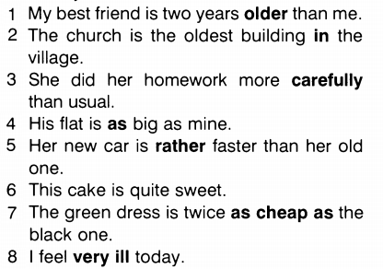

V. Fill in the gaps.