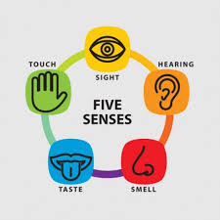
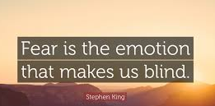
advanced_lesson_26_video_part_3
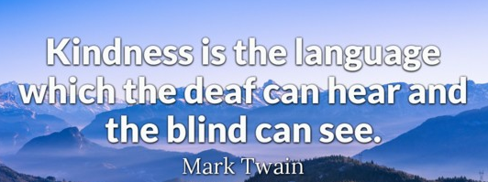
Discuss the following quotes.

Exercise 1
Watch the video and answer the questions
Quizlet
https://quizlet.com/308929178/lesson-25-adv-video-flash-cards/?new

https://bigthink.com/robby-berman/moving-beyond-the-traditional-5-human-senses
- The speaker says that people have more than five senses.
- True
- False
- Five senses always come in their separate expression but not all together.
- True
- False
- Why being on the plane there might be some optical illusions?
- Sight is influenced by the sense of balance
- Sight is influenced by the sense of hearing
- Hearing is influenced by the sense of smell
- The fundamental understanding about the shape of objects lies in:
- Connection between sight and smell
- Connection between sight and touch
- Connection between touch and taste

Exercise 2
Watch the video and try to remember as many details as possible. Before watching read carefully the instructions afterwards.
https://vimeo.com/171274812
- Pause at 1:02 and discuss everything you have seen connected with touch. What did the people do?
- Watch further from 1:02 till 1:54 and discuss which items from the video smell nice and which ones smell bad. You can use the words scent, aroma, odour, stink to describe each object.
- Watch till 2:40 and pause. Describe the tastes and foods you have seen.
- Go on till 3:24. Say which sounds were pleasant and which ones were awful.
- Pause at 4:14. What objects did you see in this part? Name as many different adjectives for each item as possible.
- Continue watching till the end

Exercise 3
Watch the incredible story of this man who is a blind painter
https://www.youtube.com/watch?v=x9vHwCIaSwM
- The has been blind for:
- 35 years
- 25 years
- 45 years
- Before going totally blind the man painted:
- People
- Nature
- Animals
- How does he measure the proportions to paint people?
- The artist uses a ruler
- He uses the marks corresponding his wife`s height
- His daughter helps him
- The works by this artist are:
- Pricy
- Valueless
- Unknown among people

Exercise 4
Watch the stunning video about a deaf musician and answer the questions
https://www.youtube.com/watch?v=OdwXPZ4vu-c
- As a child the musician enjoyed listening to
- His mother play the guitar
- His father play the violin
- His grandmother play the piano
- How could he understand the melody?
- Watching the moves
- Felling the vibrations
- Hearing the melody
- The man creates music by:
- Using drums and beats making vibrations
- Light effects corresponding the frequency of sounds
- Having invented his own sound system the musician uses the way of creation music which means the louder the sound is, the brighter the lights are.
- True
- False

