Lesson 29- Character-Vocabulary
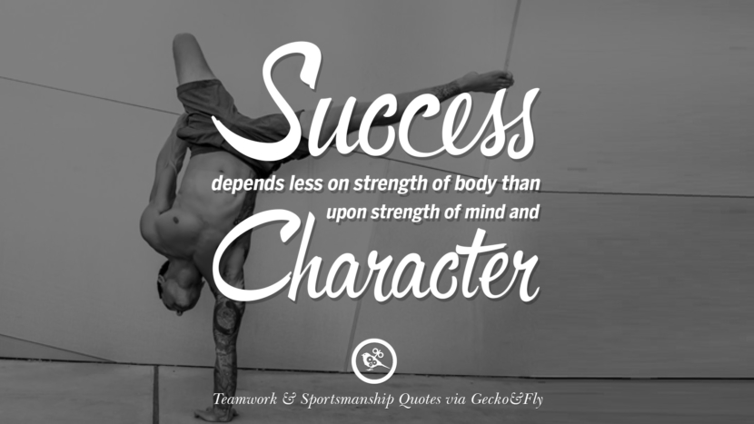
Exercise 1
https://quizlet.com/124540450/english-cambridge-advanced-19-observing-character-traits-flash-cards/

Exercise 2
Find the definion of an adjective

introvert | Similar to obstinate but stronger, more disapproving
diffident | Lack of confidence
reserved | Not believe others deserve respect
aloof | Willing to believe simple things perhaps because of inexperience
haughty | Unfriendly and think oneself better than others
disdainful | Unfriendly and not sociable
unapproachable | Not easy to be sociable with or start a conversation with
conceited | Inward-looking, quiet
self-important | Have an exaggerated sense of importance
modest | Prefer not to exaggerate own qualities
flirt | Make constant romantic approaches
naive | Not immediatly sociable
gullible | Unwilling to change, despite persuasion
conscientious | Always take his/her work seriously
obstinate | Think oneself wonderful
pig-headed | Easily deceived
unscrupulous | Lacking in moral principles, prepared to do very bad things

Exercise 3
Form a noun from an adjective

Excitable
Disdainful
Impetuous
Obstinate
Modest
Gullible
Reserved
Garrulous
Conceited
Pig-headed

Exercise 4

Fill the gaps with adjectives from the opposite page. The first letter of each word is given

I remember my grandmother so well. Her i….. generosity meant she was always giving money to beggars and other poor people. She was very a…., never a…., and would always chat to strangers. In fact, she was quite an e… and would sing and dance at parties. But when it came to work she was very c… and never missed a day in forty years. She was a very determined person, indeed she could be quite o… and p…., and could not be persuaded to do something she didn’t want to. She was proud but never c… or s…, talkative but never g…, self-confident but never p…, always wishing success for everyone else before herself. She was always d… of u… people, since she was a person of great moral principles.

Exercise 5

What makes Character qualities?

1. Give/make a gift for someone just because...
2. Remember to say, I love you.
3. Donate your time to volunteer
4. Listen carefully to others
5. Visit a nursing or retirement home
6. Email or write to a friend/relative just to say, hello!
7. Give blood
8. Smile before asking someone to do something
9. Remember to say, thank you
10. Participate in donations to charities
11. Hug a friend just because...
12. Observe and respect laws
13. Remind a friend not to drink and drive
14. Call home
15. Do not smoke
16. Encourage others...
27. If you borrow something, return it

- What personality traits do you consider important in a good friend / a boss / a partner?
- Do you think you can change a major characteristic of your personality if you try?
- Are you more introverted (focused on your inner world) or more extraverted (focused on other people and the other world)?

