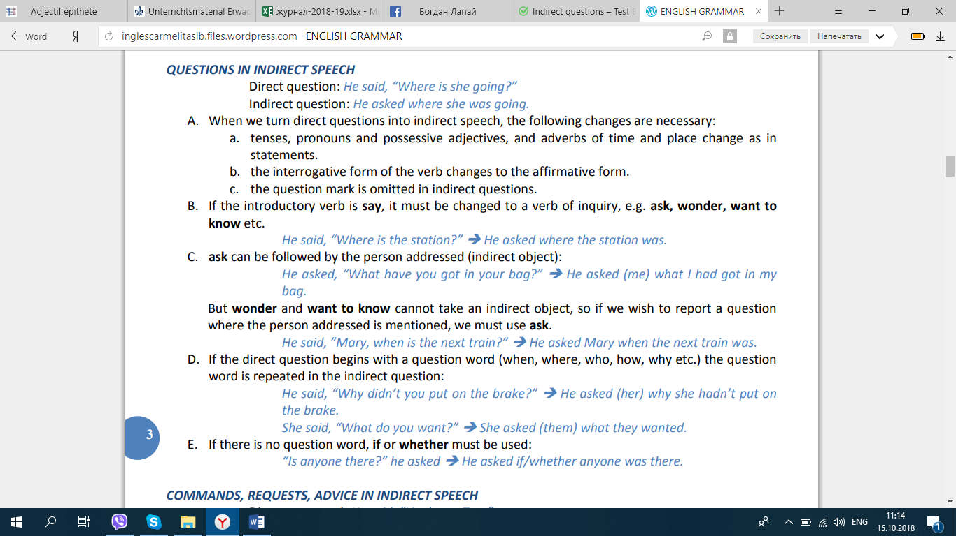

Task 1
Write these sentences as reported questions using the words given.
a. “What’s your name?”, he asked. (wanted to know)
b. “Do you like Marlon Brandon?”, she asked.
c. “How old are you?”, she said. (asked)
d. “When does the train leave?”, I asked.
e. “Are you enjoying yourself?”, he asked.
f. “How are you?”, he said. (asked)
g. “Does your father work here?”, she asked.
h. “Do you live near your father?”, he asked.
i. “Who did you see at the meeting?”, my mother asked.
j. “Why did you take my wallet?”, he asked.
Task 2
Change the questions below from direct speech to indirect speech:
1. She said to her daughter, “Are you coming home for dinner?”
2. I said, “How old are you?”
3. They asked each other, “What will we do this summer?”
4. He said to Kim, “Why are you shouting?”
5. I said to them, “Is the movie over?”
6. He asked her, “Are you ok?”
7. I asked, “When is your birthday?”
8. The teacher said, “Are you ready for the test?”

Task 3
Turn these direct questions into indirect questions.
Example: Where is the shop?-Can you tell me where the shop is?

1Where is he from?
Do you know ?
2How many countries has he travelled to?
I wonder .
3Where did you go?
Can you tell me ?
4Have you finished the report yet?
I’d like to know .
5Does he go out very often?
I’ve no idea whether .
6Who was she talking to?
I wonder who .
7Where is the nearest station?
Could you tell me where ?
8Why can’t you help your new colleague?
Would you mind telling me why ?
9What is our new boss like?
I’d like to find out what .
10How could you do that?
I don’t know how .

Task 4
Choose the correct forms to complete the following questions. There are direct and indirect questions.
1I don’t know the answer. How many times to tell you?
2I don’t know so unhappy.
3Do you have any idea when ?
4How many people for the party?
5I wonder .
6Did she tell you how often ?
7I’d like to know for the experiment.
8Could you tell me why ?
9Can I ask you how long here?
10Why ?

Task 5
Choose the correct forms to complete the questions below. There are direct and indirect questions.
1.I’d like to know ______.
a. how can I contact her
b. how I can contact her
c. how do I contact her
2.I was wondering ______ the recipe.
a. where you found
b. where did you find
c. where found you
3.Would you mind telling me ______?
a. how much did the sofa cost
b. how much cost the sofa
c. how much the sofa cost
4.How long ______ to finish the project?
a. it is going to take
b. is it going to take
c. it’s going to take
5.______ in this house?
a. How much time you have been living
b. How long you’ve been living
c. How long have you been living
6.Could you tell me ______?
a. what are you afraid
b. what you are afraid
c. what you are afraid of
7.Do you know ______?
a. if is he going to come
b. if he’s going to come
c. whether is he going to come
8.I’d like to know ______ .
a. why you are acting so weird
b. why are you acting so weird
c. why act you so weird
9.Do you have any idea ______?
a. is who the man in black
b. who’s the man in black
c. who the man in black is
10.______? Can you tell me?
a. Where is the new student from
b. Where the new student is from
c. From where is the new student

ANSWERS

Task 2
1.She asked her daughter if she was coming home for dinner.
2.I asked him how old he was.
3.They asked each other what they would do for the summer.
4.He asked Kim why she was shouting.
5.I wanted to know if the movie was over.
6.He wondered if she was ok.
7.I asked him when his birthday was.
8.The teacher wanted to know I was ready for the test.

Task 3
1Do you know where he is from?
2I wonder how many countries he has travelled to.
3Can you tell me where you went?
4like to know if you have finished the report yet.
5I’ve no idea whether he goes out very often.
6I wonder who she was talking to.
7Could you tell me where the nearest station is?
8Would you mind telling me why you can’t help your new colleague?
9I’d like to find out what our new boss is like.
10I don’t know how you could do that.

Task 4
1I don’t know the answer. How many times do I have to tell you?
2I don’t know why he’s always so unhappy.
3Do you have any idea when the results will be published?
4How many people did you call for the party?
5I wonder how long this cold weather will last .
6Did she tell you how often you should take the vitamins ?
7I’d like to know whether I can use the new product for the experiment.
8Could you tell me why you are leaving ?
9Can I ask you how long you have been living here?
10Why shouldn’t I call her ?

Task 5
1I’d like to know ______.
- a. how can I contact her
- b. how I can contact her
- c. how do I contact her
2I was wondering ______ the recipe.
- a. where you found
- b. where did you find
- c. where found you
3Would you mind telling me ______?
- a. how much did the sofa cost
- b. how much cost the sofa
- c. how much the sofa cost
4How long ______ to finish the project?
- a. it is going to take
- b. is it going to take
- c. it’s going to take
5______ in this house?
- a. How much time you have been living
- b. How long you’ve been living
- c. How long have you been living
6Could you tell me ______?
- a. what are you afraid
- b. what you are afraid
- c. what you are afraid of
7Do you know ______?
- a. if is he going to come
- b. if he’s going to come
- c. whether is he going to come
8I’d like to know ______ .
- a. why you are acting so weird
- b. why are you acting so weird
- c. why act you so weird
9Do you have any idea ______?
- a. is who the man in black
- b. who’s the man in black
- c. who the man in black is
10______? Can you tell me?
- a. Where is the new student from
- b. Where the new student is from
- c. From where is the new student

