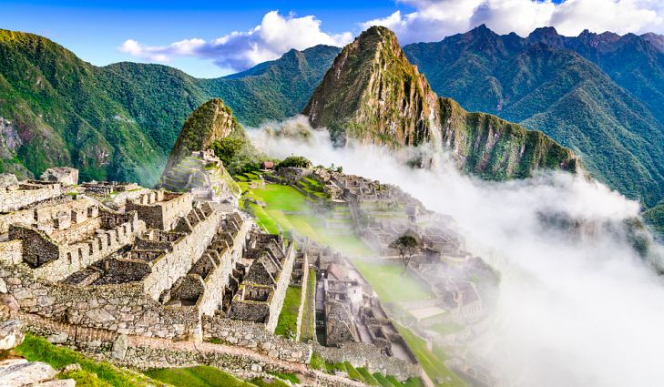

Answer these questions
- Who were the earliest people to aettle in your country?
What do you know about them?
- How long ago do you think the Incas lived?
- In what part of the world do you think the Incas lived?

Let your teacher read the text and then complete the excersises,

Why Did the Inca Empire Disappear?
The land of the Incas included what is now Bolivia, Peru, Ecuador, and part of Argentina and Chile. In the center of the Inca Empire was its capital, Cuzco, the "Sacred City of the Sun." From every part of the empire, grain, gold and silver, cloth, and food poured into the capital.
2 The Incas began as a small tribe living in the Peruvian Andes in the 1100s. In the 1300s, their strong leader, Mayta Qapaq, began to conquer neighboring lands. By the 1400s, the Incas' huge empire became the largest empire known in the Americas. Although there were only 40,000 Incas, they ruled a population of about 12 million, which included 100 different peoples. The Incas were clever governors and did not always force their own ideas on other groups. The people they conquered had to accept the Inca gods, but they were allowed to worship in their own way and keep their own customs.
3 Each new ruler of the empire was called the Sapa Inca, and each Sapa Inca claimed to be the child of the sun and was treated as a god. When a Sapa Inca died, his body was kept and taken care of by the people, and he continued to "live" in his palace. The dead Inca sat on a golden stool, and a woman watched him day and night, whisking the flies away from his face. The dead rulers were served food each day, and on special occasions they were carried out of their palaces to feast together. Each new ruler had to build a new palace. By 1500, Cuzco was full of palaces of dead Incas.
Each Sapa Inca had a queen, or Coya. She was almost always the ruler's own sister. Like him, she was thought to be a child of the sun. The Sapa Inca married his sister to make sure their children only had the pure blood of the sun. One of their sons would be the next Sapa Inca. However, each Sapa Inca had many unofficial wives and dozens of children who would become the Inca nobility.
s The Incas ruled over one of the best organized empires in history. They controlled the lives of everyone through a system of officials. This system was like a triangle or pyramid. At the bottom were millions of ordinary farmers. Above the farmers were officials and higher officials, and above these officials were the four governors of the quarters of the empire. At the very top of the pyramid was the Sapa Inca.
Ordinary people had to spend part of each year working for the state--mining, buildings roads, or serving in the army. They could not leave their villages without official permission. They had no choice but to work on the land and send one-third of their produce to the government stores. The empire had huge storehouses where food was kept. The Incas made sure no one starved. In return, everyone was expected to work.
7 Even marriage of the ordinary people was controlled. Although nobles often had several wives, an ordinary man could only have one. The state controlled whom and when each ordinary person could marry. Each year the local chiefs assembled all the eligible young men over twenty-four and women over eighteen. They were grouped into two lines and then paired together. For the first year of marriage, the couple did not have to pay taxes on either goods or labor. However, they would have to work hard for the rest of their lives. When they were elderly and became too frail or sick to take care of themselves, they received free food and clothes from the state storehouse, and their family group would care for them.
The Incas had no horses or wheels to help them with transportation, but they had a sophisticated road system. Their network of roads ran the length of the empire, from today's Peru to Chile. One road, called the Royal Road, was 3,250 miles (5,200 km) long. It was built through the
Andes Mountains. Even today, with modem tools, it would be difficult to build that road. The Incas also made extraordinary suspension bridges of ropes; these hung 300 feet (91 meters) above deep rivers. Since most people were not allowed to travel, the roads were used by soldiers and chasquis, who were government messengers. They were highly trained runners who were stationed at intervals of about two miles (3.2 km) along the roads and carried messages to and from Cuzco, the capital. Relay teams could run up to 200 miles (322 km) a day and bring fish from the sea to the capital in two days. But the main reason for the roads was for the soldiers who kept the empire under control.
9 Although they had no system of writing, the Incas sent messages in quipus, which were colored strings with knots in them. The color of the string represented what was being counted. For example, a yellow string stood for gold and a red string for soldiers. The knots stood for numbers.
10 The Incas were expert builders, although they only had basic tools. Instead of building walls with cement, they used stones that fit together perfectly. Many of the Inca walls remain in place to this day. In 1950,
two-thirds of Cuzco was destroyed in an earthquake, but none of the old walls collapsed. Today the well-preserved town of Machu Picchu shows the remarkable skills of the Inca builders. This town, which was abandoned by the Incas for unknown reasons, was only discovered in 1911.
Is The Inca Empire fell very quickly after the death of their great ruler Huayna Capac in 1525. two of his sons, Atahualpa and Huascar, quarreled over who should be the next Sapa Inca. They fought against each other in a war and finally, in 1532, Atahualpa won. During the war, news came that strange people had arrived on the coast. These visitors, the Spaniards, were dressed in metal suits, rode unknown animals (horses), and had hair growing down their chins. After his victory, Atahualpa wanted to see these strange people and invited them to visit him. There were only. Spaniards, so Atahualpa was not afraid. However, the Spaniards attacked the Inca army with guns and fired their cannons. They took Atahualpa prisoner and promised to give him his freedom In exchange for a room full of gold and two rooms full of silver. The Incas gave the Spaniards the gold and silver. However, the Spaniards didn't free Atahualpa; they killed him instead. With no leader, the Inca soldiers were weak, and the Spaniards soon defeated them. The Spaniards gave the Incas orders, and the Incas obeyed them because they were used to obeying all their lives. The Spaniards were only interested in the Inca gold and silver, so they made the people work in the mines and neglect the farming. Many Incas died from overwork and hunger. The great Inca Empire was soon destroyed. u Though the Inca civilization disappeared, traces of its culture and people survive. As a matter of fact, today the Incas' descendants form the majority of the population in the Andes of Ecuador, Peru, and Bolivia.

Ex. 1 Circle the letter of the answer that is closes in meaning to the underlined word,

- The Incas had a sophisticated road system.
- not well developed
- plain and simple
- advanced and complicated
- roughly put together
2. Each Sapa Inca claimed to be the child of the sun.
- stated as a fact
- showed to be untrue
- questioned the truth of
- demanded to know
3. They were allowed to worship in their own way.
- forced
- forbidden
- told how
- given permission
4. They made the people work in the mines and neglect the farming.
- not care for
- take care of
- do more of
- watch over
5. Machu Picchu was abandoned by the Incas.
- torn down
- left empty or alone
- made more beautiful
- built up
6. The Incas made sure that no one starved.
- had food
- went without food
- was forced to buy food
- stored food
7. When they became too frail or sick to take care of themselves, they received free food and clothes.
- completely unhappy
- lonely and afraid
- poor and hungry
- thin and weak

8. None of the old Inca walls collapsed.
- had large cracks
- fell down
- were damaged
- showed signs of aging
9. Each year the local chiefs assembled all the eligible young men.
- very intelligent
- physically strong
- suitable to be chosen
- belonging to a certain class
10. The Incas sent messages in quipus, which were colored strings with knots.
- pieces tied together
- long, separate pieces
- tiny, loose pieces
- pieces hanging from something

Ex. 2
A. Find words in the reading that go together with the words below to
- intervals
- majority ____
- on occasions
- exchange for
- stood
- in the army
- control
B. Complete the sentences with the phrases from Part A.
- When you give something in order to get something else in re you give one __________________the other.
- _________________such as birthdays and weddings, we
important events in our lives.
- You are ________________ when you become a member of and
spend time working in that part of a country's military
- Things that are ________________ are spaced certain distances
apart from each other.
- If certain letters or objects represented something else, then they ________________that thing.

Ex. 3
Circle the letter of the best answer.
I. The main idea of paragraph 2 is that
- the Incas allowed conquered people to keep their customs
- the first Incas lived in the Peruvian Andes in the 1100s
- Mayta Qapaq was a strong Inca leader
- a small tribe of Incas grew to a huge empire
2. The main idea of paragraph 5 is that
- the Inca government had many officials
- the Sapa Inca was at the top of the pyramid
- Inca rule was very organized and controlled
- the farmers had many people telling them what to do
3. The main idea of paragraph 8 is that
- the Inca roads would be hard to build today, even with modern t
- the Inca road system was used mainly by soldiers
- most people were not allowed to travel in Inca society
- the Incas built a very advanced and complex system of roads
4. Paragraph 11 is mainly about how
- the death of Hitayna Capac led to war between his two sons
- the great Inca Empire was destroyed by the Spaniards
- the Spaniards were only interested in Inca gold and silver
- Atahualpa was not afraid of the Spaniards

https://www.youtube.com/watch?v=UO5ktwPXsyM

Ex. 4
Answer the questions
- What are two advantages and two disadvantages of living in an organized and controlled society such as the society of the Incas?
- Each country is different and has its own way of doing things. Talk about two or three things that are done differently in another country.
- Who should take care of the elderly? Write the advantages and / or disadvantages of the government's taking care of the elderly.

Answers
Ex.1

1. c
2. a
3. d
4. a
5. b
6. b
7. d
8. b
9. c
10. a

Ex.2
A.
1. at
2. of
3. special
4. in
5. for
6. serving
7. under
B.
1. in exchange for
2. On special occasions
3. under control
4. majority of
5. serving in the army
6. at intervals
7. stood for

Ex.3

1. d
2. c
3. d
4. b

