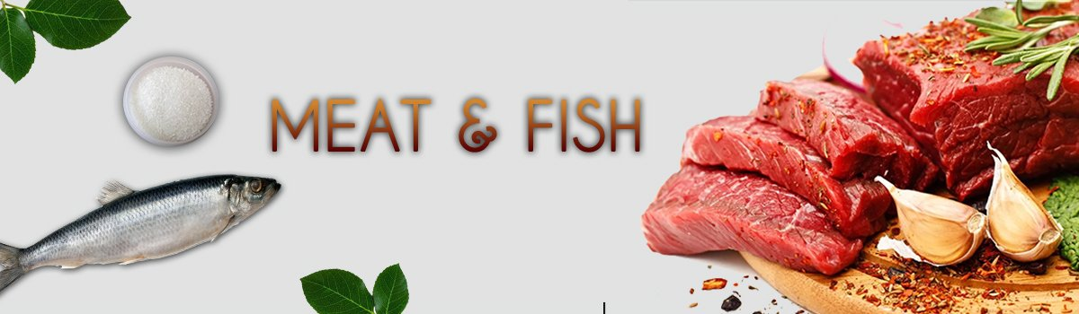
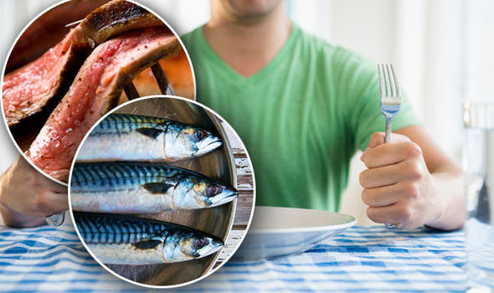

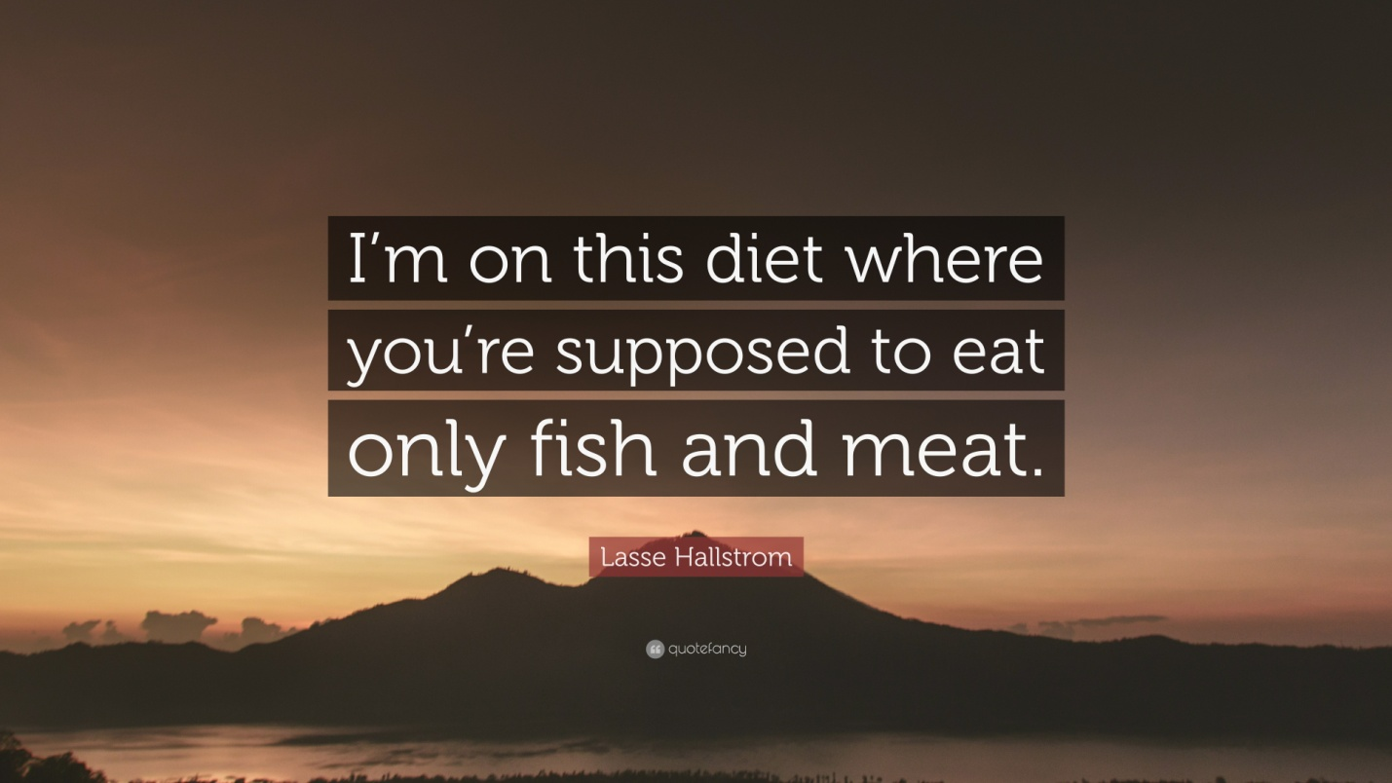
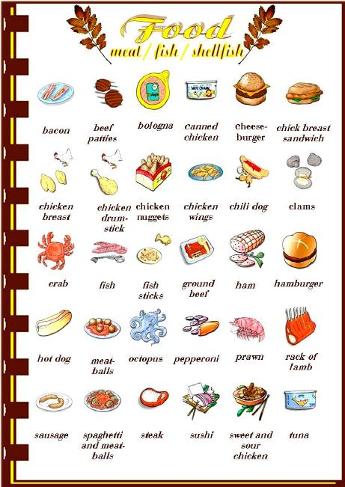
I Vocabulary.
https://quizlet.com/305278310/basic_lesson_7_meat-and-fish_vocabulary-flash-cards/

II. Match the words and pictures.
http://gamedata.britishcouncil.org/lep25_embed/MTA4OTM=/teens

III. Read the sentence and choose the correct answer.
http://gamedata.britishcouncil.org/lep25_embed/MTg4NDE=/teens

IV. Write the words to fill the gaps.
http://gamedata.britishcouncil.org/lep25_embed/MTg4NDI=/teens

V. Which one is different? Explain why?

1. cow sheep salmon pig
2. cow pig pork sheep
3. ham lamb sausages bacon
4. lamb pork beef tuna
5. salmon prawns mussels squid
6. duck cow lamb chicken

VI. Choose the best answer.
http://gamedata.britishcouncil.org/lep25_embed/MjE5NDk=/le

VII. Listen and put the letters in order to spell the words.
http://gamedata.britishcouncil.org/lep25_embed/MjE5NTE=/le

VIII. Write the words to complete the sentences.
http://gamedata.britishcouncil.org/lep25_embed/MjA2NDk=/le

Answers:
V. Which one is different? Explain why?

1. cow sheep salmon pig (salmon)
2. cow pig pork sheep (pork)
3. ham lamb sausages bacon (lamb)
4. lamb pork beef tuna (tuna)
5. salmon prawns mussels squid (salmon)
6. duck cow lamb chicken (cow)

