012_basic_vocabulary
Test
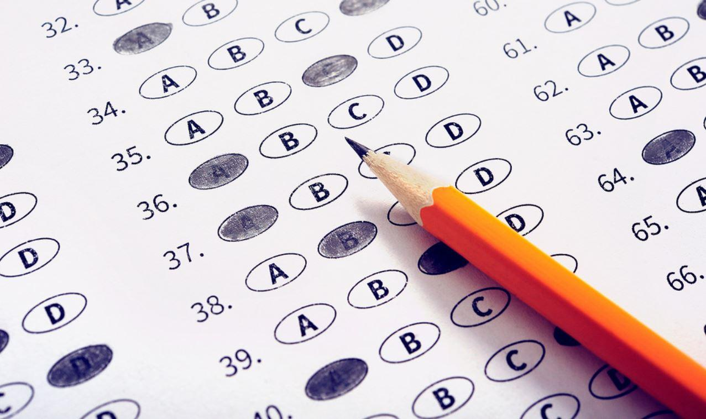

Quizlet(containers)- https://quizlet.com/304682227/containers_009_basic-flash-cards/

Exercise 1
http://gamedata.britishcouncil.org/lep25_embed/MTEyMDQ=/teens

Exercise 2
http://gamedata.britishcouncil.org/lep25_embed/MTg4Njg=/teens

Exercise 3
http://gamedata.britishcouncil.org/lep25_embed/MTg4Njk=/teens

Exercise 4
http://gamedata.britishcouncil.org/lep25_embed/MTc5NDg=/teens

Exercise 5
http://gamedata.britishcouncil.org/lep25_embed/MTg4NzQ=/teens

Exercise 6
http://gamedata.britishcouncil.org/lep25_embed/MTA5MzI=/teens

Exercise 7
http://gamedata.britishcouncil.org/lep25_embed/MTg4NzA=/teens

Exercise 8
Match
