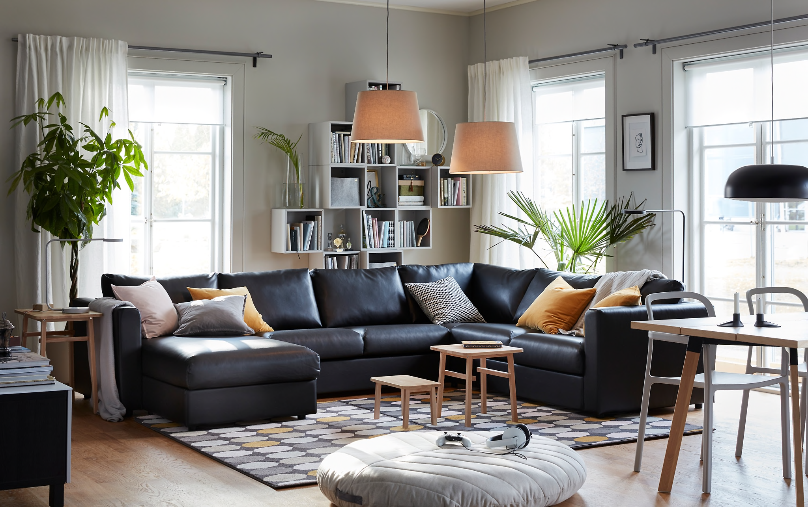

Ex 1. Look at the words and translate them into English
https://quizlet.com/306224822/english-basic-lesson-15-living-room-part-1-flash-cards/?new

Ex 2. Read the text about Anne’s living room and fill in the gaps.
Spacious carpet bookshelf vase fireplace curtains cosy
I am Anne. I’m British and I’m going to describe you my living room.
My living room is very spacious and bright. I keep it clean and tidy because it is my favourite room in the house. Its walls are blue and the floor is salmon. On the floor, in the center, there is a big blue carpet. On it I have my two sofas, the coffee table and a stool. There is also a small round table where I sometimes put the book I am reading. I enjoy reading so there is a bookshelf with many books in it. On the bookshelf there is a vase with a small plant and an old clock. On one corner of the living room there is a big plant in a vase.
The living room is very warm in winter because it has got a fireplace. Above it there are some pictures. Next to the fireplace there is a round table with a table lamp on it.
There are four windows and two of them have got lovely violet curtains I made myself.
I like to read and have a rest in my living room. It’s warm and cosy.

Ex 3. Say if the following statements are True, False or Impossible to Know.
1. Anne has got three children. Impossible to Know
2. Her favourite part of the house is the kitchen. False
3. There are two sofas in the living room. True
4. There is a big yellow carpet on the floor. False
5. Anne appreciates art. Impossible to Know
6. The living room is cold in winter. False
7. The curtains are blue. False
8. There are some pictures on the wall. True

Ex 4. Match the picture with the word
http://gamedata.britishcouncil.org/lep25_embed/MTA5Mjg=/teens

Ex 5 Match the word with its definition
http://gamedata.britishcouncil.org/lep25_embed/MTg5MTg=/teens

Ex 6 Write the word to fill the gaps
http://gamedata.britishcouncil.org/lep25_embed/MTg5MTk=/teens

Ex 7. Write the correct number in the circles you see in the picture.

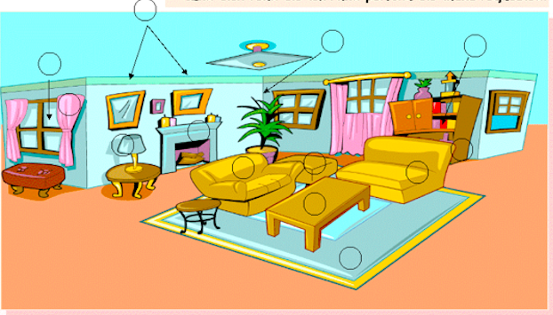

1. window
2. curtain
3. pictures
4. fireplace
5. carpet
6. stool
7. table lamp
8. coffee table
9. sofa
10. books
11. bookshelf
12. plant

PDF

Ex 1. Look at the words and translate them into English
https://quizlet.com/306224822/english-basic-lesson-15-living-room-part-1-flash-cards/?new

Ex 2. Read the text about Anne’s living room and fill in the gaps.
Spacious carpet bookshelf vase fireplace curtains cosy
I am Anne. I’m British and I’m going to describe you my living room.
My living room is very … and bright. I keep it clean and tidy because it is my favourite room in the house. Its walls are blue and the floor is salmon. On the floor, in the center, there is a big blue …. On it I have my two sofas, the coffee table and a stool. There is also a small round table where I sometimes put the book I am reading. I enjoy reading so there is a … with many books in it. On the bookshelf there is a … with a small plant and an old clock. On one corner of the living room there is a big plant in a vase.
The living room is very warm in winter because it has got a …. Above it there are some pictures. Next to the fireplace there is a round table with a table lamp on it.
There are four windows and two of them have got lovely violet … I made myself.
I like to read and have a rest in my living room. It’s warm and ….

Ex 3. Say if the following statements are True, False or Impossible to Know.
1. Anne has got three children.
2. Her favourite part of the house is the kitchen.
3. There are two sofas in the living room.
4. There is a big yellow carpet on the floor.
5. Anne appreciates art.
6. The living room is cold in winter.
7. The curtains are blue.
8. There are some pictures on the wall.

Ex 4. Match the picture with the word
http://gamedata.britishcouncil.org/lep25_embed/MTA5Mjg=/teens

Ex 5 Match the word with its definition
http://gamedata.britishcouncil.org/lep25_embed/MTg5MTg=/teens

Ex 6 Write the word to fill the gaps
http://gamedata.britishcouncil.org/lep25_embed/MTg5MTk=/teens

Ex 7. Write the correct number in the circles you see in the picture.

1. window
2. curtain
3. pictures
4. fireplace
5. carpet
6. stool
7. table lamp
8. coffee table
9. sofa
10. books
11. bookshelf
12. plant

