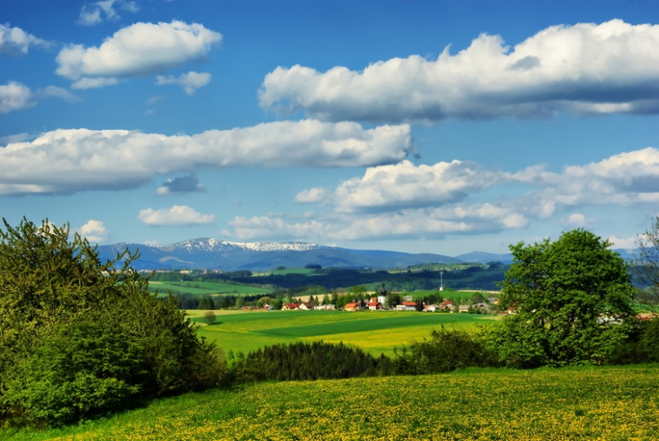
basic_lesson_18_countryside_video_part_3

Quizlet
https://quizlet.com/305799455/basic-video-countryside-18-flash-cards/?new
Exercise 1
Choose the correct word for each sentence
sailing - canoeing - picturesque - castle - countryside
- An old historic structure where kings and queens lived. _____
- A place away from the city area is called a __________.
- Another way to say ‘beautiful view’. _____
- When you take a boat it means that you don`t ‘swim in a boat’ but ‘go ______’ .
- A kind of activity when you sail a long and narrow boat. _____
Exercise 2
Watch the video and answer the questions
https://www.youtube.com/watch?v=uGyBHvtWbBU
- Match the objects or actions which you DIDN`T SEE in the video
- A bird
- Eating out
- A horse
- Airport
- Sailing
- Bus station
- Canoeing
- A castle
- Fishing
- Skiing

- Where are these people spending time?
- In the modern city
- On the sandy beach
- In the picturesque countryside

Exercise 3
Watch the video and answer the questions
https://www.youtube.com/watch?v=ssaDckbBsfA
- Choose things you saw in the video
- Mountains
- Farm
- Cliff
- Waterfall
- Volcano
- Hills
- Rainbow
- Desert
- River

Quizlet
https://quizlet.com/305799849/video-basic-countruside-ex-4-flash-cards/?new

Exercise 4
Watch the video and answer the questions afterwards
https://www.youtube.com/watch?v=EdUs8jA7AHk
- What modern facilities are there in a city?
- transport system and entertaining
- working on a farm
- Life in the country is very noisy.
- True b) False
- Countryside is always very crowded.
- True b) False
- Air in the country is _____
- polluted b) clean
- Life in a city is very slow.
- True b) False
- Education in the county is worse than in a city.
- True b) False

