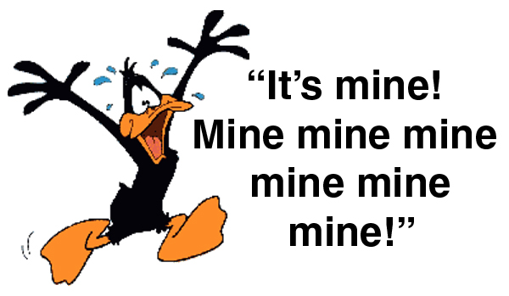
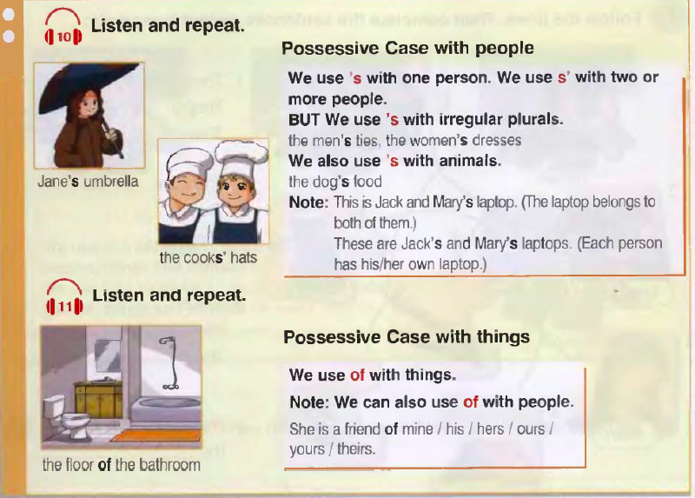

Ex.1 Look at the pictures and say
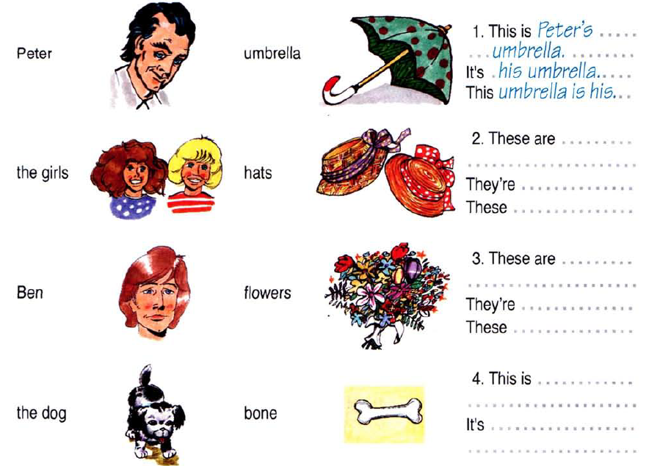

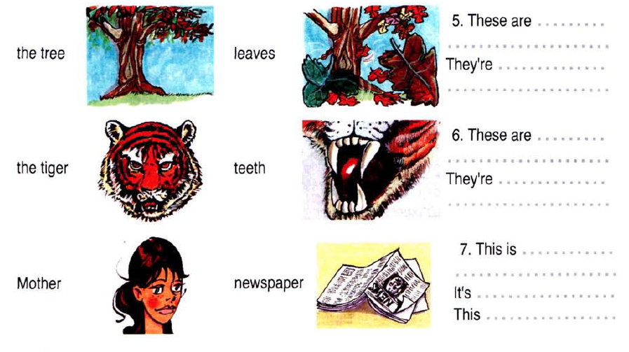

Ex.2 Look at the family tree below and say whose relatives are they.

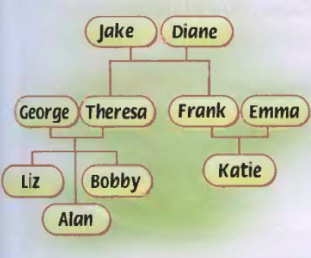

1 Jake is ______ husband. He's ______ husband.
2 Diane is ______ and ______ mother. She's ______ mother.
3 Liz is ______ and ______ sister. She's ______ sister.
4 Frank is ______ father. He's ______ father.
5 George and Theresa are ______ and ______ parents. They're ______ parents.

Ex.3 Choose the correct item.
1 My friends’ / friend’s name is Mike.
2 This is the cat's / cats bowl leaves.
3 Our children's / childrens' Art teacher is Ms Black.
4 Look at Philip's and Lucy's / Philip and Lucy’s new cameras.
5 Look at the leaves of the tree / the tree leaves.
6 He is a friend of her / hers.
7 These are the girls' / girls bikes.
8 My cousin's / cousins car is blue.

Ex. 4 Follow the lines. Then complete the sentences as in the example.

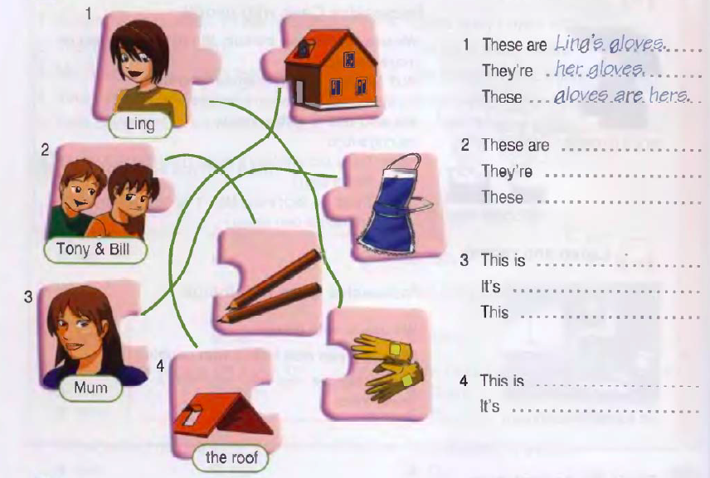

Answer key
1 Jake is Diane’s husband. He's ___her___ husband.
2 Diane is ___Frank___ and Emma’s mother. She's ____their__ mother.
3 Liz is __Alan____ and ____Bobby’s__ sister. She's their sister.
4 Frank is __Katie’s____ father. He's ___her___ father.
5 George and Theresa are ___Liz, Alan___ and ___Bobby’s___ parents. They're __their____ parents.

Ex.3 Choose the correct item.
1 My friends’ / friend’s name is Mike.
2 This is the cat's / cats bowl leaves.
3 Our children's / childrens' Art teacher is Ms Black.
4 Look at Philip's and Lucy's / Philip and Lucy new cameras.
5 Look at the leaves of the tree / the tree leaves.
6 He is a friend of her / hers.
7 These are the girls' / girls bikes.
8 My cousin's / cousins car is blue.

