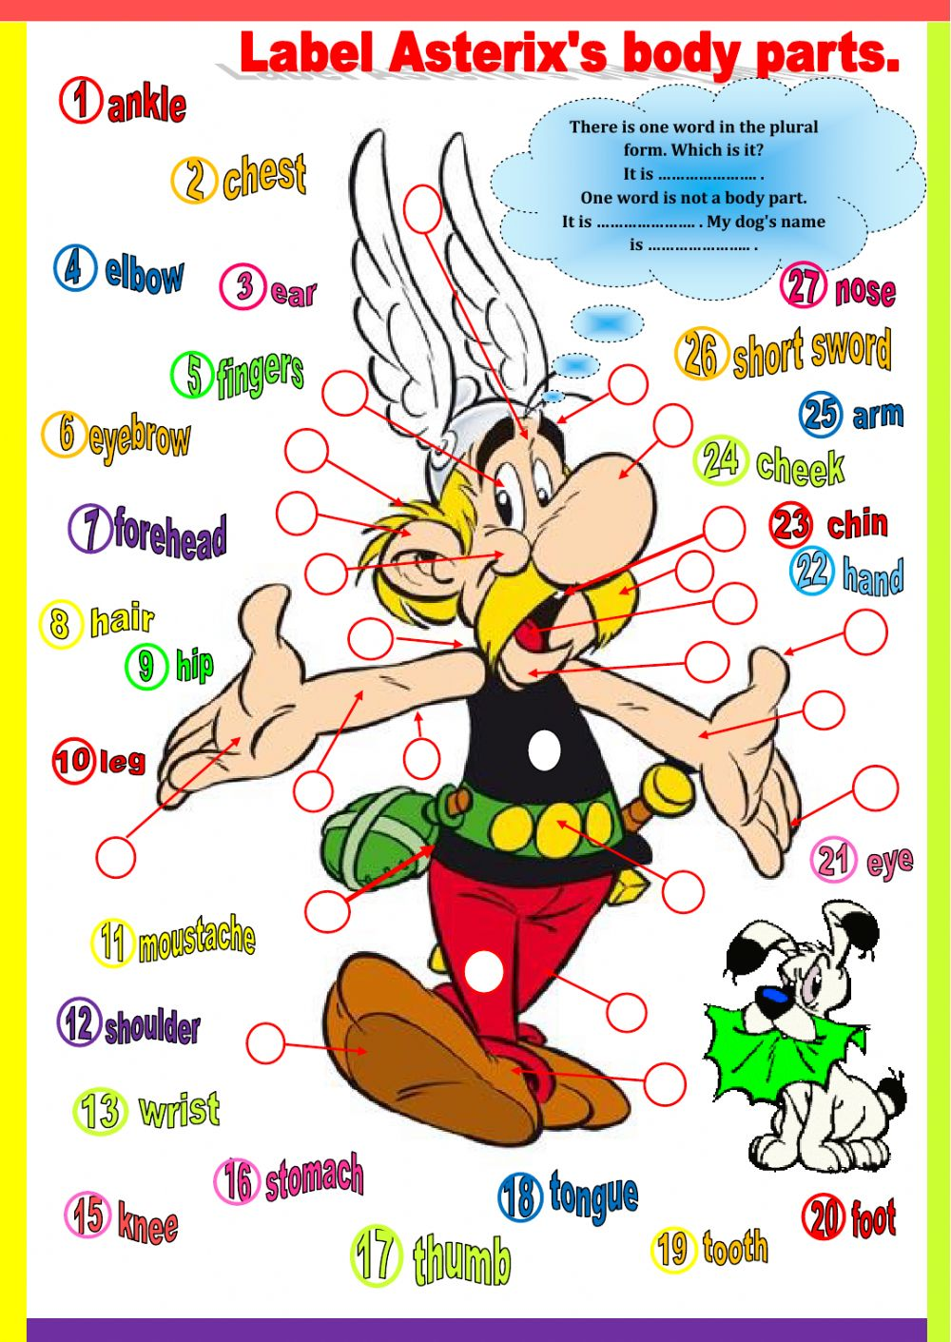

Task 1
Choose the correct form in the singular.
1.This is … .
a.Tom’s car
b.the car of Tom
2.The … are broken.
a.car’s lights
b.lights of the car
3.This shouldn’t happen because it is the … .
a.make’s newest model
b.newest model of this make
4.While his car is in the garage, Tom is using … .
a.his mother’s car
b.the car of his mother
5.On Friday, his car will be fixed so he can drive to … .
a.his friend’s birthday party
b.the birthday of his friend

Task 2
Complete with the correct form in the plural.
1.Steve has two brothers. Mother said Steve is not allowed to take his (brother) … toys without asking.
2.The (woman) … national football team won a great victory on Saturday.
3.The zoo keeper did his round and put food in all the (animal) … cages.
4.The first day of the summer holidays is the school (child) … favourite day of the year.
5.Hannah has lots of friends. Two of them have their birthday on the same day. Hannah is buying a dress for her (friend) … joint birthday party.

Task 3
Complete the sentences with the correct form.
1.My brother has a computer. → It’s ….
a.my brother’s computer
b.the computer of my brother
2.Peter has a dog called Scruffy. → The … is Scruffy.
a.dog’s name
b.name of the dog
3.The schoolbus is yellow. → The … is yellow.
a.schoolbus’s colour
b.colour of the schoolbus
4.Richard has two sisters. Each sister has a rabbit. Sometimes Richard has to feed the rabbits.
→ Sometimes, Richard has to feed … .
a.her sisters’ rabbits
b.rabbits of her sisters
5.Some say the Mona Lisa is the most beautiful painting.
→ The Mona Lisa is the … .
a.world’s most beautiful painting
b.most beautiful painting of the world

Task 4
Write the correct form of the possessives into the gaps (apostrophe 's).
1.This is … book. (Peter)
2.Let's go to the … . (Smiths)
3.The … room is upstairs. (children)
4. … sister is twelve years old. (John)
5. … and … school is old. (Susan – Steve)
6. … shoes are on the second floor. (men)
7.My … car was not expensive. (parents)
8. … CD player is new. (Charles)
9.This is the … bike. (boy)
10.These are the … pencils. (boys)

Task 5
Choose the correct variant
1.This is … book.
a.Julian’s
b.Julians’
2.He is … brother.
a.Laura’s
b.Lauras’
3.The … room is nice.
a.children’s
b.childrens’
4.Where is … football?
a.Nick’s
b.Nicks’
5.Our … van is big.
a.parent’s
b.parents’
6.My … family lives in Scotland.
a.aunt’s
b.aunts’
7.The … house is green.
a.Baker’s
b.Bakers’
8.My … watch is always slow.
a.grandma’s
b.grandmas’
9.These are my … keys.
a.mum’s
b.mums’
10.The … laptops are brand new.
a.secretaries’s
b.secretaries’

Task 6
Write the correct form of the possessives into the gaps.
1.Sarah is … aunt. (Emily)
2.These are our … cats. (friends)
3.Let's meet at … for lunch. (Giovanni)
4.Where is the … shower? (ladies)
5.This is our … car. (boss)
6.My … dad is my uncle. (cousin)
7.Did you read … newspaper? (yesterday)
8. … and … bags are black. (Jack – Joe)
9.Our grandparents live in an old … home. (people)
10.That sandwich would not be to … taste. (everyone)

ANSWERS
Task 1
- This is Tom’s car.
- The lights of the car are broken.
- This shouldn’t happen because it is the newest model of this make.
- While his car is in the garage, Tom is using his mother’s car.
- On Friday, his car will be fixed so he can drive to his friend’s birthday party.
Task 2
- Steve has two brothers. Mother said Steve is not allowed to take his brothers’ toys without asking.
- The women’s national football team won a great victory on Saturday.
- The zoo keeper did his round and put food in all the animals’ cages.
- The first day of the summer holidays is the school children’s favourite day of the year.
- Hannah has lots of friends. Two of them have their birthday on the same day. Hannah is buying a dress for her friends’ joint birthday party.
Task 3
- My brother has a computer. → It’s my brother’s computer.
- Peter has a dog called Scruffy. → The dog’s name is Scruffy.
- The schoolbus is yellow. → The colour of the schoolbus is yellow.
- Richard has two sisters. Each sister has a rabbit. Sometimes Richard has to feed the rabbits.
→ Sometimes, Richard has to feed his sisters’ rabbits.
- Some say the Mona Lisa is the most beautiful painting.
→ The Mona Lisa is the most beautiful painting of the world.

Task 4
- This is Peter's book.
- Let's go to the Smiths'.
- The children's room is upstairs.
- John's sister is twelve years old.
- Susan and Steve's school is old.
- Men's shoes are on the second floor.
- My parents' car was not expensive.
- Charles's CD player is new.
- This is the boy's bike.
- These are the boys' pencils.

Task 5
- This is Julian's book.
- He is Laura's brother.
- The children's room is nice.
- Where is Nick's football?
- Our parents' van is big.
- My aunt's family lives in Scotland.
- The Bakers' house is green.
- My grandma's watch is always slow.
- These are my mum's keys.
- The secretaries' laptops are brand new.

Task 6
- Sarah is Emily's aunt.
- These are our friends' cats.
- Let's meet at Giovanni's for lunch.
- Where is the ladies' shower?
- This is our boss's car.
- My cousin's dad is my uncle.
- Did you read yesterday's newspaper?
- Jack's and Joe's bags are black.
- Our grandparents live in an old people's home.
- That sandwich would not be to everyone's taste.

