Lesson 23-Parts of the body-Vocabulary (part 1)
Exercise 1
Presentation basic
Exercise 2
Answer these questions about the body and choose the proper picture
- What do you see with and what do you hear with?
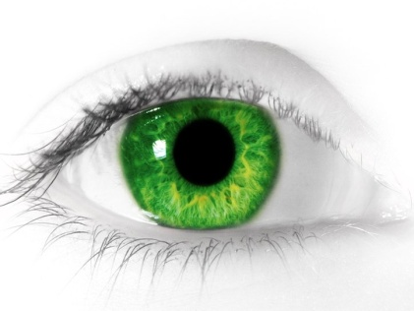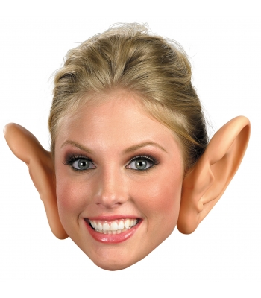
- What two parts of your body do you regularly cut?

- What does the heart move round the body?
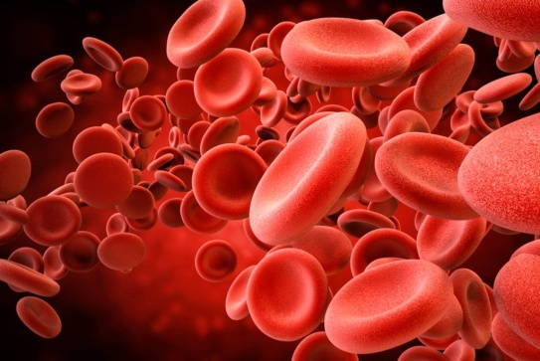
- What part of the body controls what you do?
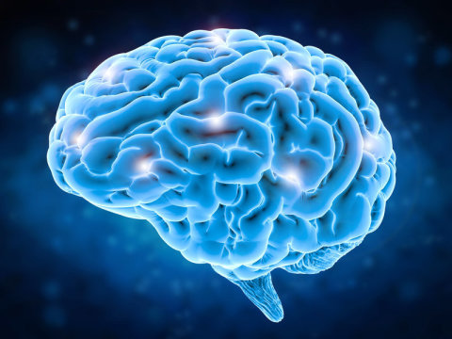
- What covers all your body?
- On your foot you have a big toe. What do you have on your hand?
- What part of the body do people often lie on when they sleep?
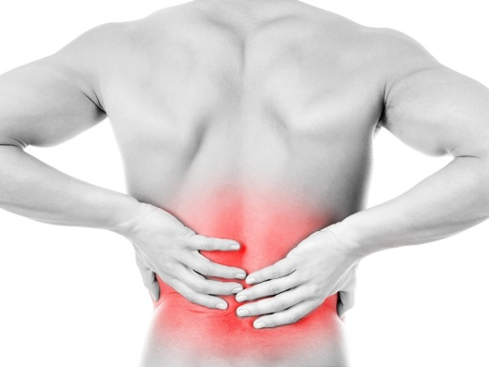
- What is inside your mouth?
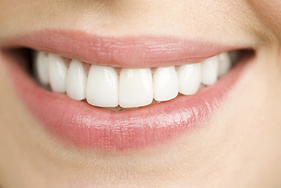

Exercise 3
http://learnenglishteens.britishcouncil.org/vocabulary/beginner-vocabulary/body-parts
упражнение Check your vocabulary: gap fill
Exercise 4
http://learnenglishteens.britishcouncil.org/vocabulary/beginner-vocabulary/body-parts
Check your vocabulary: grouping
Exercise 5
Play the game
https://www.eslgamesplus.com/body-parts-esl-interactive-pirate-board-game/
Exercise 6 hot potatoes-выпадающий список
Name the parts of the head
Knee, thumb, leg, hurt, neck, teeth, finger, shoulder, nose, stomach

