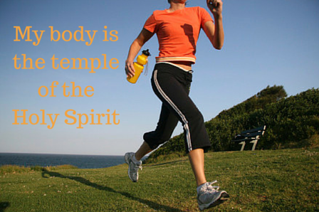
basic_lesson_23_parts_of_the_body_reading _part_3
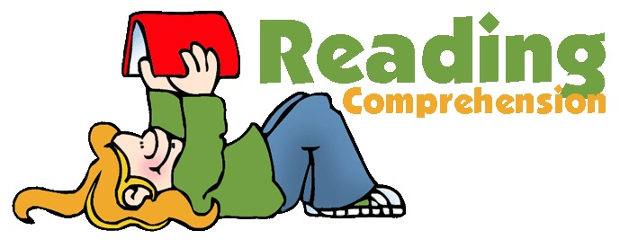

Quizlet
https://quizlet.com/306961675/basic-reading-lesson-20-body-flash-cards/?new

Exercise 1
Define if the statements are True or False
Your heart is really a muscle. It's located a little to the left of the middle of your chest, and it's about the size of your fist. There are lots of muscles all over your body in your arms, in your legs, in your back, even in your behind. But this muscle is special because of what it does the heart sends blood around your body. The blood provides your body with the oxygen it needs. It also carries away the waste that your body has to get rid of.

- A heart is not a muscle.
- A heart is located in your chest.
- The size of a heart is the same as your fist.
- A heart sends blood around your body.
- The blood provides your body with water.

Exercise 2

Complete these sentences:
- There are five fingers in my .
- There are five toes in my .
- I've got an above my eye.
- I can smell with my .
- I can hear with my .
- I can taste with my .
Exercise 3
Match the pictures with the words
shoulder neck belly toes knees forehead

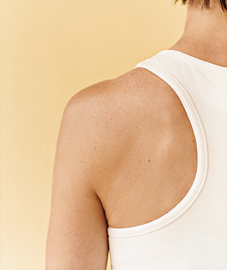
belly shoulder

neck
knees
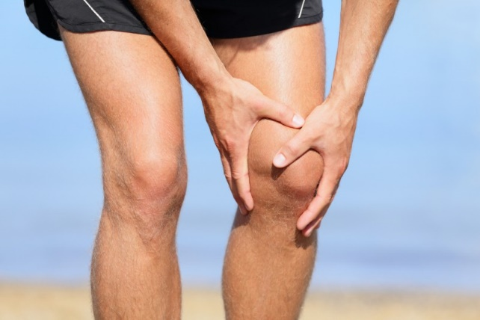

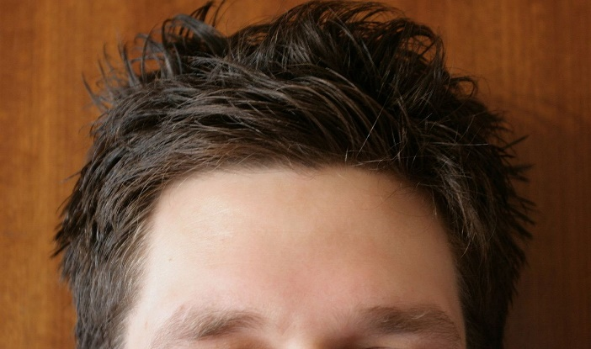
forehead
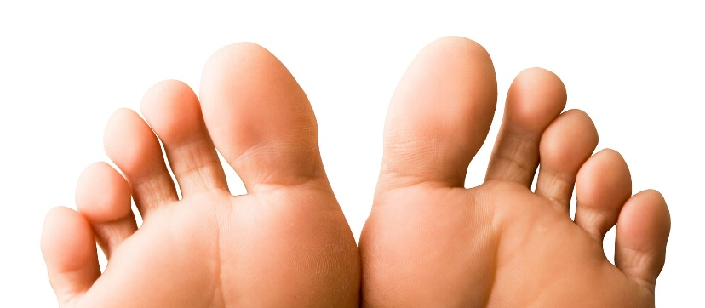
toes

Exercise 4
Read the text and answer the questions

Our body is a hard system that consists of so-called “parts”. Each part of our body has its own task. For instance, we need eyes to see different articles, legs and arms – to move and do various things.
Literally our body can be divided into a head, trunk and limbs. A forehead, face and mouth belong to a head. A trunk – it’s a neck, belly and a chest. The limbs are arms, shoulders, hands, fingers, legs as well as feet, toes and knees.
Such parts of the body as head and back are important for us. Brain (our head) is responsible for all our body. In other words, it controls both our physical organs and psychological state. As for a spine, which is situated on our back, it also supports healthy function of all organs.
We should pay more attention to the health of all our body parts. To be much healthier we need to spend a lot of time on physical exercises, go in for sports and eat well-balanced food.

- The general word for hands and legs is:
- limbs
- chest
- forehead
- What is trunk?
- arms, legs, knees
- neck, chest, belly
- eyes, nose, lips
- Which part is responsible for all your body?
- neck
- brain
- back
- Where is a spine situated?
- On our head
- On our foot
- On our back
- What helps you be much healthier?
- do physical exercises
- eat less
- drink coffee

