Adjectives
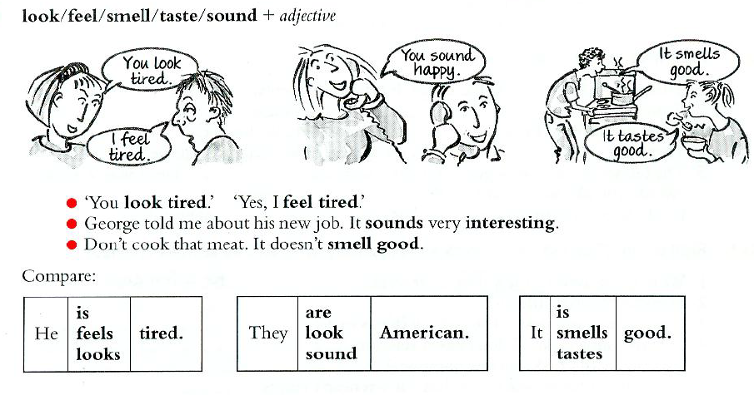
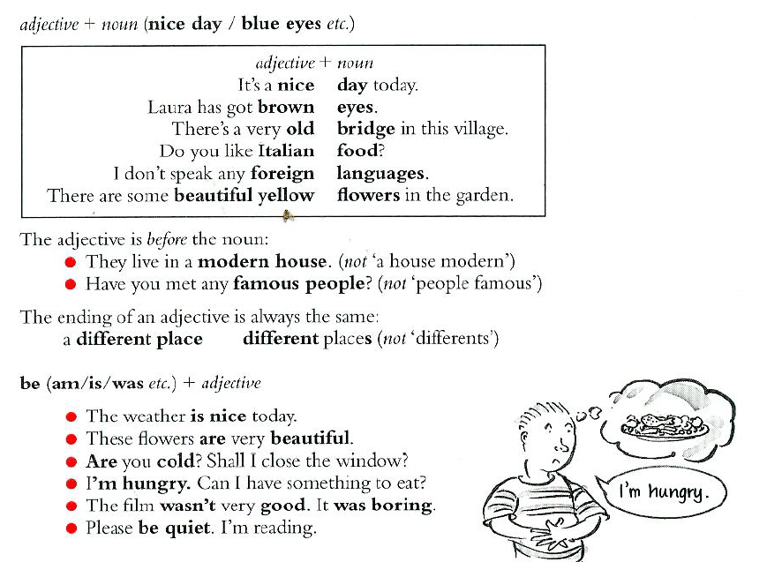

Ex.1 Put the words in the right order.

1 (new / live in / house / they / a)
2 (like / jacket / I / that / green)
3 (music / like / do / classical / you?)
4 (had / wonderful / a / I / holiday)
5 (went to / restaurant / a / Chinese / we)

Ex.2 The words in the box are adjectives (black/foreign etc.) or nouns (air/job etc.). Use an adjective and a noun to complete each sentence.

air clouds foreign holiday job languages sharp
black dangerous fresh hot knife long water

1 Do you speak any ___________.
2 Look at those ___________. It's going to rain.
3 Sue works very hard and she's very tired. She needs a ___________.
4 I want to have a bath but there's no ___________.
5 Can you open the window? We need some ___________.
6 I need a ___________ to cut these onions.
7 Fire-fighting is a ___________.

Ex.3 A and B don't agree. Complete B's sentences. Use the word in brackets (...).

1 | You look tired. |  | Do I? I _____________. (feel)
2 | This is a new coat. |  | Is it? It _____________. (look)
3 | I'm American. |  | Are you? You _____________. (sound)
4 | You look cold. |  | Do I? I _____________. (feel)
5 | These bags are heavy |  | Are they? They _____________. (look)
6 | That soup looks good. |  | Does it? It (taste)

Ex.4 Match pictures with adjectives

Happy
Ill
Nice
Horrible
New
Surprised
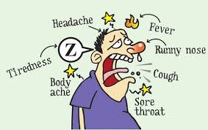

Adverbs

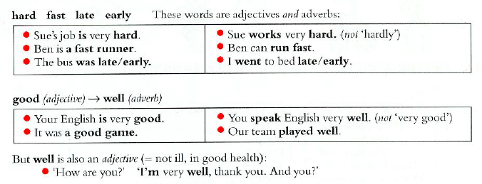
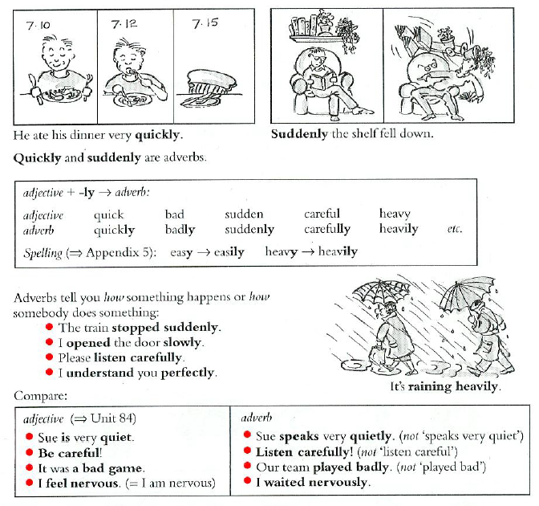

Ex.4 Look at the pictures and complete the sentences with one of these adverbs

Angrily
Badly
Dangerously
Fast
Heavily
Quietly
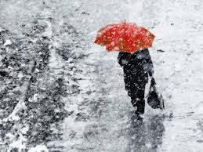
It's raining _____________.

He sings very _____________.

They came in _____________.

She shouted at me ___________

She can run very _____________.

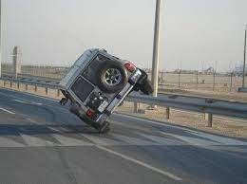
He was driving _____________.

Ex.5 Which is right?

1 Don't eat so quick/quickly. It's not good for you.
2 Why are you angry/angrily? I haven't done anything.
3 Can you speak slow/slowly, please?
4 Come on, Dave! Why are you always so slow/slowly?
5 Bill is a very careful/carefully driver.
6 Jane is studying hard/hardly for her examinations.
7 'Where's Diane?' She was here but she left sudden/suddenly:
8 Please be quiet/quietly. I'm studying.
9 Some companies pay their workers very bad/badly.
10 Those oranges look nice/nicely. Can I have one?
Ex.6 Put in good or well.

1 Your English is very ................ You speak English very ...............
2 Jackie did very ............... in her exams.
3 The party was very I enjoyed it very much.
4 Martin has a difficult job but he does it ................
5 How are your parents? Are they ?
6 Did you have a ............. holiday? Was the weather ....... ?

Answer key

Ex.1
- They live in a new house.
- I like that green jacket.
- Do you like classical music?
- I had a wonderful holiday?
- We went to Chinese restaurant.

Ex.2
- foreign languages
- black clouds
- long holiday
- hot water
- fresh air
- sharp knife
- dangerous job.
Ex.3
1. I don’t feel tired
2. It doesn’t look new
3. You don’t sound American.
4. I don’t feel cold.
5. They don’t look heavy.
6. It doesn’t taste good.

Ex.4 Картинки стоят в правильном порядке
Happy
Ill
Nice
Horrible
New
Surprised

Ex.5

It's raining _____heavily________.
He sings very _____badly________.
They came in ______quietly_______.
She shouted at me ____angrily_______
She can run very ____fast_________.
He was driving ____dangerously______.

Ex.6
1 quickly
2 angry
3 slowly
4 slow
5 carefully
6 hard
7 suddenly
8 quiet
9 badly
10 nice

Ex.6

1 good, well
2 well
3 good
4 well
5 well
6 good, good

