Types of People
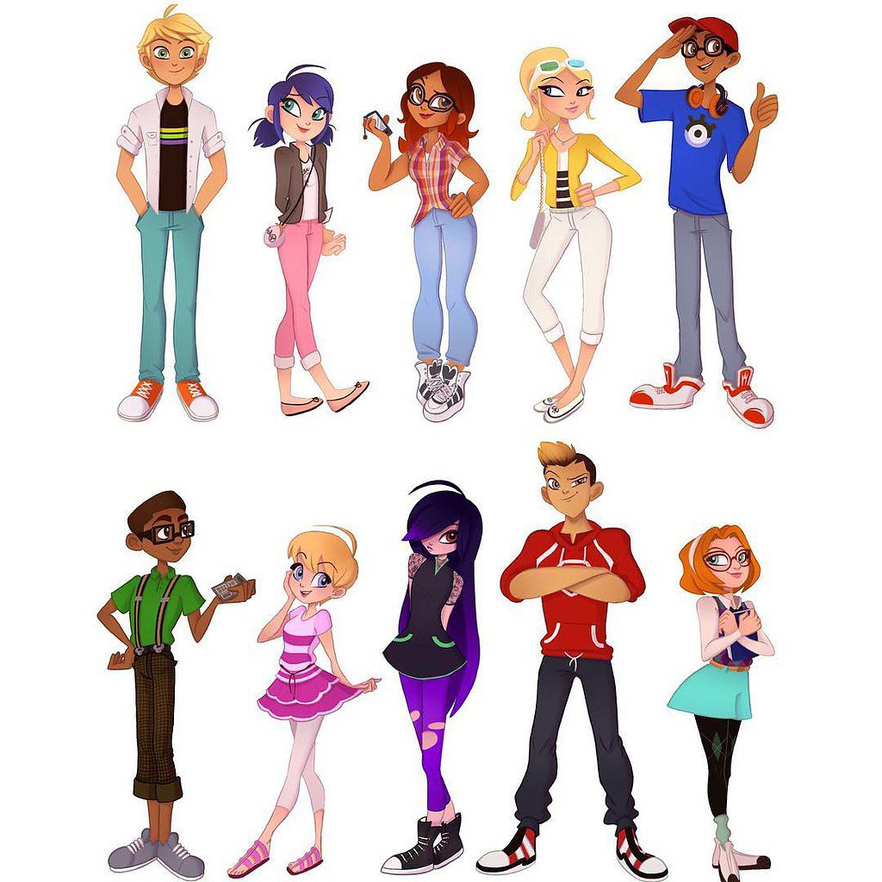
Exercise 1
Study the following words and expressions
https://quizlet.com/324500311/flashcards
Exercise 2
Match words and their definitions (сделать выпадающий список)
polite
handsome
rude
miserable
mean
intelligent
hard-working
lazy
generous
- Showing a readiness to give more of something, especially money, than is strictly necessary or expected.
- A person working a lot, with much energy
- (of a man) good-looking
- Very smart
- Unwilling to work or use energy
- Unwilling to give or share things, especially money; not generous
- (of a person) very much unhappy or uncomfortable
- Having or showing behaviour that is respectful and considerate of other people
- Very impolite or bad-mannered
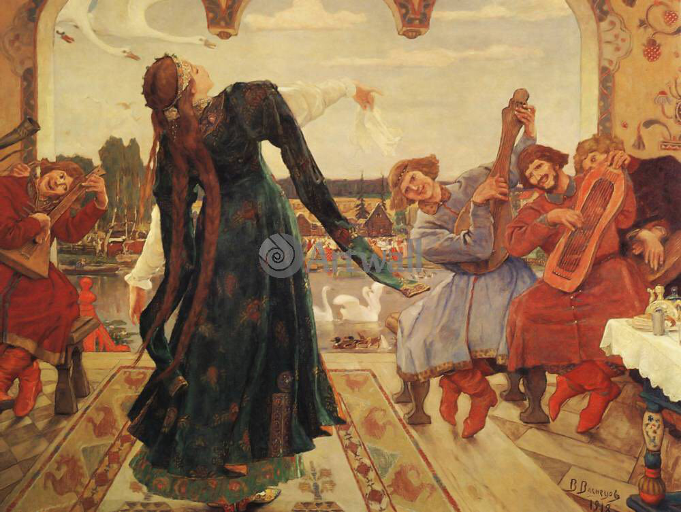
Exercise 3
Fill in the gaps
rude mean stupid miserable handsome lazy
intelligent generous polite happy beautiful
He looks like a film-star. Every girl in the office wants to go out with him. He is very _____.
She finds it easy to learn things and has passed all her exams. She is very _____.
She always buys things for people. She is very _____.
He hates working and would prefer to stay at home all day in front of television. He is so _____.
He doesn’t know anything. He can’t even add up two and four. He is so _____.
The children next-door are so _____. They never say “Please” or “Thank you” and always shout back at their parents.
He is always smiling and thinks life is wonderful. He seems to be really _____.
She works as a model. When she walks into a room every man turns and stares at her. She is really _____.
He hates spending money. He is so _____.
She always says “Please” and “Thank you”. She is a very _____ child.
She never has a smile on her face and always looks unhappy. She is so _____.
Exercise 4
Study the following words and expressions
https://quizlet.com/324509406/flashcards
Exercise 5
Match words and their definitions (сделать выпадающий список)
boring
jealous
imaginative
ambitious
shy
sociable
patient
impatient
selfish
Wanting very much to become successful
Not interesting
Having or showing creativity
A person cannot wait
Very angry if one’s boyfriend/girlfriend or husband/wife is attracted of looks at someone else
Able to wait or tolerate problems
Interested only in own personal profit or pleasure, not thinking about others
Wanting to talk and engage in activities with other people; friendly
Nervous in the company of other people
Exercise 6
Fill in the gaps
impatient selfish patient ambitious
imaginative tidy sociable boring
Everything is always in the right place in his room and on his desk. He is really_____.
She finds it very easy to make up stories to tell her children, and can always think of new ideas. She is so_____.
He only ever thinks of himself. He is really_____.
She wants to get a top job one day and even talks about becoming Prime Minister. She is extremely______.
He hates waiting for people or trains and can’t stand it when things don’t happen immediately. He is very_____.
He loves going to parties and meeting people. He is very_____.
The only thing she ever talks about is golf. I almost fell asleep listening to her. She is so_____!
He never shouts at us and will explain things over and over again until we understand them. He is very_____.
She doesn’t like meeting strange people and usually feels nervous and uncomfortable at parties. She is extremely_____.

Key
Exercise 2
Showing a readiness to give more of something, especially money, than is strictly necessary or expected. | generous
A person working a lot, with much energy | hard-working
(of a man) good-looking | handsome
Very smart | intelligent
Unwilling to work or use energy | lazy
Unwilling to give or share things, especially money; not generous | mean
(of a person) very much unhappy or uncomfortable | miserable
Having or showing behaviour that is respectful and considerate of other people | polite
Very impolite or bad-mannered | rude

Exercise 3
Fill in the gaps
He looks like a film-star. Every girl in the office wants to go out with him. He is very _____ handsome.
She finds it easy to learn things and has passed all her exams. She is very _____ intelligent.
She always buys things for people. She is very _____ generous.
He hates working and would prefer to stay at home all day in front of television. He is so _____ lazy.
He doesn’t know anything. He can’t even add up two and four. He is so _____ stupid.
The children next-door are so _____ rude. They never say “Please” or “Thank you” and always shout back at their parents.
He is always smiling and thinks life is wonderful. He seems to be really _____ happy.
She works as a model. When she walks into a room every man turns and stares at her. She is really _____ beautiful.
He hates spending money. He is so _____ mean.
She always says “Please” and “Thank you”. She is a very _____ polite child.
She never has a smile on her face and always looks unhappy. She is so _____ miserable.
Exercise 5
Wanting very much to become successful | ambitious
Not interesting | boring
Having or showing creativity | imaginative
A person cannot wait | impatient
Very angry if one’s boyfriend/girlfriend or husband/wife is attracted of looks at someone else | jealous
Able to wait or tolerate problems | patient
Interested only in own personal profit or pleasure, not thinking about others | selfish
Wanting to talk and engage in activities with other people; friendly | sociable
Nervous in the company of other people | shy

Exercise 6
Fill in the gaps
Everything is always in the right place in his room and on his desk. He is really_____ tidy.
She finds it very easy to make up stories to tell her children, and can always think of new ideas. She is so_____ imaginative.
He only ever thinks of himself. He is really_____ selfish.
She wants to get a top job one day and even talks about becoming Prime Minister. She is extremely______ ambitious.
He hates waiting for people or trains and can’t stand it when things don’t happen immediately. He is very_____ impatient.
He loves going to parties and meeting people. He is very_____ sociable.
The only thing she ever talks about is golf. I almost fell asleep listening to her. She is so_____ boring!
He never shouts at us and will explain things over and over again until we understand them. He is very_____ patient.

