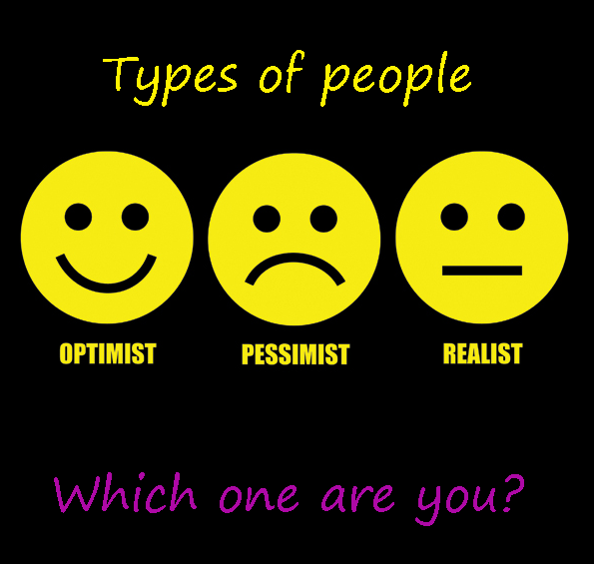
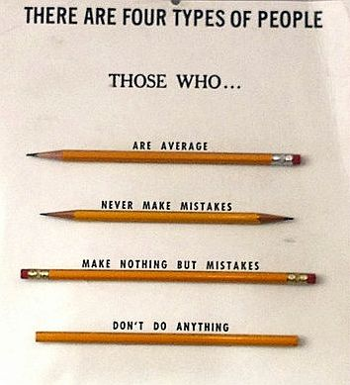
Quizlet.
https://quizlet.com/38943571/flashcards

I. Watch the video and answer the questions.
<iframe width='640' height='480' src='https://en.islcollective.com/video-lessons/embed/28835' frameborder='0' allowfullscreen></iframe>

II. Watch a short film, predict how the film will end, speak about the film.
Step 1.Write the following sentences on the board.
- I’m like my brother.
- My brother and I are alike.
Explain that two sentences mean the same thing, but that like followed by another person, alike goes at the end of a sentence.

Step 2. Ask your students to describe character of their members of family. Then ask them to tell about themselves and a member of their family using like or alike.

Step 3. Tell your students they are going to watch a short film about a father and his son. They should notice in what ways the father and son, and their lives are alike.
<iframe src="https://player.vimeo.com/video/194276412" width="640" height="360" frameborder="0" allowfullscreen></iframe>

Step 4. Ask your students the following questions:
- How can you describe the father and his son?
- How does the film make you feel?
- What problem does the film illustrate?
III. Watch the video and answer the questions.
<iframe width='640' height='480' src='https://en.islcollective.com/video-lessons/embed/49109' frameborder='0' allowfullscreen></iframe>

